Press release

Bauma 2022: Product highlights and innovations for Liebherr earthmoving and material handling machines

⸺

Presentation of numerous new products, highlights and innovations for earthmoving machines and material handlers

Daily live demos show practical applications of current and future alternative drive technologies

Insight into future-oriented solutions for digitisation and service

Dedicated indoor stand for comprehensive portfolio of attachments and quick coupling systems for earthmoving machines and material handlers

At Bauma 2022 Liebherr will present many new products, highlights and innovations for the earthmoving and material handling sectors. Practical applications of current and future alternative drive concepts are presented in the form of live shows taking place several times a day. At the main trade fair stand visitors will find an overview of future-oriented services and solutions for its earthmoving and material handling machines. The comprehensive portfolio of Liebherr attachments and quick coupling systems will be on display in hall B5 stand 439.

Munich (Germany), 21 June 2022 – At outdoor stand FG 809-813 of Bauma 2022 Liebherr is planning a large area for the topics of the two product segments earthmoving and material handling technology. Apart from the impressive live shows, Liebherr presents its new products and highlights in a static exhibition. Here Liebherr shows, e.g., two completely revamped series of Generation 8 in the wheel loaders with the compact loaders and the medium-sized wheel loaders. As a representative of the new Generation 8 crawler excavator, the R 928 will be equipped with a semi-automatic machine control.

In addition, Liebherr presents the A 922 Rail Litronic for the first time at Bauma with a hydrostatic drive concept and new LIKUFIX® quick coupling system, as well as the articulated dump truck TA 230 Litronic, which can also be seen in Munich for the first time on an international trade fair stage.

Liebherr showcases three representatives from the area of material handling technology: The specialist audience can look forward to the LH 22 M Industry Litronic for efficient use in tree care and the timber industry. With the LH 26 M Industry E and LH 150 M Port E Liebherr also shows two electric material handlers for applications in recycling and port handling.

Future-oriented solutions: Alternative drives, digitisation and service

As a continuation of the Bauma showcase in 2019, this year Liebherr provides an insight into Liebherr's work in the area of alternative drive concepts which is open to all types of technology within the framework of live shows taking place several times a day. Practical applications of current and future alternative drive technologies for earthmoving machines and material handling technology are also presented. Practical concepts as well as construction equipment and material handlers which are powered by different primary energy sources such as diesel, HVO (Hydrotreated Vegetable Oils), electricity and hydrogen are showcased.

In this context several innovative machines are on show, which highlight the work of alternative concepts: For example, the first battery-electric wheel loader and the first battery-electric telescopic handler of the Liebherr Group. These two Bauma exhibits are near-series pre-production machines. The Liebherr electric material handler LH 26 M Industry E with battery-operated Mobility Kit for temporary operation independent of the mains is also part of the live shows.

In addition to the work on alternative drives, Liebherr also takes its product responsibility very seriously in other areas. The aim is to offer customers safe, efficient and environmentally-friendly products over the long term. This also includes services such as the Reman programme, among other things. Old components are reconditioned to the highest quality standards and at the customer's request can be used for a component exchange instead of a new part – the old part is up to par with a new part in terms of performance and reliability and is also a resource-friendly and at the same time economic alternative.

The areas digitisation and service are another focal point. Together with sales and service partners as well as customers Liebherr continuously develops services and solutions – digitisation plays an increasingly important role here. Apart from the latest developments, existing customer solutions from the areas driver assistance, construction site communication and automated data exchange are also presented. Liebherr cordially invites customers and interested parties to its Bauma stand to discuss ideas and exchange experiences.

The increasing digitisation also makes it possible to be able to make services and solutions even more individual, consistent and transparent. A variety of new, digital solutions are presented at Bauma, with which an increase in efficiency, performance, reliability, safety and comfort can be achieved. For workshop managers performance and maintenance data on the machines will be available in future in the MyLiebherr portal in a clear and concise form and made available for subsequent processes such as maintenance planning and spare parts orders. Liebherr also presents several intelligent assist systems and applications for the increasingly complex requirements of the machine operators: With the MyAssistance for Earthmoving app machine operators obtain relevant information on the operation and maintenance of Liebherr machines. The Remote Service provides optimal support for the daily work of service technicians, which allows construction machines to be serviced at any time and place.

Numerous new features for the Generation 8 Liebherr wheel loaders

Liebherr presents two completely revamped series for the wheel loaders with the compact loaders and the medium-sized wheel loaders. The compact loaders, which includes a new additional model, the L 504 Compact, can be seen for the first time in Germany at a trade fair. Liebherr also showcases the medium-sized wheel loaders to a cross-industry audience for the first time. These new wheel loaders are characterised by a significant performance boost compared to their predecessor models.

The Liebherr compact loaders are represented at Bauma 2022 with the models L 504 Compact and L 508 Compact. The new L 504 Compact is the smallest wheel loader of the Liebherr Group. It embodies the qualities of the larger Liebherr wheel loaders and impresses with a particularly good price-performance ratio. The L 546 model represents the medium-sized wheel loader series at the Liebherr stand. The trade fair exhibit is equipped with numerous intelligent assist systems such as the upgraded, high-performance Skyview camera system or the active person recognition.

Liebherr crawler excavator R 928 with factory-installed machine control from Leica Geosystems

Liebherr-France SAS in Colmar produces the new Generation 8 crawler excavators, among other things. This new generation is primarily characterised by a higher performance as well as increased productivity and comfort for the machine operator. The R 928 crawler excavator also impresses with high traction, outstanding lifting force, as well as a large capacity backhoe bucket. The operating weight of less than 30 tonnes was optimised with the aim of making the transport logistics between the operation sites as easy as possible. The R 928 complements the present range of Liebherr crawler excavators with an additional model between the well-known machines R 926 and R 930.

The R 928 is presented at Bauma with the factory-installed, semi-automatic machine control from Leica Geosystems. This assist system for the machine control is the key for precise and efficient work. The strategic partnership between Liebherr and Leica Geosystems announced in March 2020 makes it possible to make available the know-how of both companies to customers and provide even more advanced and reliable solutions. Factory-installed 2D and 3D machine controls are available in future for Generation 6 and 8 Liebherr crawler excavators and wheeled excavators as optional equipment.

Liebherr rail-road excavator with hydrostatic drive concept and new, fully hydraulic quick coupling system LIKUFIX®

At Bauma Liebherr presents a representative from the range of rail-road machines with the A 922 Rail Litronic. The trade fair exhibit is equipped with a hydrostatic drive concept as well as the new, fully hydraulic quick coupling system LIKUFIX®. On this machine Liebherr also provides an outlook of solutions in terms of intelligent handling of attachments.

The exhibit at the trade fair has an operating weight of around 23,000 kg, meets the requirements of exhaust emissions standard Stage V and mainly impresses thanks to high performance and reliability. The hydrostatic rail travel drive of the A 922 Rail is new: Two drive motors drive the rail-road excavator directly in the rail axis. Another highlight is the new quick coupling system LIKUFIX® 33-9, which enables attachments such as tamping units, mulchers with flaps or Liebherr stick extensions to be changed quickly, simply and safely from the operator's cab, thanks to the integration of the second high-pressure circuit, as well as the overflow oil line and lubrication line.

At the A 922 Rail exhibit Liebherr also provides an outlook of solutions in terms of intelligent handling of attachments. The new track-based and intelligent attachment detection from Liebherr is also presented within the framework of the attachment changes taking place at the trade fair. The A 922 Rail on show is also equipped with a MIC 4.0 interface. This is a vendor-independent standard in communication and enables simplified integration as well as control of various attachments in combination with Liebherr machines.

Début on international trade fair stage – TA 230 Litronic articulated dump truck

The TA 230 Litronic articulated dump truck is presented for the first time on an international trade fair stage. The powerful, robust and efficient machine was developed for tough off-road applications and is therefore perfect for transporting excavated materials and for the mining industry. The machines are also used successfully for larger infrastructure projects and special applications such as tunnel construction. The Liebherr dump trucks deliver superb performance across all applications.

The exhibit at the trade fair has an operating weight of 24,600 kg. The 6-cylinder construction machine engine with 12 l capacity and 265 kW / 360 hp in combination with the exhaust gas aftertreatment system positioned behind the operator's cab fulfils the requirements of exhaust emissions standard Stage V. The dump truck transports up to 28,000 kg of material in its large and robust trough.

Liebherr material handlers for diverse applications

The product portfolio of Liebherr material handlers is huge – at Bauma Liebherr showcases three representatives for different application areas. The LH 22 M Industry Litronic for efficient use in tree care and the timber industry. A wide selection of compatible attachments rounds off the portfolio for this specific application.

In addition, two electric material handlers: the LH 26 M Industry E with battery-operated Mobility Kit and the LH 150 M Port E with a new, mobile gantry portal undercarriage are on display.

The LH 26 M Industry E can be used in recycling and scrap handling. The wired electric material handler is equipped with a battery-operated Mobility Kit for temporary operation independent of the mains. It is easily accessible on the uppercarriage and supplies it with electrical energy when disconnected from the power supply allowing it up to 30 minutes emission-free travel. Alternatively, the energy can also be used for short-term, reduced-speed work.

Specially designed for the handling of bulk goods and general cargo in ports the electric LH 150 M Port E material handler on display features a new, mobile gantry portal undercarriage which allow passing trucks or wagons to be loaded and unloaded quickly and efficiently. Thanks to the modular design, the customer can choose a clearance width of 4.5 - 9.0 metres and a height of 5.0 - 6.5 metres. Various cable feeds such as trailing cable or winding systems are available for the electric material handlers, which guarantee the necessary freedom of movement for the machines.

Comprehensive portfolio of Liebherr attachments and quick coupling systems

Liebherr develops and manufactures innovative attachments and quick coupling systems according to the highest quality standards. This comprehensive product portfolio can be experienced at a separate stand in Hall B5 Stand 439.

For applications in the area of civil engineering Liebherr showcases a representative of the new generation of tilt rotators with the TR 20B. It is even more durable with the new die-cast housing and steel bushes. The Liebherr 2-in-1 bucket is also on display: tool, backhoe bucket and face shovel attachment combined in a single product. The latter was optimised in the course of continuous product development for a better opening angle. For industrial material handling technology there is the new multi-tine grab GMM 35-5 with the fully automatic coupling system MH 40C LIKUFIX® for quick change of attachments. The five-tine grab developed in line with customer feedback features exceptional load-bearing capacity, resistance and durability and is designed for tough applications in the area of recycling and scrap handling.

At the hall stand visitors will receive further information about the fully hydraulic quick coupling system LIKUFIX®. On the one hand, the new LIKUFIX® 33-9 will be on display as a static model. In addition, Liebherr has further expanded the availability of LIKUFIX® for Liebherr wheel loaders: shown in use on an L 550 XPower® at Bauma in 2019, the fully hydraulic quick coupling system is now successfully in series production for the majority of wheel loader models. Liebherr showcases the L 504 Compact wheel loader, a representative of its new compact loader range, complete with LIKUFIX®.

About the Liebherr Group

The Liebherr Group is a family-run technology company with a highly diversified product portfolio. The company is one of the largest construction equipment manufacturers in the world. It also provides high-quality and user-oriented products and services in a wide range of other areas. The Liebherr Group includes over 140 companies across all continents. In 2021, it employed more than 49,000 staff and achieved combined revenues of over 11.6 billion euros. Liebherr was founded in Kirchdorf an der Iller in Southern Germany in 1949. Since then, the employees have been pursuing the goal of achieving continuous technological innovation, and bringing industry-leading solutions to its customers.

Pictures

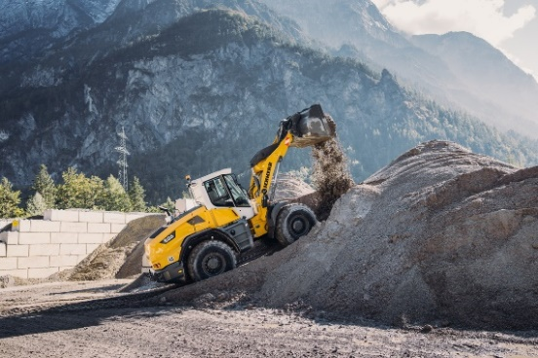

liebherr-new-mid-sized-wheel-loader-bauma-2022.jpg  
Robust top performers: Liebherr presents the new medium-sized wheel loaders at Bauma 2022.

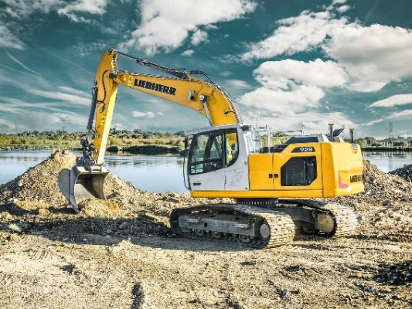

liebherr-r928-96dpi.jpg  
At Bauma 2022 the R 928 is presented with factory-installed semi-automatic machine control from Leica Geosystems.

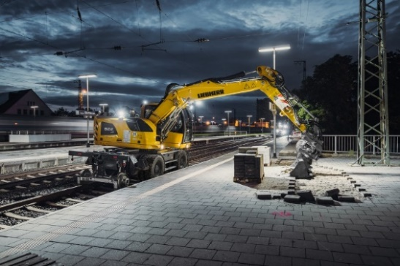

liebherr-a922-rail-litronic.jpg  
At Bauma 2022 Liebherr shows the A 922 Rail Litronic with hydrostatic drive concept as well as the new, fully hydraulic quick coupling system LIKUFIX® 33-9.

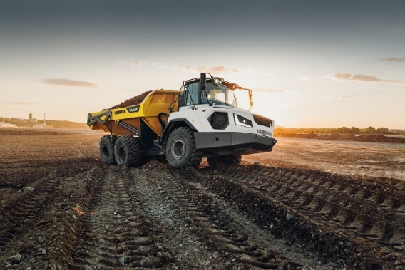

liebherr-ta230-litronic.jpg  
The articulated dump truck TA 230 Litronic from Liebherr celebrates its début at Bauma 2022: This is the first international trade fair appearance of the machine.

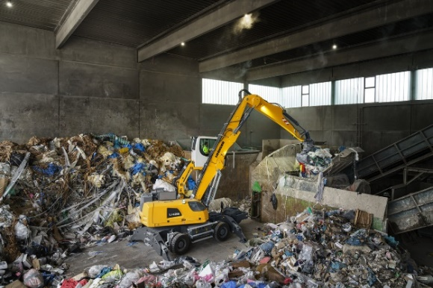

liebherr-lh26-m-industry-e.jpg  
The LH 26 M Industry E at Bauma 2022: The wired electric material handler is equipped with a battery-operated Mobility Kit for temporary operation independent of the mains.

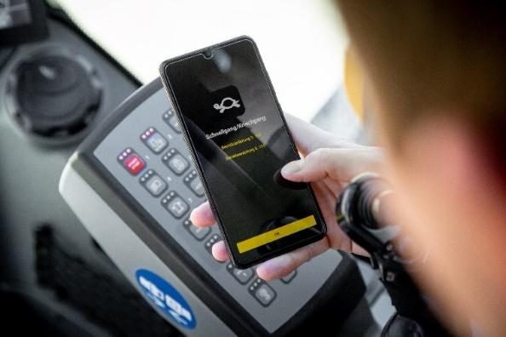

liebherr-myassistant-earthmoving-app.jpg  
Presentation of future-oriented services and solutions: The new MyAssistant for Earthmoving app makes available all relevant information on machine operation and maintenance of Liebherr earthmoving machines and material handlers in a digital format.

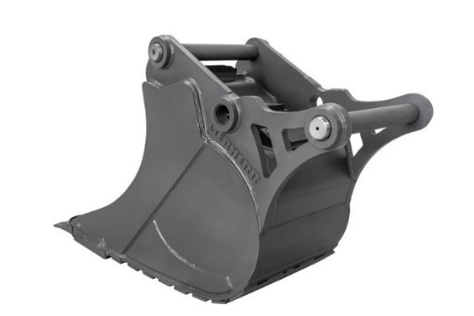

liebherr-2in1.jpg  
At a separate stand in Hall B5 Stand 439 Liebherr presents the comprehensive portfolio of attachments and quick coupling systems. The new Liebherr 2-in-1 bucket is also exhibited here.

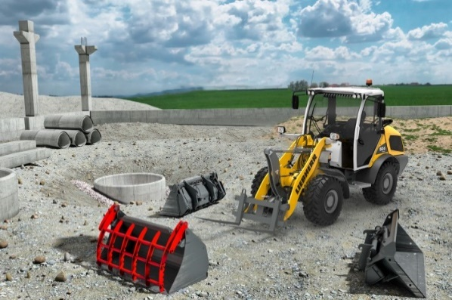

liebherr-radlader-likufix.jpg  
Liebherr extended the availability of its fully automatic quick coupling system LIKUFIX® for other wheel loader models.

Contact

Nadine Willburger  
Marketing  
Tel.: +49 7354 / 80 - 7332  
E-mail: nadine.willburger@liebherr.com

Published by

Liebherr-EMtec GmbH  
Kirchdorf an der Iller / Germany  
[www.liebherr.com](http://www.liebherr.com)