Press release

Lightweight to increase capacity – the new fibre rope cranes from Liebherr

⸺

258 HC-L 10/18 Fibre luffing jib crane will be available to order worldwide after the Bauma 2022 and is ideal for the construction of high buildings in metropolitan areas

The most powerful standard crane from Liebherr, the 1188 EC-H 40 Fibre high-top crane, will be available to order worldwide after the Bauma 2022

The 520 EC-B 20 Fibre and 370 EC-B 16 Fibre flat-top cranes will be available to order worldwide after the Bauma 2022 when it will be added to the portfolio of “Tough Guys”

The benefits of fibre rope are particularly noticeable on large cranes because each metre of additional hook height makes the significantly lower rope weight even more noticeable. Liebherr is now extending its fibre crane portfolio with extremely powerful machines – including the EC-B series for the first time. The 258 HC-L 10/18 Fibre, 1188 EC-H 40 Fibre, 520 EC‑B 20 Fibre and 370 EC-B 16 Fibre will be new to the market.

Munich (Germany), 21 June 2022 – Enormous hook heights, a small footprint and no slewing over neighbouring properties – the construction of high buildings in densely populated city centres often pose these challenges. The new 258 HC-L 10/18 Fibre featuring the 25 millimetre fibre rope from Liebherr may be the ideal crane for these projects. This machine is the first luffing jib crane from Liebherr to feature high-tensile fibre rope and delivers some extremely impressive performance values.

The 258 HC-L 10/18 Fibre reaches similar hook heights to the 230 HC-L 8/16. With a maximum jib length of around 60 metres, the lifting capacity at the jib head is still 2500 kilograms. The 230 HC‑L 8/16 with the steel rope version can only manage a maximum of 1900 kilograms at the jib head. Furthermore, the maximum lifting capacity for the 258 HC-L 10/18 Fibre has been increased by 25 percent to ten tonnes, which meets the current market requirements for this size class.

These high values are primarily made possible by using the high-tensile fibre rope. The fibre rope is significantly lighter than a steel rope with a comparable diameter. This means that higher lifting capacity values and faster working speeds are possible using a similar crane design and this applies to the complete portfolio of Liebherr fibre cranes. In addition to the fibre rope, the hook block also weighs less.

Just like its steel rope version brothers, the 258 HC-L 10/18 Fibre can perform level luffing. When moving the load, the control system automatically adjusts the hoist gear so that the load hook is moved horizontally. Sophisticated assistance systems such as Micromove and an ergonomic crane cab mean that crane operators can also carry out heavyweight hoists safely.

1188 EC-H 40 Fibre with a maximum lifting capacity of 40 tonnes

Hoists involving heavy weights are also no problem for the new 1188 EC-H 40 Fibre – in fact quite the opposite is true. The new fibre crane will be the most powerful standard crane available from Liebherr. The 1188 EC‑H 40 Fibre delivers an impressive maximum lifting capacity of 40 tonnes. A lifting capacity of up to 13,100 kilograms is possible at the jib head with a jib length of 80 metres. This means that the fibre crane beats the extremely powerful steel rope version of the 1000 EC-H by up to two tonnes in terms of its lifting capacity at the jib head. The maximum standard radius of the crane is 90 metres.

That makes high-top cranes from Liebherr the perfect choice for handling high lifting capacities. Hoisting prefabricated parts with weights of several tonnes is particularly commonplace in bridge, power station and plant construction. Furthermore, this crane series also features high handling capacity and precision even for hoisting very heavy loads. Various assistance systems in the Litronic control system support the crane operator to deliver even greater safety and productivity.

New “Tough Guys”

The cranes in the EC‑B series are particularly useful on sites with multiple cranes operating simultaneously. Their flat-top up design enables them to slew easily over each other and therefore operate safely. This series already includes multiple cranes with high-tensile fibre rope. The series has now been expanded once again by the 520 EC-B 20 Fibre. The 520 EC-B 20 Fibre can perform heavy hoists of up to 2900 kilograms at the jib head at its maximum jib length of 83 metres. A maximum lifting capacity of up to 20 tonnes is possible.

The 370 EC-B 16 Fibre is another new crane. Just like the 520 EC-B 20 Fibre, it features a fibre rope with a diameter of 25 millimetres. All the other fibre cranes in the EC-B series are fitted with 20 and 22 millimetre fibre rope versions. At a maximum jib length of 78 metres, the 370 EC-B 16 Fibre achieves a lifting capacity at the jib head of up to 2500 kilograms. Its maximum lifting capacity is 16 tonnes. The twelve tonne version of the 370 EC-B Fibre has already been launched successfully.

Benefits of the high-tensile fibre rope

The high-tensile fibre rope, which is the result of 10 years of development work by Liebherr and rope manufacturer Teufelberger, is a pioneering technology. Fibre cranes achieve significantly better performance values than equivalent cranes with a steel rope. At the same time, a fibre rope is more durable, is easier to handle for reeving and maintenance work is more straightforward. The components of the cover wear at different rates – and the ropes must be removed from use at the latest when the red layer is reached. That means the crane operator can see at a glance when the fibre rope has to be replaced.

About the Liebherr Tower Cranes Division

More than seven decades of experience make Liebherr an renowned specialist for hoisting technology on all kinds of construction sites. The Liebherr Tower Cranes portfolio includes an extensive range of high quality tower cranes suitable for use all over the world. They include fast-erecting, top-slewing, luffing jib and special cranes as well as mobile construction cranes. Alongside its products, Liebherr Tower Cranes has an extensive range of other services to round off its portfolio – Tower Crane Solutions, the Tower Crane Centre and Tower Crane Customer Service.

About the Liebherr Group

The Liebherr Group is a family-run technology company with a highly diversified product portfolio. The company is one of the largest construction equipment manufacturers in the world. It also provides high-quality and user-oriented products and services in a wide range of other areas. The Liebherr Group includes over 140 companies across all continents. In 2021, it employed more than 49,000 staff and achieved combined revenues of over 11.6 billion euros. Liebherr was founded in Kirchdorf an der Iller in Southern Germany in 1949. Since then, the employees have been pursuing the goal of achieving continuous technological innovation, and bringing industry-leading solutions to its customers.

Images

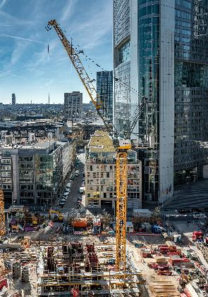liebherr-258-hc-l-10-18-fibre-01.jpg  
The 258 HC-L 10/18 Fibre is the first luffing jib crane from Liebherr to feature the high-tensile fibre rope.

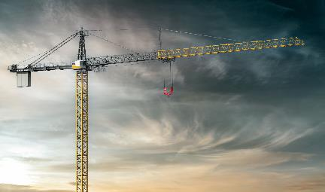  
liebherr-1188-ec-h-fibre-02.jpg  
In the future, the new 1188 EC-H 40 Fibre will be the most powerful standard crane from Liebherr.

liebherr-520-ec-b-fibre-03.jpg  
The new 520 EC-B 20 Fibre is the new flagship of the well-known EC series from Liebherr with its “Tough Guys”.

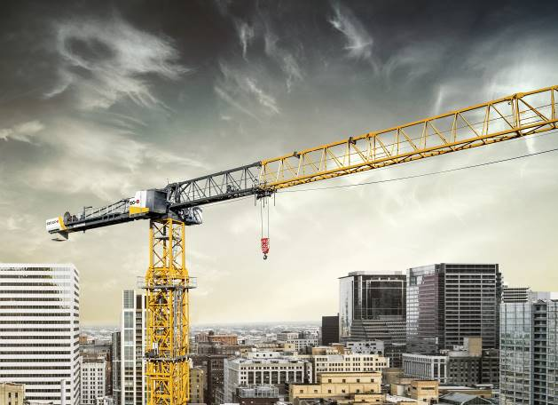

liebherr-370-ec-b-fibre-04.jpg  
The 370 EC-B Fibre from Liebherr is already available in a twelve tonne version. The 16 tonne version is now being launched.

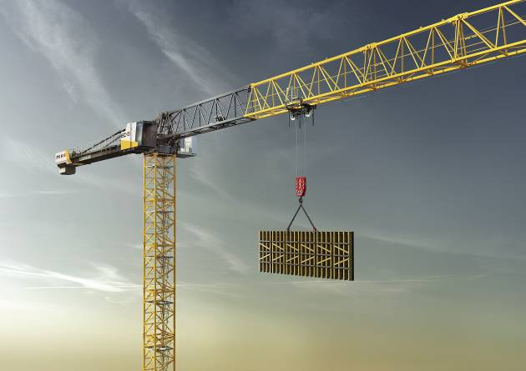

Contact

Daniel Haefele  
Global Communication  
Phone: +49 7351 / 41 - 2330  
Email: daniel.haefele@liebherr.com

Published by

Liebherr-Werk Biberach GmbH  
Biberach / Germany  
www.liebherr.com