Press release

New Liebherr wheel loaders at Bauma 2022

⸺

New compact loaders now available to order from Liebherr sales partners in Europe, Australia and New Zealand

New L 504 Compact model; L 506 Compact and L 508 Compact with many innovations

New mid-sized wheel loaders now available to order from Liebherr sales partners in Europe, and from autumn 2022 from Liebherr sales partners in North America, Australia and New Zealand

New lift arms and greater engine output delivers increased performance for mid-sized wheel loaders

Liebherr is showcasing compact loaders and mid-sized wheel loaders at Bauma 2022 – two wheel loader product lines which have undergone complete overhauls. At Bauma 2022, the compact loaders, also including the new L 504 Compact model, can be seen for the first time at a trade show in Germany. Liebherr is also using the world's leading trade fair for construction machinery as a stage for presenting the mid-sized wheel loaders to a cross-industry audience for the first time. Their stand-out feature is a significant increase in performance compared to previous models.

Munich (Germany), 21 June 2022 – The Liebherr compact loaders are represented at Bauma 2022 by the L 504 Compact and L 508 Compact models. The new L 504 Compact is the group' s smallest wheel loader. It embodies the qualities of the larger series while also representing an excellent value for the money. The L 546 model will represent the mid-sized wheel loaders at the Liebherr booth The trade fair exhibit is equipped with numerous intelligent assistance systems such as the redesigned and powerful Skyview camera system and the active personnel detection with brake assist. Other wheel loaders from other product lines, such as the L 509 Tele or the L 586 XPower®, complete the range of Liebherr wheel loaders on show at this year's Bauma.

Robust and powerful performers: the new mid-sized Liebherr wheel loaders

Liebherr has redeveloped and completely redesigned its range of mid-sized wheel loaders. The newly-designed lift arms, featuring a z-bar linkage and improved working hydraulics, ensure maximum breakout, holding and return forces. Structural reinforcements on the lift arms and cross tube increase robustness. The modified z-bar linkage with electrohydraulic pilot controls has larger hydraulic cylinders and more powerful working pumps than before. The combination of these innovations enables faster cycle times and dynamic work movements – even with heavy attachments such as high dump buckets or log grapples.

In addition to the new lift arms, the optimisation of the hydrostatic travel drive in particular contributes to the increased productivity of the wheel loaders. The more powerful engines are characterised by a higher maximum torque at a lower nominal speed. This results in power and efficiency increases with the same low fuel consumption. More powerful hydraulic components, such as larger travel motors and travel pumps, ensure greater traction in all three models and thus powerful bucket filling. To ensure the highest possible reliability, Liebherr has reinforced the axles in addition to the travel drive components: depending on the model, all three wheel loaders have larger front or rear axles than their predecessors.

Intelligent assistance systems are also part of the overall package of the new mid-sized Liebherr wheel loaders. An example of this is the active personnel detection with brake assist. This optional assistance system, installed at the rear, warns the machine operator of dangers in the rear area both visually on the display and with acoustic signals. In order to provide a specific warning of imminent injury to people, the assistance system independently distinguishes between people and objects using smart sensors. As soon as the active personnel detection emits a warning signal, the brake assistant automatically reduces the speed of the wheel loader to a standstill in order to avoid a potential accident.

Safe and reliable helpers: the new Liebherr compact loaders

Liebherr has overhauled its compact loaders. Now, almost 10 years on from their launch, the compact loader has become established as a safe and reliable helper in a wide range of sectors. The most important innovations include the operator's cab, which provides the operator with excellent visibility thanks to its enlarged glass surfaces. The optimised visibility of the lift arms also ensures an unobstructed view of the working attachment, and therefore maximum safety. Due to customer demand, the L 506 and L 508 models are now available as Speeder variants for the first time ever. In this version, they can reach a top speed of 30 km/h.

The compact loaders have robust lift arms with a z-bar linkage, which facilitates the use of a wide variety of working tools. Liebherr has optimised the parallel guide for safe and precise operation when working with forks. For instance, this is important when transporting palettes with pavers or decking tiles in garden and landscaping applications. To increase versatility even more, Liebherr also offers the lift arms for the L 506 and L 508 models in the High Lift version on request. This is an extended version of the lift arms with a greater reach, which enables the compact loaders to also load larger transport vehicles.

Liebherr compact loaders are confronted with a myriad of challenges when used in municipal services. Transporting materials with various buckets or forks, excavating with a 4 in 1 bucket, cleaning work with a sweeper, or winter services with a snow blade are just some examples of this. To ensure the mastery of this wide variety of applications, Liebherr also offers its fully automatic quick coupler system LIKUFIX for the three compact loaders. LIKUFIX allows the machine operator to change between mechanical and hydraulic working tools from the cab within seconds at the touch of a button. This saves time and reduces the risk of accidents as the operator doesn't have to leave the cab when changing the equipment.

Performance data for the two new wheel loader series from Liebherr

All specifications refer to the standard version. The wheel loaders meet the currently applicable emission standards.

|  |  |  |  |  |
| --- | --- | --- | --- | --- |
| Model: | Tipping load: | Bucket capacity: | Operating mass: | Engine power: |
| L 504 compact | 3,000 kg | 0.7 m³ | 4,600 kg | 34 kW / 46 hp |
| L 506 compact | 3,500 kg | 0.8 m³ | 4,970 kg | 47.5 kW / 64 hp |
| L 508 compact | 3,900 kg | 1.0 m³ | 5,700 kg | 47.5 kW / 64 hp |
| L 526 | 8,730 kg | 2.2 m³ | 13,170 kg | 116 kW / 158 hp |
| L 538 | 9,650 kg | 2.6 m³ | 14,520 kg | 129 kW / 175 hp |
| L 546 | 11,010 kg | 3.0 m³ | 15,410 kg | 138 kW / 188 hp |

About Liebherr-Werk Bischofshofen GmbH

Liebherr-Werk Bischofshofen GmbH (Austria) develops, produces and sells wheel loaders of the Liebherr Group. The plant in the state of Salzburg has grown steadily over the decades thanks to sustainable innovations, creative solutions and high quality standards. The wheel loader range is constantly being expanded and includes different models in four different product groups: Compact loaders, Stereoloaders, medium-sized wheel loaders and large wheel loaders, which convince with their innovative drive concepts.

About the Liebherr Group

The Liebherr Group is a family-run technology company with a highly diversified product portfolio. The company is one of the largest construction equipment manufacturers in the world. It also provides high-quality and user-oriented products and services in a wide range of other areas. The Liebherr Group includes over 140 companies across all continents. In 2021, it employed more than 49,000 staff and achieved combined revenues of over 11.6 billion euros. Liebherr was founded in Kirchdorf an der Iller in Southern Germany in 1949. Since then, the employees have been pursuing the goal of achieving continuous technological innovation, and bringing industry-leading solutions to its customers.

Images

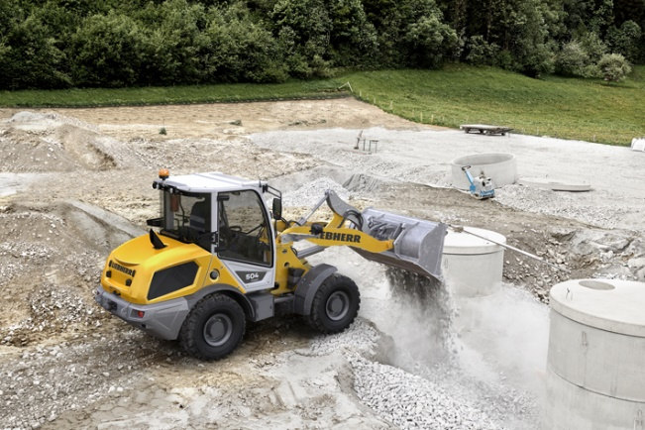

liebherr-compact-loader-l504.jpg  
At Bauma 2022, the new L 504 Liebherr compact loader can be seen for the first time at a trade fair in Germany.

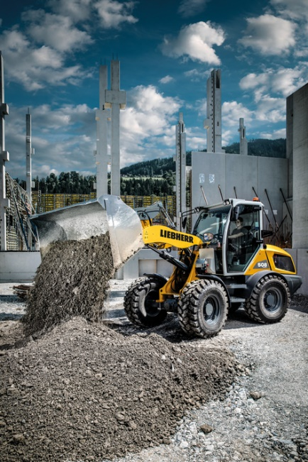

liebherr-compact-loader-l508.jpg  
The new L 508 Liebherr compact loader, pictured being used on a construction site, can be seen on the Liebherr Bauma booth.

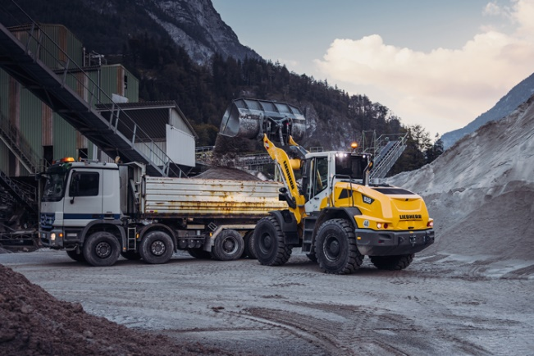

liebherr-new-mid-sized-wheel-loader-l538-loading-truck.jpg  
More engine power, higher breakout forces: the new mid-sized Liebherr wheel loaders are robust performers.

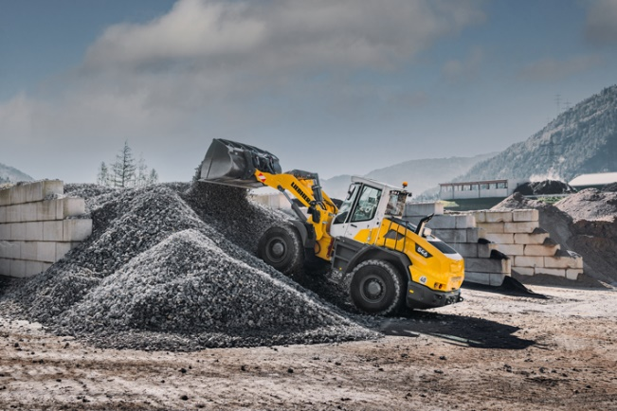

liebherr-new-mid-sized-wheel-loader-l546-quarry.jpg  
This year at Bauma, Liebherr is showcasing the L 546, a representative of the new mid-sized wheel loaders.

Contact

Martin Koller  
Marketing and Public Relations  
Phone: +43 50809 11475  
Email: [martin.koller.lbh@liebherr.com](mailto:martin.koller.lbh@liebherr.com)

Published by

Liebherr-Werk Bischofshofen GmbH  
Bischofshofen/Austria  
[www.liebherr.com](http://www.liebherr.com)