Press release

R 928 G8 with Leica semi-automatic machine control at Bauma 2022

⸺

The R 928 is presented with factory-installed Leica Geosystems semi-automatic machine control

The machine is characterised by a low total weight of less than 30 tonnes and high tractive and lifting force

The model is globally available since 2021 in accordance with local emissions standards and in a large number of configurations and equipment variants

Streamlined, fast and safe maintenance work

**Liebherr-France SAS in Colmar also produces the latest Generation 8 series of earthmoving crawler excavators. This new stage is characterised especially by even higher performance, even greater productivity and even more comfort for the operator. Like all models of the new generation, this machine also benefits from many improvements. At Bauma 2022, the R 928 will be presented with factory-installed semi-automatic machine control from Leica Geosystems.**

Munich (Germany), 21 June 2022 – The R 928 is equipped with a semi-automatic pull-off system. This assistance system for controlling the machine is the key to precise and efficient work. Announced in March 2020, the strategic partnership between Liebherr and Leica Geosystems enables the expertise of both companies to become available to customers, delivering even more advanced and reliable solutions. The software of the Liebherr crawler excavator and the Leica machine control was optimally coordinated by the development teams of both companies in collaboration. The electric servo control of the working hydraulics of the crawler excavator of the 8th generation eliminates the need for additional hydraulic components, as communication takes place via CANbus. Installation in the factory has the advantage of optimum integration of all components. This is also where the factory pre-calibration of the machine control takes place, which considerably simplifies commissioning at the customer's site. This new, integrated assistance system can significantly increase productivity on the construction site.

The perfect completion of Generation 8

The R 928 G8 crawler excavator features high drawbar pull, excellent lifting capacity and a large backhoe bucket. The operating weight of less than 30 tonnes has been optimised with the aim of making transport logistics between operating locations as simple as possible. The R 928 G8 complements the existing range of crawler excavators with an additional model between the well-known R 926 G8 and R 930 G8 models.

Continuous improvements, quality and service

Liebherr Generation 8 crawler excavators are the result of intensive research and improvement work and the experience gained from more than 60 years in the development and manufacture of crawler excavators. This new generation is characterised by a modern design and modular architecture. It has been redesigned to provide optimum ergonomics and performance, as well as greater comfort and safety.

Compared to the previous generation, Generation 8 develops higher tearing and breakaway forces. In combination with the now increased torque of the upper carriage, this results in higher outputs and a considerable gain in productivity on the construction site.

What’s more, a new concept of working attachment enables an optimised load curve. The weight-optimised components also increase the machine's dynamics while reducing its fuel consumption at the same time.

The new robust X-shaped undercarriages provide better stability in all situations. The automatic central lubrication ensures a longer service life of the parts and improves the productivity of the machines.

Excellent service, consultation and support before, during and after the purchase decision, as well as the wide range of individual customisation options for the machines, e.g. through individualisation and equipment variants, are the key purchase criteria according to Liebherr customers.

Maximum safety combined with the greatest possible comfort

A particularly spacious and air-conditioned driver’s cab is available to the operator. For comfortable working, the hydraulic excavators are equipped with vertically and longitudinally suspended air seats and a high-resolution and very user-friendly 9" touchscreen. The front windscreen can be opened fully and pushed in under the cab roof.

Working headlights with LED technology replace the previously used halogen and xenon versions. This new technology results in a longer service life and lower energy consumption while providing much better illumination. The lighting range is available in separate packages, with the dimmable LED+ lighting package being the most powerful solution and available as an option.

The completely unobstructed panoramic field of view and the surveillance cameras at the rear and side ensure maximum safety in the operator's working environment. The folding left console allows easy safe entry and exit into and out of the operator's cab. The rollover protection-certified cabin structure provides optimum protection in an accident situation. Regardless of the excavator configuration, emergency exit is via the rear window. The front and right-hand windows are made of tinted laminated glass.

Streamlined and even safer maintenance work

To increase safety during maintenance work, access to the uppercarriage and platform has been enlarged and revised. Access is now from the side and is available as standard or as an option, depending on the country of sale. Generation 8 crawler excavators feature a new maintenance concept with maintenance points that can be accessed from the ground. The levels of engine oil, hydraulic oil, fuel and diesel exhaust fluid are shown to the operator on the display.

About the Liebherr Group

The Liebherr Group is a family-run technology company with a highly diversified product portfolio. The company is one of the largest construction equipment manufacturers in the world. It also provides high-quality and user-oriented products and services in a wide range of other areas. The Liebherr Group includes over 140 companies across all continents. In 2021, it employed more than 49,000 staff and achieved combined revenues of over 11.6 billion euros. Liebherr was founded in Kirchdorf an der Iller in Southern Germany in 1949. Since then, the employees have been pursuing the goal of achieving continuous technological innovation, and bringing industry-leading solutions to its customers.

Images

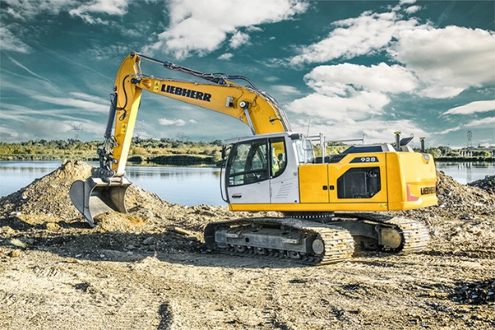

liebherr-r928-leica.jpp  
The R 928 G8 has a larger maximum bucket size than the R 926 G8, high drawbar pull and excellent lifting capacity.

Contact

Alban Villaumé  
Marketing & Communication  
Telephone: +33 3 89 21 36 09  
E-mail: alban.villaume@liebherr.com

Published by

Liebherr-France SAS  
Colmar, France  
www.liebherr.com