Press release

Liebherr presents material handlers for diverse applications at Bauma 2022

⸺

Liebherr LH 22 M Industry Litronic material handler for efficient use in tree care and the timber industry

Wired Liebherr LH 26 M Industry E electric material handler with battery-operated Mobility Kit

Liebherr electric material handler LH 150 M Port E with new, mobile gantry portal undercarriage

Liebherr presents material handlers for diverse applications at Bauma 2022. With the LH 22 M Industry Litronic Liebherr presents a material handler for efficient use in tree care and the timber industry. A wide selection of compatible attachments rounds off the portfolio on site. In addition, Liebherr presents two representatives of its electric material handlers: the LH 26 M Industry E with battery-operated Mobility Kit and the LH 150 M Port E with a new, mobile gantry portal undercarriage.

Munich (Germany), 21 June 2022 – The product portfolio of Liebherr material handlers is huge – at Bauma Liebherr showcases three representatives for different application areas. The Liebherr LH 22 M Industry material handler is perfect for use in tree care and the timber industry in combination with the corresponding attachments. The LH 26 M Industry E can also be used in recycling in addition to applications in scrap handling. The wired electric material handler is equipped with a battery-operated Mobility Kit for temporary operation independent of the mains. The Liebherr LH 150 M Port E is also equipped with an electric drive and can be seen at Bauma with a new, mobile gantry portal undercarriage.

Liebherr LH 22 M Industry Litronic material handler for efficient use in tree care and the timber industry

Whether it is for logging roads, working on slopes and embankments, clearing roads or felling problem trees, Liebherr material handlers in combination with the right attachment can be optimally used in tree care and the timber industry. At Bauma Liebherr presents the LH 22 M material handler as one representative with a wide selection of perfectly matched attachments both from Liebherr and the cooperative venture partner Westtech. Equipped with the fully hydraulic quick coupling system LIKUFIX®, attachments from both companies can be changed quickly, comfortably and safely from the operator's cab.

The handling of tall trees and thick branches often poses a particular challenge. The machine on show is equipped with the Westtech telescopic rung T 4000 and the Woodcracker® CS510 crane. This gives the material handler a reach of up to 16.5 metres enabling it to extend high up into the trees for trimming operations. The hydraulically adjustable cab can be tilted in 30° increments, to give the operator an optimal view of his working area. An alternative equipment combination, also on show, is the Liebherr stick extension which, in combination with the Westtech Woodcracker® C250, achieves a reach of up to 13.8 metres.

Using LIKUFIX® the operator can easily change to another attachment, such as the Liebherr SG 25 sorter grab, also showcased at the trade fair. This enables the material handler to be used for other applications in typical recycling during the seasonal felling prohibitions between March and October.

Liebherr LH 26 M Industry E electric material handler with battery-operated Mobility Kit

The Liebherr LH 26 M Industry E material handler is also perfect for recycling in addition to scrap handling. Examples of its possible applications are the handling, unloading and sorting of waste paper, waste wood and waste materials. High machine availability is guaranteed with the innovative recycling package from Liebherr. The reversible fan increases the productive work time, while the radiator and protective grid can be blown by the reversal of the fan's direction of rotation. The separate position of the climate condenser maximises the air stream in the radiator and fan unit to guarantee a high level of reliability even in very dusty conditions.

The material handler combines tried-and-tested technology with a new electric drive concept: low maintenance, quiet and independent of legal emission standards. The core of the machine is the 90 kW electric motor. This allows powerful, dynamic work movements with low maintenance costs and low noise emissions at the same time. Moreover, the drive concept includes an additional electric motor for auxiliary consumers, guaranteeing purposeful power distribution and maximum energy efficiency. Sophisticated frequency converter technology allows the engine speed to be individually adjusted to the respective use of the machine. Besides the simple adjustment to all common power supply networks worldwide, the frequency converter is also characterised by a substantial reduction in operation costs. This is achieved by preventing switch-on current peaks with a gentle ramp-up when starting and the related conservation of the hydraulic drive components.

The material handler comes with a battery-operated Mobility Kit for temporary operation independent of the mains. It is easily accessible on the uppercarriage and supplies the machine with electrical energy when disconnected from the power supply. The Mobility Kit allows emission-free travel for up to 30 minutes independent of the mains. Instead of travel, the energy can also be used for short-term, reduced-speed work.

The LH 26 E on display is configured with a 6.60 m straight boom and a 4.50 m stick with tilt geometry. It is fitted with a Liebherr SG 25B sorter grab with a capacity of 0.75 m³ and perforated shells with a width of 1,000 mm. This model also features the height-adjustable hydraulic operator's cab. The cable feed operates with a cable winding system that allows the machine to move safely within a working radius of 40 m, or more upon request.

Liebherr LH 150 M Port E electric material handler with new, mobile gantry portal undercarriage

The Liebherr LH 150 M Port E material handler is specially designed for handling bulk goods and general cargo in ports. It is equipped with an electric drive and has an operating weight of around 165 tonnes. The machine sets new standards in terms of efficiency and economy. With the 400 kW electric motor it can reach an overall system capacity of 614 kW together with the ERC system. The electrical drive concept of the material handler is low maintenance, quiet, environmentally friendly and independent of exhaust gas regulations.

The trade fair exhibit is equipped with a new mobile gantry portal undercarriage which enables it to be relocated quickly and easily. Various steering modes allowing excellent manoeuvrability. The 4-point outrigger ensures that any ground unevenness can be optimally balanced, thus ensuring good stability for fatigue-free and quiet work. With the gantry portal undercarriage passing trucks or wagons can be loaded and unloaded quickly and efficiently. Thanks to the modular design, the customer can choose a clearance width between 4.5 and 9.0 metres and a clearance height between 5.0 and 6.5 metres. Various cable feeds such as trailing cable or winding system are available for the electric material handler, which guarantee the necessary freedom of movement of the machine.

The exhibit at Bauma is equipped with a 16.5 m long, angled boom and a 15 m long straight stick. The fully automatic MH 110B quick coupling system allows attachments to be changed quickly, comfortably and safely from the operator's cab. The Liebherr GMZ 120 clamshell bucket with fill volume of 8 m³ and the Liebherr GMM 120-5 multi-tine grapple with fill volume of 3 m³ round off the configuration. Another highlight is the height-adjustable double-articulated hydraulic operator's cab that can be moved forward for comfortable entry and exit. With the flexible eye point the machine operator always has an optimal view of the working area, which boosts the productivity of the machine.

About Liebherr-Hydraulikbagger GmbH

Kirchdorf an der Iller is considered the birthplace of the Liebherr Group. Hans Liebherr founded the company there in 1949 on the basis of his parent's construction business. Today Liebherr-Hydraulikbagger GmbH develops and produces a comprehensive range of high-quality hydraulic excavators, material handlers and articulated dump trucks in Kirchdorf. The company produces approximately 2,500 machines a year and is a global leader in the area of wheeled excavators.

About the Liebherr Group

The Liebherr Group is a family-run technology company with a highly diversified product portfolio. The company is one of the largest construction equipment manufacturers in the world. It also provides high-quality and user-oriented products and services in a wide range of other areas. The Liebherr Group includes over 140 companies across all continents. In 2021, it employed more than 49,000 staff and achieved combined revenues of over 11.6 billion euros. Liebherr was founded in Kirchdorf an der Iller in Southern Germany in 1949. Since then, the employees have been pursuing the goal of achieving continuous technological innovation, and bringing industry-leading solutions to its customers.

Images

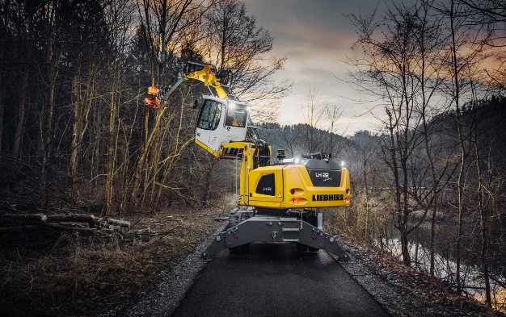

liebherr-lh22-m-industry.jpg  
The Liebherr LH 22 M Industry material handler is perfect for use in tree care and the timber industry in combination with the corresponding attachments.

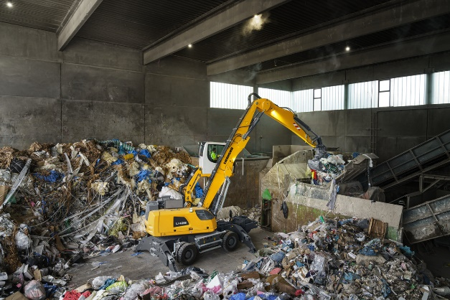

liebherr-lh26-m-industry-e.jpg  
The LH 26 M Industry E at Bauma 2022: The wired electric material handler is equipped with a battery-operated Mobility Kit for temporary operation independent of the mains.

Contact

Nadine Willburger  
Marketing  
Tel.: +49 7354 / 80 - 7332  
E-mail: nadine.willburger@liebherr.com

Published by

Liebherr-Hydraulikbagger GmbH   
Kirchdorf an der Iller/ Germany  
[www.liebherr.com](http://www.liebherr.com)