Press release

At Bauma 2022: Liebherr rail-road excavator with hydrostatic drive concept and début for articulated dump truck

⸺

Presentation of Liebherr rail-road excavator with hydrostatic drive concept and new, fully hydraulic quick coupling system LIKUFIX®

Intelligent handling of attachments: Outlook of solutions

First time on international trade fair stage: TA 230 Litronic articulated dump truck

At Bauma Liebherr presents a representative from the area of rail-road excavators with the A 922 Rail Litronic. The trade fair exhibit is equipped with a hydrostatic drive concept as well as the new, fully hydraulic quick coupling system LIKUFIX®. Liebherr also provides a general outlook of solutions in terms of intelligent handling of attachments using the rail-road excavator. The articulated dump truck TA 230 Litronic also celebrates its début at Bauma – this is the first appearance of the machine on an international trade fair stage.

Munich (Germany), 21 June 2022 – Liebherr has been successfully developing and manufacturing rail-road excavators for track construction since 1967. At Bauma Liebherr presents the A 922 Rail for the first time with a hydrostatic drive concept. The new, fully hydraulic quick coupling system LIKUFIX® is also shown at the machine. Following the successful, digital product launch at the end of 2020, the articulated dump truck from Liebherr celebrates its début on the international trade fair stage at Bauma in Munich. The powerful, robust and efficient machine was developed for tough off-road applications.

Liebherr rail-road excavator A 922 Rail Litronic with hydrostatic drive concept and new, fully hydraulic quick coupling system LIKUFIX®

At Bauma Liebherr presents the A 922 Rail Litronic for the first time with a hydrostatic drive concept and new LIKUFIX® quick coupling system. The exhibit at the trade fair has an operating weight of around 23,000 kg, meets the requirements of exhaust emissions standard Stage V and mainly impresses thanks to high performance and reliability. With the 120 kW / 163 hp engine and the perfectly matched hydraulic system, the machine reaches high work speeds with the usual fluid movements of the attachments.

The innovative hydraulic concept consists of a Liebherr variable displacement double pump with a volume of 2x220 l/min and independent control circuits. High-performance, hydraulic attachments can thus be operated independently of the working and travel movements of the machine.

Huge importance is attached to safety in track construction. As an OEM manufacturer, Liebherr offers comprehensive safety systems from one source, which are perfectly adapted to the machine requirements. These include technologies such as the load moment limitation, the height and turning radius limitation, as well as the virtual wall.

The hydrostatic rail travel drive of the A 922 Rail is new: Two drive motors drive the rail-road excavator directly in the rail axis. This leads to lower tyre wear as there is no direct rail contact. In the trade fair configuration the machine is equipped with a standard gauge of 1435 mm. However, more track gauges will also be available in the future.

Another highlight of the A 922 Rail is the new quick coupling system LIKUFIX® 33-9. With this quick coupling system attachments such as tamping units, mulchers with flaps or Liebherr stick extensions can be changed quickly, simply and safely from the operator's cab thanks to the integration of the second high-pressure circuit, as well as the overflow oil line and lubrication line. The new LIKUFIX® 33-9 is backwards compatible. This means that attachments which are equipped with the current quick coupling system LIKUFIX® 33 can also be changed.

The A 922 Rail exhibit also gives visitors the opportunity to experience solutions in terms of intelligent handling of attachments. The new track-based attachment detection from Liebherr is presented live at the trade fair. In addition to displaying tool, application and location information, the solution also recognises the respective Liebherr attachment and automatically adapts it to the machine. The A 922 Rail at the trade fair is also equipped with a MIC 4.0 interface. This is a vendor-independent standard in communication and allows significantly simplified integration as well as control of various attachments in combination with Liebherr machines.

Début on international trade fair stage – TA 230 Litronic articulated dump truck

The TA 230 Litronic articulated dump truck is presented for the first time on an international trade fair stage. The machine was developed for tough off-road applications and is therefore perfect for transporting excavated materials and the mining industry. The machines are also used successfully for larger infrastructure projects and special applications such as tunnel construction. The powerful, robust and efficient Liebherr dump trucks deliver superb performance across all applications.

The exhibit at the trade fair has an operating weight of 24,600 kg. The 6-cylinder construction machine engine with 12 l capacity and 265 kW / 360 hp in combination with the exhaust gas aftertreatment system positioned behind the operator's cab fulfils the requirements of exhaust emissions standard Stage V. The dump truck transports up to 28,000 kg of material in its large and robust trough. The trough volume can be increased with the tailgate. This also ensures that no material is lost during the journey. A big advantage of the TA 230 is shown in frequent changes of construction site: With wide tyres, tailgate and the side mirrors that can be folded in without the need for tools, the TA 230 has an overall width of under 3 metres and can therefore be transported quickly and without any costly special permit.

The Liebherr dump truck is characterised by its innovative vision and lighting concept. The spacious operator's cab offers superb panoramic visibility of the driving, working and articulating area of the machine thanks to the excellent panoramic windows without any annoying struts and the short, inclined bonnet. The lighting concept with LED headlights also ensures a better view and thus also enhanced safety. LED dipped-beam headlamps with integrated high beam optimally illuminate the road and the extra powerful, optional LED headlights on the front of the cab illuminate the entire working area. The lighting at the rear of the trough and another light package at the mudguards light up the manoeuvring areas at night.

**About Liebherr-Hydraulikbagger GmbH**

Kirchdorf an der Iller is considered the birthplace of the Liebherr Group. Hans Liebherr founded the company there in 1949 on the basis of his parent's construction business. Today Liebherr-Hydraulikbagger GmbH develops and produces a comprehensive range of high-quality hydraulic excavators, material handlers and articulated dump trucks in Kirchdorf. The company produces approximately 2,500 machines a year and is a global leader in the area of wheeled excavators.

About the Liebherr Group

The Liebherr Group is a family-run technology company with a highly diversified product portfolio. The company is one of the largest construction equipment manufacturers in the world. It also provides high-quality and user-oriented products and services in a wide range of other areas. The Liebherr Group includes over 140 companies across all continents. In 2021, it employed more than 49,000 staff and achieved combined revenues of over 11.6 billion euros. Liebherr was founded in Kirchdorf an der Iller in Southern Germany in 1949. Since then, the employees have been pursuing the goal of achieving continuous technological innovation, and bringing industry-leading solutions to its customers.

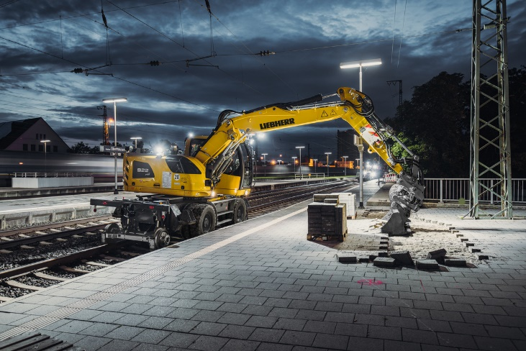Pictures

liebherr-a922-rail-litronic.jpg  
At Bauma 2022 Liebherr presents the A 922 Rail Litronic with hydrostatic drive concept as well as the new, fully hydraulic quick coupling system LIKUFIX®.

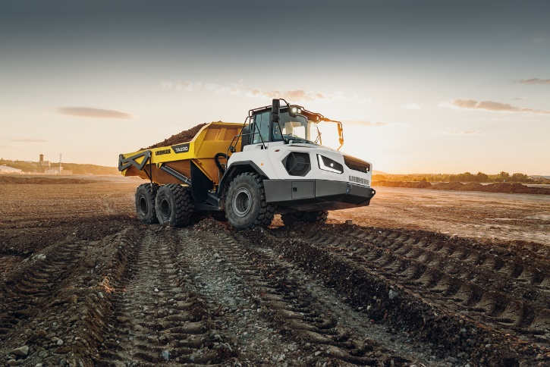

liebherr-ta230-litronic.jpg  
The articulated dump truck TA 230 Litronic from Liebherr celebrates its début at Bauma 2022: This is the first international trade fair appearance of the machine.

**Contact**

Nadine Willburger  
Marketing  
Tel.: +49 7354 / 80 - 7332  
E-mail: nadine.willburger@liebherr.com

Published by

Liebherr-Hydraulikbagger GmbH   
Kirchdorf an der Iller/ Germany  
[www.liebherr.com](http://www.liebherr.com)