Press release

Liebherr presents its new mixing plant generation at Bauma

⸺

Modular design fulfils practically every combination requested by customers

Different performance classes from one system

Frequency converters reduce current consumption by up to 30 %

Higher weighing accuracy saves cement

Available from 2023 in Germany, Austria and Switzerland, with the global market launch to follow soon afterwards

Liebherr has been developing and supplying mixing plants for concrete production for more than 60 years. All of this experience has now been incorporated into the new development of an innovative modular system. The company is presenting the new edition of Betomix to the public for the first time at Bauma, the new plant will be available from 2023.

Munich (Germany), 21 June 2022 – The new Betomix and Mobilmix mixing plant series can be flexibly combined using prefabricated modules and replace several predecessor series. For the customer, this means: More freedom when configuring the plants, shorter delivery times, faster assembly and increased parts availability. Improvements to the drive also reduce current consumption by up to 30 % and increase weighing accuracy, so that up to 7.5 kg of cement can be saved per cubic metre of concrete.

Reaching your goal faster with modules

The new concept is based on a consistently implemented modular design. Individual modules can be planned and manufactured independently of each other and combined with other modules. They are almost completely wired and fully assembled at Liebherr. After testing, the modules are delivered as complete transport units to the construction site. Cost effective transport: The module dimensions are optimised and are maximum three metres wide. This makes special transports superfluous for almost all plant variants. Due to their innovative folding concept and plug connections, the modules can be quickly and efficiently assembled and put into operation at the construction site.

One concept for many solutions

Everything fits together: Depending on the customer’s requirements and use, mixer systems can be installed in the same basic system. Liebherr uses its own twin-shaft or ring-pan mixers. Output rates of 100 to 210 m³ of compacted fresh concrete per hour are possible. Multiple optional accessories can be integrated without additional effort. Various storage facilities for the aggregates can be incorporated, such as a tower silo. Even the optional winter cladding is standardised for all variants. Everything can be combined.

The frequency converter ensures improved energy and resource efficiency

For energy savings of up to 30 %, the frequency converters control the drives for the mixer and charger elevator and optimise the mixing process as a whole. Hybrid mixing processes and shorter mixing times are easy to implement, avoiding power peaks. Also wear is considerably reduced due to the soft starting and soft stopping of the drives. It is the frequency converters however that offer the greatest and most important potential in the dosing of cement with an accuracy of +/- 0.5 %. With a typical recipe with 300 kg of cement per cubic metre of concrete, up to 7.5 kg of cement can be saved - which is an important argument for the new mixing plant generation from an ecological and financial point of view.

Mobile design

The mobile design of the new mixing plant generation is marketed under the name of Mobilmix. Thanks to the practical modules, it can be moved to another construction site very quickly. Customers can decide for themselves to what extent the mixing plant should be mobile. The following versions are possible for mobile use: Steel foundation, integrated technical container for wiring at the factory, a mobile in-line silo on steel foundations inclusive of folding chamber walls and mobile cement silo, also on steel foundations. The plant can be optionally equipped with a mobile cladding. The mobile version is also available from 2023.

Vertical skip

An example of the modular construction is the skip. It can be simply “hung” on the respective mixing plant, regardless of the required plant performance. Different height levels of the aggregate storage are easier to realize with the vertical skip than with an inclined construction. Due to the vertical construction, up to 20 % less space is required for the installation area. The elevator is designed as a structurally separate element and can be used with the stationary and mobile versions of the new mixing plants.

Comfortable work thanks to the well thought-out space concept

All accessible areas of the mixing plant are generously sized and offer sufficient space, ensuring simplified maintenance and cleaning. There is also enough space for the arrangement of additional containers, such as for steel fiber dosage.A chain hoist can be installed on the weighing platform which can be used to lift Euro pallets with loads of up to 1,000 kg to the appropriate working level through the material hatches. Headroom was also improved in the entire inner area. All stairs and steps are one metre wide as standard. The completely revised mixer high-pressure cleaning system “LiClean”, together with the "creep speed" cleaning mode, enables optimum cleaning results with a high level of safety. Furthermore, upon request, there is an automatic cleaning system for the truck mixer feeding hopper. Liebherr customers have already been able to be impressed by the LiClean cleaning system, saving much water and time.

Highest quality

The fully galvanised modules have a long service life and are very robust. The modules are pre-wired at the factory. Q-gates are used to check and document the quality requirements of the respective assembly steps. The plug-in modules can be immediately connected at the construction site. Smooth start-up is guaranteed due to the tested modules.

About Liebherr-Mischtechnik GmbH

Liebherr-Mischtechnik GmbH is a global manufacturer and supplier of high-quality concrete mixing plants, concrete pumps and ready-mixed concrete truck mixers. The company is part of the Liebherr group and is headquartered in Bad Schussenried, Germany.

About the Liebherr Group

The Liebherr Group is a family-run technology company with a highly diversified product portfolio. The company is one of the largest construction equipment manufacturers in the world. It also provides high-quality and user-oriented products and services in a wide range of other areas. The Liebherr Group includes over 140 companies across all continents. In 2021, it employed more than 49,000 staff and achieved combined revenues of over 11.6 billion euros. Liebherr was founded in Kirchdorf an der Iller in Southern Germany in 1949. Since then, the employees have been pursuing the goal of achieving continuous technological innovation, and bringing industry-leading solutions to its customers.

Images

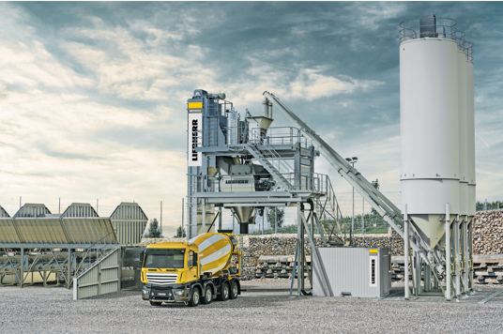

liebherr-betomix-2022.jpg  
The new Betomix from the modular kit is presented to the public for the first time at Bauma.

Contact

Klaus Eckert  
Head of marketing  
Telephone: +49 7583 949-328  
E-Mail: [klaus.eckert@liebherr.com](mailto:klaus.eckert@liebherr.com)

Published by

Liebherr-Mischtechnik GmbH   
Bad Schussenried / Germany  
[www.liebherr.com](http://www.liebherr.com)