Press release

Liebherr Mining to unveil new mid-class excavator model and other innovations at Bauma

⸺

At Bauma 2022, Liebherr Mining will unveil the latest addition to its mining excavator portfolio and exhibit the new T 274 305 tonne mining truck

The dedicated technology pavilion will display the Liebherr Mining’s new Technology Product portfolio, which was launched at MINExpo 2021

The latest updates and developments from the Liebherr Mining Zero Emission Program, including current low carbon emission solutions for mining trucks, will be presented

At Bauma, held in Munich Germany from October 24 - 30 2022, Liebherr Mining will unveil a brand-new mid-size class hydraulic excavator – the second Generation 8 machine within the Liebherr Mining portfolio. The T 274, a class-leading 305-tonne mining truck will be on display, featuring an impressive demonstration of the Trolley Assist System. Visitors will also experience the latest products and services from Liebherr Mining’s Technology Product portfolio in the dedicated technology pavilion including the company’s modular approach to emission reduction, contributing to a more environmental oriented development in the mining industry.

Munich (Germany), 21 June 2022 – Liebherr Mining will take advantage of Bauma 2022 to unveil its latest hydraulic mining excavator model that will join the ranks of the mining product segment’s mid-class excavator range.

First introduction of a new mid-size class “Generation 8” hydraulic excavator

A pre-series model of the new machine will be exhibited at the Liebherr booth. As the second machine within the Liebherr mining portfolio to receive the “Generation 8” label, after the R 9600 excavator, which was launched in 2021, this new model comes equipped with the latest Liebherr technology products.

The hydraulic excavator to be displayed at Bauma 2022 has already entered the testing phase, with the company planning the start of serial production in early 2024.

Powerful, strong, and reliable: The T 274 mining truck with Trolley Assist System

The newly introduced T 274, a class-leading 305 t / 336 tons haul truck will take centre stage at the Liebherr Mining exhibit. Designed and adapted from years of experience in mining truck development, the T 274 is a true 305 tonne machine that provides fast cycle times, higher production rates, low fuel consumption, and a low cost per tonne.

A wide range of options are available for the T 274 and the entire Liebherr haul truck product line, including the Trolley Assist System and the next generation of interoperable machine automation solutions, both of which will be showcased at Bauma 2022.

The Liebherr Trolley Assist System uses an overhead pantograph to connect the electric-drive system to a mine site’s electrical network, powered by the customer’s energy source of choice. The Trolley Assist System offers increased truck fleet productivity, and potential for reduction in fleet size while maintaining yearly production, when compared with standard trucks. The potential for significant reduction of diesel fuel consumption and carbon footprint by decreasing the truck fleet’s CO2 emissions, demonstrates the Trolley Assist System as an effective first step on the road to zero emission mine sites of the future.

Liebherr already delivers proven field experience with 56 Liebherr trucks fitted with the Trolley Assist System currently in operation across three mine sites.

Technology Product portfolio: solutions to enhance safety and overall equipment effectiveness

Liebherr Mining’s recently launched Technology Product portfolio will be showcased at Bauma 2022.

Mining excavator technology products to be presented will include the Truck Loading Assistant, Performance Monitoring and Application Severity analytic products, Liebherr Power Efficiency, and the Bucket Filling Assistant which offers the first step towards excavator automation.

For trucks, Liebherr Mining will showcase the Trolley Guidance System, Crusher Guidance System, and autonomous haulage solutions. Trade fair visitors will learn about Liebherr’s industry-first open protocol, which delivers the next generation of interoperable autonomous haulage solutions.

Supporting all product lines, the Liebherr digital platform comprising products to support assets, operations, and maintenance activities, will be displayed at the technology pavilion. These products use machine-generated data to provide recommendations and insights to drive fleet availability, performance, enhanced machine health, and improve the customer’s service journey.

The new Content Delivery Portal, Troubleshoot Advisor and Remote Support Solutions offering real-time 24/7 digital support from Liebherr experts, will also be showcased.

Zero Emission roadmap: delivering sustainable solutions

Liebherr Mining has committed to offer fossil fuel-free solutions for its mining applications by 2030. Two objectives have been defined to achieve this goal.

The first objective to offer mining products with low CO2 emissions by 2022 has already been successfully achieved through the implementation of two key technologies: the Trolley Assist System and an electric excavator range. Both technologies are consistently achieving proven results in the field to lower carbon emissions.

The second objective is to eliminate fossil fuels for majority of Liebherr Mining equipment applications while maintaining machine mobility. With a defined roadmap for the coming years and support from strategic partnerships, Liebherr Mining will offer its customers long-term sustainable solutions for a transition to an emission-free future.

The basis of the Zero Emission Liebherr Mining products is a modular approach, which allows the machines to be energy type agnostic and drive train agnostic, enabling an upgrade or retrofit on existing equipment to zero emission drives. To further support customers in their zero emission transformation journey, along with accelerating the research and development process and ensuring the best solutions will be offered, Liebherr has formed key strategic partnerships with industry experts ABB and ENGIE.

About the Liebherr Group

The Liebherr Group is a family-run technology company with a highly diversified product portfolio. The company is one of the largest construction equipment manufacturers in the world. It also provides high-quality and user-oriented products and services in a wide range of other areas. The Liebherr Group includes over 140 companies across all continents. In 2021, it employed more than 49,000 staff and achieved combined revenues of over 11.6 billion euros. Liebherr was founded in Kirchdorf an der Iller in Southern Germany in 1949. Since then, the employees have been pursuing the goal of achieving continuous technological innovation, and bringing industry-leading solutions to its customers.

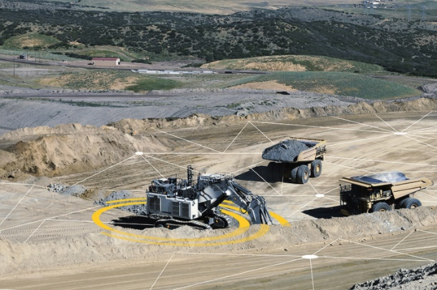Images

Liebherr-mining-assistance-systems.jpg  
The Liebherr Mining Assistance Systems are advanced onboard products and applications designed to support operators to become more efficient through analytics.

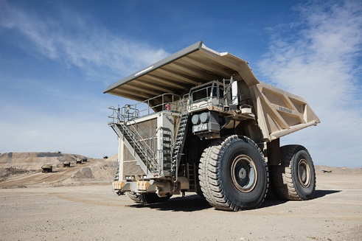

liebherr-T274-mining-truck.jpg  
The T 274 is a true 305 tonne machine that provides fast cycle times, higher production rates, low fuel consumption, and a low cost per tonne.

Contact

Swann Blaise  
Divisional General Manager: Marketing & Business Intelligence  
Telephone: [+1 757 928 2239](tel:+17579282239)  
Email: swann.blaise@liebherr.com

Grégory Schuh

Group Leader / Marketing Department

Telephone: [+33 (0) 369 492199](tel:+33(0)369492199)

Email: [gregory.schuh@liebherr.com](mailto:gregory.schuh@liebherr.com)

Published by

Liebherr-Mining Equipment Colmar SAS  
Colmar / France  
[www.liebherr.com](http://www.liebherr.com)