Press release

Liebherr Application Center in Colmar: customised crawler excavators

⸺

Customised solutions for crawler excavators, directly from Liebherr

Customisation and special-purpose products as an important service from the company

The construction industry – with its divergent fields of application and operating locations – increasingly demands products that have been adapted to specific uses

The long-standing Liebherr production location in France, Liebherr-France SAS, is the Group’s development centre for crawler excavators. In addition to machines for earthmoving and quarry use, the comprehensive range of models also includes products for special-purpose applications. Since 2020, a specialised team known as the Liebherr Application Center has been busy designing and implementing customised solutions for customers.

Colmar (France), 24 June 2022 – Since the 1980s, Liebherr-France SAS has been developing and producing crawler excavators for special-purpose applications, including selective dismantling, tunnelling and material handling. For more than 30 years, the range from Liebherr-France SAS has also included electric models powered by cable, as an alternative to diesel engines. Additionally, special-purpose models have long been an important component and have a firm position in the company’s history.

**Customised solutions directly from the manufacturer**

A heterogeneous field of application such as the construction industry requires customised machines that customers can use anywhere in the world and for any kind of work – machines that satisfy both performance and environmental requirements on site. Against this background, and in accordance with the company’s philosophy, the Group decided – in 2020 – to put further investment into the individual design of its products. The new Liebherr Application Center, which undertakes special orders for customised machines, has been established to meet the growing demand from customers requiring specific machine solutions. Customer requests received through the sales network are systematically analysed by a team of specialists who have a thorough understanding of both the products and the potential scopes of application. This allows them to identify the very best solution for each customer’s specific requirements.

The principal aim of this multidisciplinary and broad-based team is to improve the ability to respond to customers. Contributing to this is optimised integration of projects running in parallel to series production into the processes of Liebherr-France SAS.

**Tried-and-tested Liebherr quality, tailored to the needs of customers**

The Liebherr Application Center allows machines to be more comprehensively tailored to customer requirements and their diverse projects and will in the future be able to offer high-quality customised products directly ex works.

Its scope of services includes feasibility studies and investigations into adaptability based on standard models, guaranteed CE marking, proven manufacturer quality and – last but not least – high availability of spare parts.

About Liebherr-France SAS

Liebherr-France SAS, founded in 1961, is responsible for the development and production of the Liebherr Group’s crawler excavators in Colmar. The current product range includes around 30 models, from the R 914 Compact to the R 980 SME, for use in earthworks and quarries. Production also includes a range of attachments for specific tasks such as demolition, material handling, bridge or tunnel applications, as well as electric excavators. The crawler excavators with an operating weight of 14 to 100 tonnes are equipped with Liebherr engines with an output of 90 to 420 kW. Liebherr-France SAS employs more than 1,400 people and generates a turnover of EUR 692 million.

About the Liebherr Group

The Liebherr Group is a family-run technology company with a highly diversified product portfolio. The company is one of the largest construction equipment manufacturers in the world. It also provides high-quality and user-oriented products and services in a wide range of other areas. The Liebherr Group includes over 140 companies across all continents. In 2021, it employed more than 49,000 staff and achieved combined revenues of over 11.6 billion euros. Liebherr was founded in Kirchdorf an der Iller in Southern Germany in 1949. Since then, the employees have been pursuing the goal of achieving continuous technological innovation, and bringing industry-leading solutions to its customers.

Images

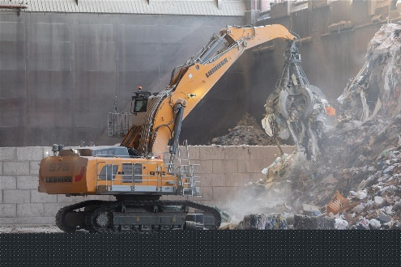

liebherr-application-center-1.jpg  
A customised solution. The R 976 crawler excavator has been adapted for use in a waste sorting plant operated by Veolia: operator’s cab elevation, walkway, individual working attachment and tools.

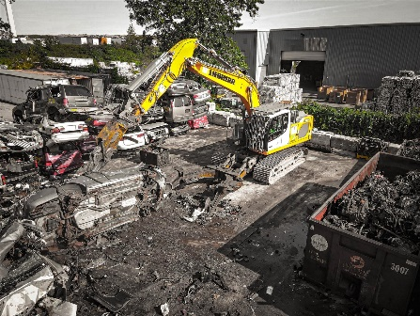

liebherr-application-center-2.jpg  
The R 922 crawler excavator with Powerhand grapple for vehicle dismantling.

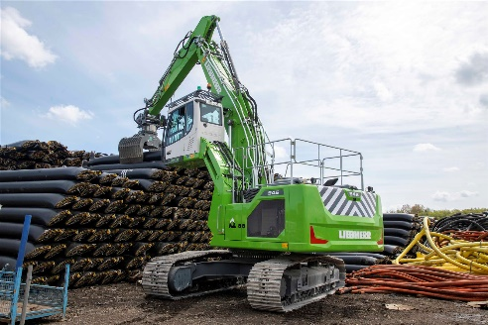

liebherr-application-center-3.jpg  
This R 945, operated by Polymer, has been equipped with a hydraulic operator’s cab elevation. A shear has also been fitted to the boom.

Contact

Alban Villaumé jpg  
Marketing and Communication Manager jpg  
Telephone: +33 3 89 21 36 09 jpg  
E-mail: alban.villaume@liebherr.com

Published by

Liebherr-France SAS jpg  
Colmar, France jpg  
www.liebherr.com