Press release

Alpine crane job on constricted site

⸺

Liebherr LR 11000 crawler crane replaces railway bridges in the Swiss Alps

Increased central ballast means no need for a derrick boom or suspended ballast

First bridge replacement completed after a few hours

A Liebherr LR 11000 crawler crane has installed a 176-tonne railway bridge not far from the fashionable spa and holiday resort of St. Moritz in the Swiss canton of Graubünden. This, the most powerful crawler crane in Switzerland, belongs to logistics and haulage contractor Emil Egger AG and did the job at an altitude of almost 2,000 metres in the Alps - with an unusual set-up configuration due to the lack of available space. A total of three aged truss bridges of the Rhaetian Railway were replaced by the Liebherr crane.

Ehingen (Donau) (Germany), 2 August 2022 – Michael Egger, Managing Director of Emil Egger AG, based in St. Gallen, transported his 1,000-tonne crawler crane to the south-east of Switzerland to replace three railway bridges, all of which were around 100 years old. Work on the first bridge structure was particularly challenging – due to the limited space available for the crane on a metalled embankment facing the adjacent road, it was not possible to use the derrick boom with its suspended ballast.

"To ensure we have sufficient stability for lifting the new, significantly heavier railway bridge, we had to maximise the central ballast on the crane to compensate for the lack of suspended ballast," explains Egger, who planned the operation with his colleague, Andreas Schönenberger. Prior to carrying out the work, he had discussed the load case in this unusual configuration with the specialists at Liebherr in Ehingen: "The LR 11000 is equipped with 90 tonnes of central ballast as standard. We have therefore packed 130 tonnes into the crane for this operation after Liebherr gave us the OK to do so." The slewing platform ballast was loaded with the maximum counterweight of 250 tonnes.

"Up to the limit of the load chart"

Before the new steel structure, which is around 35 metres long and was assembled on site from several segments, could be placed in position, the old bridge structure first had to be removed. The 65-tonne truss construction was quickly lifted off the abutments and set down on the edge of the mountain river, actually next to LR 11000. It was then repositioned later for removal. Afterwards, the crawler crane was able to lift the new bridge from the special transporter on the road and position it above the river using a radius of around 22 metres. "With this radius and a gross load case of 205 tonnes, we are almost at the limit of the load chart for the crane in this particular configuration," says Egger.

The LR 11000 was erected and dismantled by a Liebherr LTM 1250-6.1 mobile crane belonging to Sabesa SA, a crane and haulage contractor based in Ticino. Andrea Saccomandi, Managing Director of Sabesa, which was actually the main contractor for the replacement of the three railway bridges, was personally on site for the crane job. Based on the northern shore of Lake Maggiore, the company's portfolio includes crane work, transport services and platform hire, and its fleet includes around a dozen Liebherr mobile, compact and mobile construction cranes.

**About Liebherr-Werk Ehingen GmbH**

Liebherr-Werk Ehingen GmbH is a leading manufacturer of mobile and crawler cranes. Its range of mobile cranes extends from 2-axle 35 tonne cranes to heavy duty cranes with a lifting capacity of 1200 tonnes and a 9-axle chassis. Its lattice boom cranes on mobile or crawler crane chassis deliver lifting capacities of up to 3000 tonnes. With universal boom systems and extensive additional equipment, they can be seen in action on construction sites throughout the world. The Ehingen site has a workforce of 3,800. Extensive, global service guarantees the high availability of Liebherr mobile and crawler cranes. In 2021, the Liebherr plant in Ehingen recorded a turnover of 2.33 billion euros.

About the Liebherr Group

The Liebherr Group is a family-run technology company with a highly diversified product portfolio. The company is one of the largest construction equipment manufacturers in the world. It also provides high-quality and user-oriented products and services in a wide range of other areas. The Liebherr Group includes over 140 companies across all continents. In 2021, it employed more than 49,000 staff and achieved combined revenues of over 11.6 billion euros. Liebherr was founded in Kirchdorf an der Iller in Southern Germany in 1949. Since then, the employees have been pursuing the goal of achieving continuous technological innovation, and bringing industry-leading solutions to its customers.

**Images**

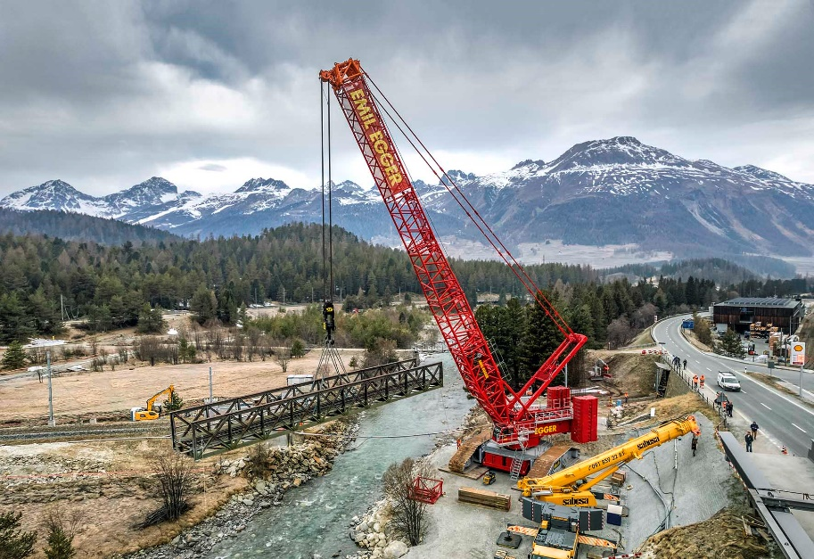  
liebherr-lr11000-egger-1.jpg  
Replacement: The old truss bridge has provided sterling service for around 100 years.

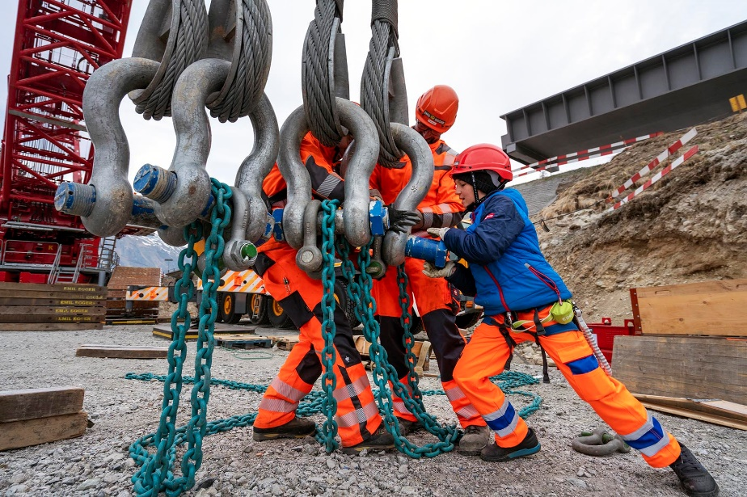  
liebherr-lr11000-egger-2.jpg  
A steady hand – Fabio Egger, part of the fourth generation of the family business, gets to work.

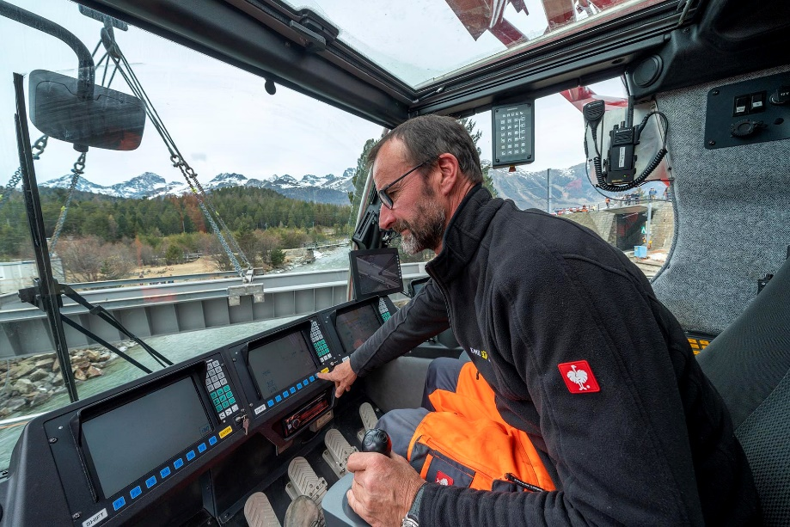  
liebherr-lr11000-egger-3.jpg  
Panoramic view – Peter Stricker, in the crane operator’s cab of the LR 11000, places the 17  tonne steel bridge precisely on the abutments of the refurbished river crossing.

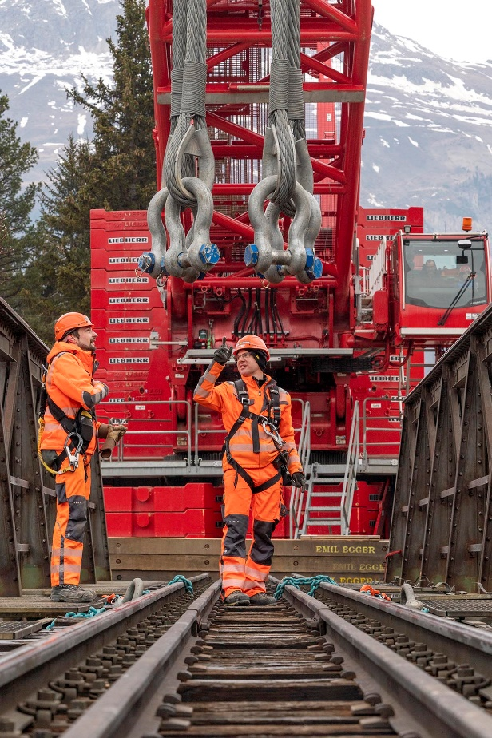  
liebherr-lr11000-egger-4.jpg  
"Hook up” – company boss Michael Egger (centre) with his colleague and project manager for crawler crane operations, Andreas Schönenberger, on the old truss bridge.

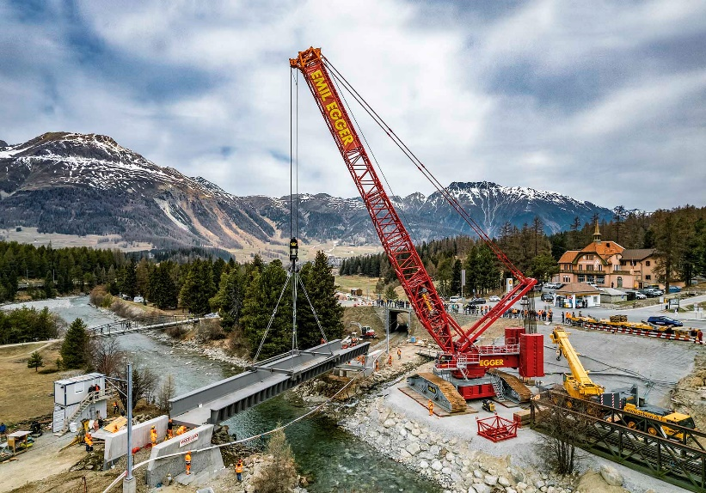  
liebherr-lr11000-egger-5.jpg  
Very tight – this shows clearly that there is no space for the derrick boom or suspended ballast.

**Contact**

Wolfgang Beringer  
Marketing and Communication  
Phone: +49 7391/502 - 3663  
Email: wolfgang.beringer@liebherr.com

**Published by**

Liebherr-Werk Ehingen GmbH  
Ehingen (Donau), Germany  
[www.liebherr.com](http://www.liebherr.com)