Press release

Road construction in Africa: INZAG procures Liebherr LTM 1090-4.2 mobile crane for Ghana

⸺⸺

* German construction company buys Liebherr mobile crane for use in Africa
* An LTM 1090-4.2 will be used as a flexible all-rounder for road construction in Ghana
* INZAG promotes economic and social development in African countries

INZAG Germany GmbH has procured a Liebherr LTM 1090-4.2 mobile crane specifically for a road construction project in Ghana. The German construction company has been awarded the contract for the expansion of the 64-kilometre-long first section of the Eastern Corridor Road from the port city of Tema, not far from the capital Accra, to Akosombo.

Ehingen (Donau) (Germany), 18 August 2022 – The "Rehabilitation of the Eastern Corridor Road" is one of the most important projects undertaken by the Ministry of Roads and Highways of Ghana. It is of central importance for the transport and economic development in the east of the West African state on the Gulf of Guinea. The 700-kilometre road is a very important north-south axis from the border with landlocked Burkina Faso to Tema, the country's main port city.

The German construction company INZAG, headquartered in Wiesbaden, has been awarded the contract for "Lot 1". Managing Director Achim Becker explains: "The development of the first 64 kilometres from the port town of Tema to Akosombo is highly complex. Through the city, the road will be widened from two to six lanes. This will be followed by a section with a four-lane expansion. Even further north, the road will have two lanes. Included in the project are roundabouts, flyovers and river crossings, as well as numerous pedestrian bridges."

**Flexible 4-axle crane**

INZAG is currently setting up the construction site. Purchasing Manager Benjamin Knell reports: "The new Liebherr LTM 1090-4.2 will also be used during the mobilisation phase to set up the construction site. In addition, we will use the flexible 4-axle crane for steel construction and prefabricated assembly. As an all-rounder, the 90-tonne mobile crane will be a key piece of equipment for the construction project. In addition, more cranes are needed on site, especially larger equipment for the heavy lifts."

The LTM 1090-4.2 combines mobility, performance and economy in a superb package. It is economically mobile all over the world, as it can be moved with different axle loads for road and construction site travel. ECOdrive and ECOmode reduce its fuel consumption and noise emissions – better for drivers and the environment. The VarioBallast® variable counterweight radius and the VarioBase® variable support base provide extra performance and safety as well as enormous flexibility in use. With its 60-metre telescopic boom and lattice extensions, the 90-tonne crane can reach lifting heights of up to 76 metres and radii of up to 62 metres.

**Economic and social development in African countries**

INZAG aims to contribute to the economic and social development of African countries by developing projects in the fields of logistics, water infrastructure, energy, mining and industrial facilities. The company develops infrastructure projects for public and private clients in Africa. The focus of the strategy is on structuring public construction projects with export financing. In this type of project, supplies and services are exported to Africa from Germany and other European countries.

Achim Becker says: "The Eastern Corridor Road Lot 1” project is our first in Ghana. Currently we have 150 employees, but in the peak phase there will be up to 900. We have a long-standing business relationship with Liebherr. We appreciate their renowned excellent service. It is a great advantage that Liebherr is present here with a branch office in the capital Accra. It is also an important aspect of our corporate strategy to work with German manufacturers in the African market and to establish strategic partnerships with them in Africa.

**About Liebherr-Werk Ehingen GmbH**

Liebherr-Werk Ehingen GmbH is a leading manufacturer of mobile and crawler cranes. Its range of mobile cranes extends from 2-axle 35 tonne cranes to heavy duty cranes with a lifting capacity of 1200 tonnes and a 9-axle chassis. Its lattice boom cranes on mobile or crawler crane chassis deliver lifting capacities of up to 3000 tonnes. With universal boom systems and extensive additional equipment, they can be seen in action on construction sites throughout the world. The Ehingen site has a workforce of 3,500. Extensive, global service guarantees the high availability of Liebherr mobile and crawler cranes. In 2020, the Liebherr plant in Ehingen recorded a turnover of 2.03 billion euros.

About the Liebherr Group

The Liebherr Group is a family-run technology company with a highly diversified product portfolio. The company is one of the largest construction equipment manufacturers in the world. It also provides high-quality and user-oriented products and services in a wide range of other areas. The Liebherr Group includes over 140 companies across all continents. In 2021, it employed around 48,000 staff and achieved combined revenues of over 10.3 billion euros. Liebherr was founded in Kirchdorf an der Iller in Southern Germany in 1949. Since then, the employees have been pursuing the goal of achieving continuous technological innovation, and bringing industry-leading solutions to its customers.

Images

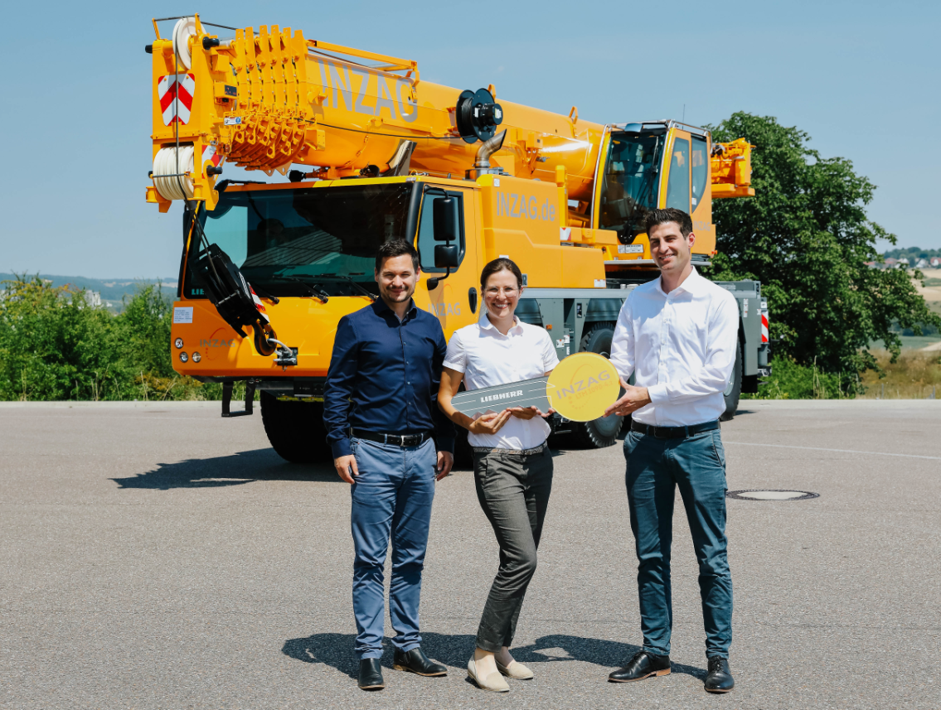

liebherr-ltm1090-4.2-inzag-handover.jpg  
Crane handover in Ehingen (from left to right): Benjamin Knell, Maike Schneider (both INZAG Germany GmbH), Claudio Sortino (Liebherr-Werk Ehingen GmbH).

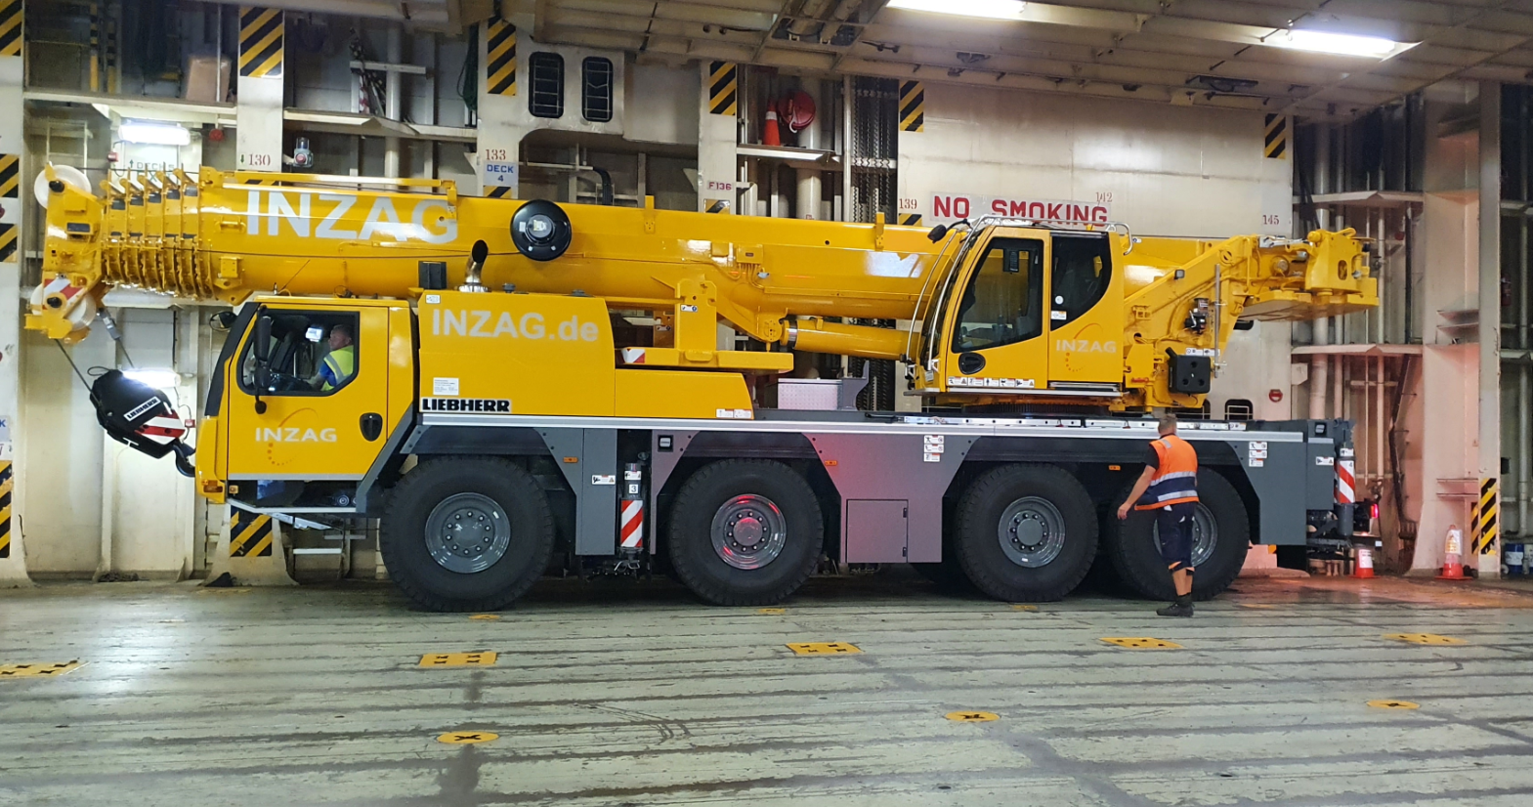

liebherr-ltm1090-4.2-inzag-transport.jpg  
The LTM 1090-4.2 being transported to Ghana by ship.

Contact

Wolfgang Beringer  
Marketing and Communication  
Phone: +49 7391/502 - 3663  
Email: wolfgang.beringer@liebherr.com

Published by

Liebherr-Werk Ehingen GmbH  
Ehingen (Donau), Germany  
[www.liebherr.com](http://www.liebherr.com)