Press release

Liebherr Refrigerators and Freezers launches online parts and accessories store

⸺

Parts and accessories store to further expand support for consumers and partners

New website also offers database of tools and resources in one convenient location

Liebherr Refrigerators and Freezers releases online resource to enhance customer experience including nationwide shipping and tracking, customer support and parts information.

Miami, FL (USA), August 15, 2022 – Liebherr USA, Co., Refrigerators and Freezers - The experts in refrigeration and freezing have just launched [www.liebherrpartsstore.com](http://www.liebherrpartsstore.com), a dedicated website that offers parts and accessories for commercial and residential appliances. The site delivers on the brand’s commitment to customers and partners by providing an online space with comprehensive guides, expert support and real-time information on parts and accessories.

“This new resource offers an intuitive, customer-centric experience with vibrant photos, key information and ease-of-use,” said Christian Lopez, E-commerce Specialist, Liebherr USA, Co. “It’s optimized and designed to help visitors quickly find what they are looking for, from parts and manuals to select accessories and real-time inventory status.”

A seamless transition

The website has been developed in a partnership and collaboration with Encompass Supply Chain Solutions. “We are proud to have Liebherr Refrigerators and Freezers as an integral partner of Encompass,” said Jayne Sutherst, Digital Marketing & Ecommerce Director. “We have developed this website for customers to easily locate and purchase parts quickly and seamlessly. Creating brand loyalty and trust is at the core of Encompass.”

Visitors can expect shipping from coast to coast, order tracking and the ability to register new Liebherr appliances by using the serial locator.

The website offers pricing and purchasing of spare parts for all Liebherr models currently on the market in addition to most discontinued products. The website includes detailed photos, design guides, specification sheets and magnified view of each part within the appliance. Visitors can also chat with a customer service representative 24/7 and register new & current Liebherr products.

“We are listening to our customers and dealer partners,” said Alex Squarize, Divisional Director, Liebherr USA, Co. - Refrigerators and Freezers, “to create a resource that is user-friendly, practical, and easy to navigate while prioritizing what Liebherr consumers wanted.”

The new website is now live at [www.liebherrpartsstore.com](http://www.liebherrpartsstore.com). For more information on Liebherr’s newest products, please visit [home.liebherr.com](http://home.liebherr.com).

**About Liebherr USA, Co.**

[Liebherr USA, Co](https://www.liebherr.com/en/usa/start/start-page.html). based in Newport News, VA provides sales and service on behalf of ten different Liebherr product segments: earthmoving, material handling, mining, mobile and crawler cranes, tower cranes, concrete technology, deep foundation machines, maritime cranes; components, and refrigeration and freezing.

**About the Liebherr Group**

The [Liebherr Group](https://www.liebherr.com/en/usa/about-liebherr/about-liebherr.html) is a family-run technology company with a highly diversified product portfolio. The company is one of the largest construction equipment manufacturers in the world. It also provides high-quality and user-oriented products and services in a wide range of other areas. The Liebherr Group includes over 140 companies across all continents. In 2021, it employed more than 49,000 staff and achieved combined revenues of over 11.6 billion euros. Liebherr was founded in Kirchdorf an der Iller in Southern Germany in 1949. Since then, the employees have been pursuing the goal of achieving continuous technological innovation, and bringing industry-leading solutions to its customers.

Images

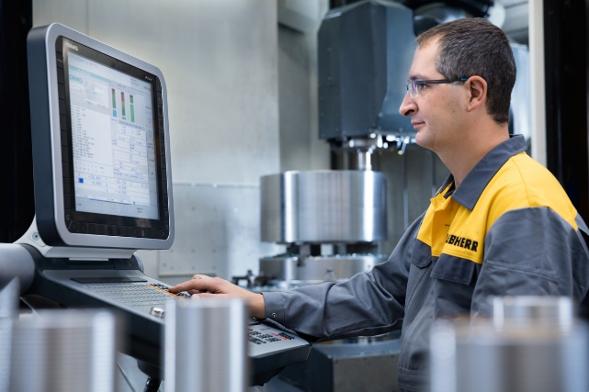

liebherr-first-parts.jpg  
Liebherr employee designing high-quality OEM parts for appliances.

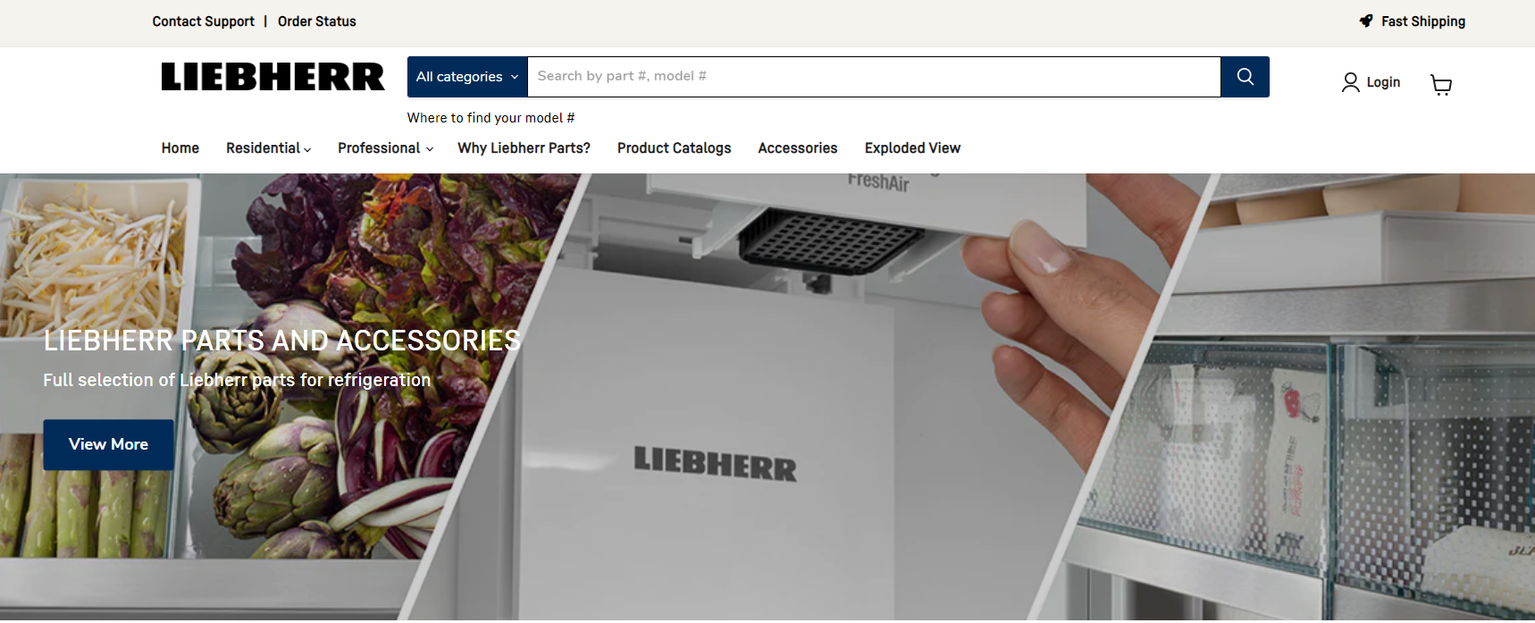

liebherr-parts-site.jpg  
Liebherr Refrigerators and Freezers launches online parts and accessories store.

Contact

Ana Cabiedes   
General Manager, Marketing, Liebherr USA, Co.  
Phone: +1 757-240-4250   
E-Mail: ana.cabiedes@liebherr.com

Jonathan Barfell  
Senior Marketing Manager, Liebherr USA, Co., Refrigerators and Freezers  
Phone: +1 305-817-7500  
E-Mail: jonathan.barfell@liebherr.com

Published by

Liebherr USA, Co.  
Newport News / USA  
www.liebherr.com