Press release

Flexibility on eight axles: Colonia takes over Liebherr LTM 1650-8.1 mobile crane

⸺

LTM 1650-8.1 closes gap between 400- and 750-tonne mobile cranes in fleet

Colonia opts for 54- and 80-metre telescopic booms

Detachable telescopic boom offers increased mobility and flexibility

Colonia Spezialfahrzeuge Gottfried Schönges GmbH & Co. KG has taken delivery of a Liebherr LTM 1650-8.1 mobile crane. With the new crane, the Cologne-based company replaces a 15-year-old 500-tonne crane and strengthens its fleet in the range between 400 and 750 tonnes lifting capacity. In addition to the high performance, the flexibility and mobility of the Liebherr 8-axle crane were important decision criteria. Colonia ordered the 54 and 80 metre telescopic boom as well as equipment to be able to remove the telescopic boom easily, quickly and without an auxiliary crane.

Ehingen (Donau) (Germany), 22 August 2022 - For optimised transport logistics, Liebherr has designed a solution to enable the telescopic boom to be fitted and removed quickly and easily: The LTM 1650-8.1 can be driven without its boom with a total weight of less than 60 tonnes. This significantly increases mobility on public roads. The reduced total weight means that more bridges can be crossed, for example, which saves detours and time. Colonia sales manager Thomas Reuther explains: "We have to face the difficult infrastructure problems especially here in the Cologne area. For this reason, we were the first in Germany to tackle the issue of detachable booms. The LTM 1650-8.1 is now the fourth large crane with this system in our fleet. More will follow in the future."

Colonia's main areas of operation are in the chemical sector. The LTM 1650-8.1 will also find its work mainly in the Cologne chemical belt, in addition to many other applications and activities. "The LTM 1650-8.1 was the only reasonable alternative for us to close our gap between the LTM 1400-7.1 and LTM 1750-9.1. In order to take full advantage of all the technical possibilities of the LTM 1650-8.1, we opted for the 54-metre and also the 80-metre telescopic boom. The variable support base VarioBase® and the hydraulically adjustable ballast radius VarioBallast® are Liebherr innovations that we no longer want to do without. They were also reasons for us to opt for the new Liebherr 8-axle crane," says Reuther.

Colonia Spezialfahrzeuge celebrated its 75th anniversary two years ago. It all started in 1945 with a self-built trailer and a towing vehicle. In the 1960s, the first truck-mounted cranes were acquired. In 2020, Colonia entered the crawler crane class with the Liebherr LR 1800-1.0. Today, with around 220 employees, the company offers industrial assembly and towing services in addition to heavy-duty and crane rental.

About Liebherr-Werk Ehingen GmbH

Liebherr-Werk Ehingen GmbH is a leading manufacturer of mobile and crawler cranes. Its range of mobile cranes extends from 2-axle 35 tonne cranes to heavy duty cranes with a lifting capacity of 1200 tonnes and a 9-axle chassis. Its lattice boom cranes on mobile or crawler crane chassis deliver lifting capacities of up to 3000 tonnes. With universal boom systems and extensive additional equipment, they can be seen in action on construction sites throughout the world. The Ehingen site has a workforce of 3,500. Extensive, global service guarantees the high availability of Liebherr mobile and crawler cranes. In 2020, the Liebherr plant in Ehingen recorded a turnover of 2.03 billion euros.

About the Liebherr Group

The Liebherr Group is a family-run technology company with a highly diversified product portfolio. The company is one of the largest construction equipment manufacturers in the world. It also provides high-quality and user-oriented products and services in a wide range of other areas. The Liebherr Group includes over 140 companies across all continents. In 2021, it employed around 48,000 staff and achieved combined revenues of over 10.3 billion euros. Liebherr was founded in Kirchdorf an der Iller in Southern Germany in 1949. Since then, the employees have been pursuing the goal of achieving continuous technological innovation, and bringing industry-leading solutions to its customers.

Image:

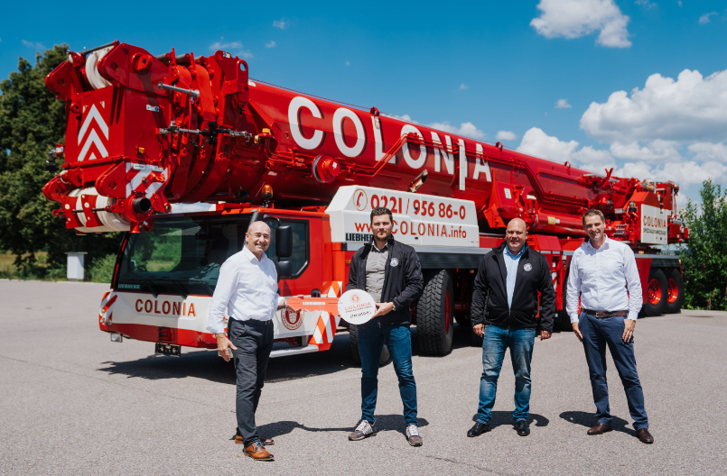

liebherr-ltm1650-8-1-colonia-handover.jpg  
Crane handover at the Liebherr works in Ehingen: (from left) Erich Schneider (Liebherr-Werk Ehingen GmbH), Nico Oprée, Thorsten Titz (beide Colonia Spezialfahrzeuge), Florian Maier (Liebherr-Werk Ehingen GmbH).

**Contact**

Wolfgang Beringer  
Marketing and Communication  
Phone: +49 7391/502 - 3663  
Email: wolfgang.beringer@liebherr.com

**Published by**

Liebherr-Werk Ehingen GmbH  
Ehingen (Donau), Germany  
[www.liebherr.com](http://www.liebherr.com)