Press release

Liebherr Transform: unleash the full potential

⸺

Extended service life and reduced CO2 footprint

Increased performance and fit for the future

Customer-oriented solutions

Liebherr Transform is the new upgrade, modification and overhaul service that has a tailor-made solution for customer needs. It is available for crawler cranes (up to 400 t), deep foundation equipment, duty cycle crawler cranes, and maritime cranes[1].

Nenzing/Rostock/Killarney, August 23, 2022 – The new Liebherr Transform provides tailored solutions that respond to the continuously growing demands on today’s businesses. A range of ingenious upgrades, clever retrofits, machine overhauls and service modifications breathe new life into customers’ existing machines. Using the latest technology and years of experience, Liebherr brings a combination of sustainability, smart technologies, maximum productivity and cost-effectiveness in one complete solution. This allows existing equipment to reach its full potential.

New service solution includes overhauls, upgrades, retrofits and much more

It is inevitable that equipment becomes outdated over time but that does not mean it has to be replaced. As the name suggests, existing machines are transformed using affordable complete or partial machine overhauls, retrofits and upgrades. This not only saves the increased capital expenditure of investing in new machines, but also reduces the carbon footprint by avoiding the need for new equipment through the extension of the service life. A number of retrofits and upgrades are available which increase versatility and performance, or ensure compliance with more stringent regulations, and so open up a wider spectrum of opportunities. At the same time, operators do not have to get used to new machines and can continue to benefit from their vast experience with existing equipment. The Liebherr team of expert engineers takes care of the entire planning and implementation of Transform projects – from consultation, through to installation and technical support and service.

Stronger, faster, smarter, greener

Companies are under pressure to increase volume and performance, widen scopes, or reduce emissions and costs, the list is endless. Liebherr Transform helps to lighten the load through a comprehensive range of structural, electrical, mechanical, ergonomic or digital modifications. Through the application of new technologies and expertise, Liebherr machines are transformed for the workplace of the future. They are stronger, faster, smarter, greener, and ultimately...better.

Further details about Liebherr Transform can be found on the [maritime website](https://www.liebherr.com/en/deu/products/maritime-cranes/services-and-support/customer-service-maritime-cranes/transform/transform.html) and [construction machinery website](https://www.liebherr.com/en/deu/products/construction-machines/deep-foundation/customer-service/transform/transform.html).

Watch the [Liebherr Transform video](https://youtu.be/ZIASGk_RXTw):



Images

Ein Bild, das Mann, Person, drinnen, stehend enthält.

Liebherr-Transform_hydraulic.jpg  
Liebherr Transform includes complete overhauls.

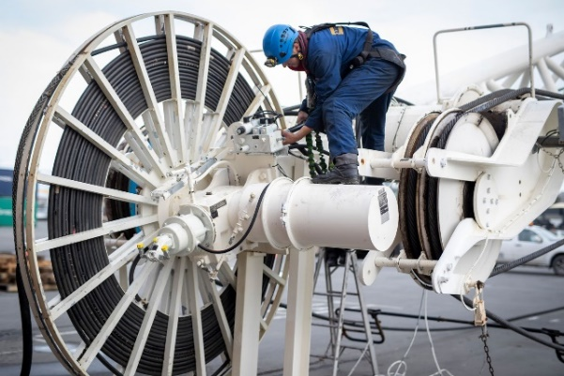

Liebherr-Transform_retrofits.jpg  
Maximum productivity with new technologies.

Contact

Aleksandra Krstic  
Marketing Manager Customer Service  
Maritime cranes, crawler cranes and foundation equipment  
Email: [aleksandra.krstic@liebherr.com](mailto:aleksandra.krstic@liebherr.com)

Published by

Liebherr-Werk Nenzing GmbH  
Nenzing / Austria

Liebherr-MCCtec Rostock GmbH  
Rostock/Germany

Liebherr Container Cranes Ltd.  
Killarney/Ireland

[www.liebherr.com](http://www.liebherr.com)

1. Maritime cranes: ship to shore container cranes, rubber tyre gantry cranes, rail mounted gantry cranes, mobile harbour cranes, offshore and ship cranes.