Press release

Always on track for progress: Liebherr at InnoTrans 2022

⸺

Liebherr shows a range of innovations for the railway system

The Liebherr booth is located in the outdoor area south – booth no. O/170

Liebherr will be attending InnoTrans in Berlin from 20 to 23 September under the motto "Always on track for progress". As one of the largest exhibitors at the fair, the company will be showing innovative products and technologies – including world premieres – for use on and off the rails.

Berlin (Germany), August 2022 – Rail vehicles are among the safest and most sustainable means of transport worldwide. The many advantages that rail already offers in terms of environmental friendliness and efficiency must be further expanded in the coming years. In this way, it can play a central role in the future in a digital, low-emission and ultimately efficient interconnection of the various modes of transport. In this context, Liebherr as a renowned supplier of innovative technologies and railway-proven solutions will continue to make an important contribution to making the rail transport sector even more sustainable and attractive in the future.

For decades, Liebherr products and technologies have been helping to drive progress in the rail industry. The trade fair motto for this year's InnoTrans points to this: "Always on track for progress". At the international exhibition of the railway industry in Berlin, the company will be presenting products and technologies from three product segments that revolve around the subject of rail: Firstly, innovative solutions for rail vehicles from the fields of heating, ventilation and air-conditioning technology, electronics and hydraulic actuation systems. Among them is a world premiere: the air-free brake actuator.

In addition, Liebherr will be presenting a representative of its new generation of railroad excavators from the construction machinery sector. The company has been producing powerful and high-quality railroad excavators since 1967. These can be used both on the road and in rail transport. There they carry out, for example, work related to the maintenance or renewal of rail systems as well as the laying of track infrastructures.

In the components product segment, the company is presenting the horizontal version of the D966H engine with 13 litres displacement, which was specially developed for railcars. This combustion engine, which is being presented in its diesel version, is HVO-capable. Currently, the engine technology is being further developed for use with hydrogen.

The products and technologies primarily contribute to improving efficiency and reducing emissions. Through the further development of technologies and components, in the future, the good environmental balance of rail transport and reliability can be further increased and maintenance costs reduced.

About the Liebherr Group

The Liebherr Group is a family-run technology company with a highly diversified product portfolio. The company is one of the largest construction equipment manufacturers in the world. It also provides high-quality and user-oriented products and services in a wide range of other areas. The Liebherr Group includes over 140 companies across all continents. In 2021, it employed more than 49,000 staff and achieved combined revenues of over 11.6 billion euros. Liebherr was founded in Kirchdorf an der Iller in Southern Germany in 1949. Since then, the employees have been pursuing the goal of achieving continuous technological innovation, and bringing industry-leading solutions to its customers.

Images

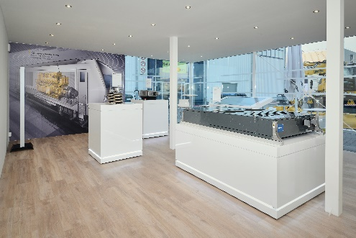

liebherr-innotrans-2018-booth-inside.jpg  
InnoTrans was last held in 2018, with Liebherr as one of the largest exhibitors. Three product segments are represented on the booth: Aerospace and transportation systems, earthmoving and components.

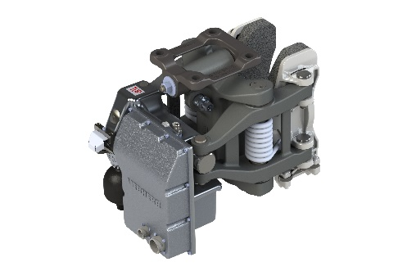

air-free-break-actuator-copyright-liebherr.jpg  
Ready for serial application – the air-free brake system of Siemens Mobility and its key component, the air-free brake actuator developed by Liebherr in close cooperation with Siemens Mobility.

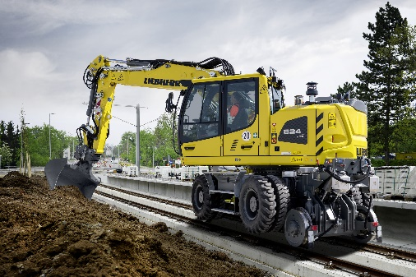

liebherr-a924-rail.jpg

Liebherr has been successfully developing and producing railroad excavators for use both on the road and in rail transport at its site in Kirchdorf an der Iller since 1967. With the A 924 Rail Litronic, Liebherr is presenting a representative of the new generation at the trade fair.

Contact

Ute Braam  
Liebherr-Transportation Systems GmbH & Co. KG  
Phone: +49 8381 / 46 - 4403  
E-mail: ute.braam@liebherr.com

Carole Viola  
Liebherr-Components Colmar SAS  
Phone: +33 3 / 89 - 30 73 26  
E-Mail: carole.viola@liebherr.com

Nadine Willburger  
Liebherr-Hydraulikbagger GmbH  
Phone: +49 7354 / 80 - 7332  
E-mail: nadine.willburger@liebherr.com

Published by

Liebherr-International Deutschland GmbH   
Biberach (Riss) / Deutschland  
[www.liebherr.com](http://www.liebherr.com)