Press release

Double pack complete: Guindastes Tatuapé receives its second LTM 1120-4.1

⸺⸺

* First of two ordered LTM 1120-4.1 already in operation at Guindastes Tatuapé
* Second LTM 1120-4.1 now handed over to Tatuapé
* LTM 1120-4.1 is the strongest four-axle mobile crane on the market
* Decades of partnership between Liebherr and Tatuapé based on tremendous satisfaction with Liebherr products

The Brazilian crane and heavy transport company Guindastes Tatuapé has taken delivery of its second Liebherr LTM 1120-4.1 mobile crane. Since December 2021, the first LTM 1120-4.1 has already impressed Tatuapé with its efficiency and high mobility on several assignments. The second crane, which has now been delivered, is initially scheduled for maintenance work in wind farms in Brazil after being exhibited at the M&T EXPO trade fair in Sao Paulo. Tatuapé emphasizes above all the reliability and quality of Liebherr products. The partnership between Liebherr and the Brazilian company goes back more than two decades.

Ehingen (Donau) (Germany), 6. September 2022 – Following the first LTM 1120-4.1 was shipped from the Port of Hamburg to the crane and heavy transport company Guindastes Tatuapé in Brazil in November 2021, the second crane ordered has now been handed over too. The 4-axle truck represents the 400thequipment from Tatuapé’s fleet, so it has a special metalized painting. It will be exhibited at the M&T EXPO trade fair in Sao Paulo at the end of August. Tatuapé has initially earmarked the new LTM 1120-4.1 for maintenance work in wind farms. Its long boom is sure to make it ideal for such work.

Powerful with long telescopic boom and high mobility

66 metres in length, the LTM 1120-4.1 features one of the longest jibs in this crane class. With a lattice jib, it reaches a maximum lifting height of 91 metres and has extremely high lifting capacities even in a steep position. Despite its low overall weight as a 4-axle unit, the Liebherr mobile crane has a lifting capacity of 120 tonnes. The powerful crane type comes with the very latest crane technology: The VarioBase® variable supporting base and VarioBallast® adjustable ballast radius make jobs in extreme conditions safer and more flexible.

"Compared to a five-axle crane we used for similar operations, we gain efficiency deploying a crane with only four axles: more economical repositioning and better access to confined areas.”, states Denys Garzon Rodrigues, Commercial Director of Guindastes Tatuapé, highlighting the compact design and manoeuvrability of the powerful 4-axle.

High satisfaction with the reliability and quality of Liebherr products

The first LTM 1120-4.1 – which Tatuapé has already been using for months – impressed with its high mobility and easy manoeuvrability. The crane has also already proven itself in maintenance work on wind turbines. "Its performance was crucial to the success of the missions!" declares Rodrigues. "We're very satisfied with the performance and efficiency of the new mobile crane – just as we're really satisfied with all our Liebherr products," Rodrigues continues. The partnership between Tatuapé and Liebherr goes back several decades. "A large part of our success is closely linked to the reliability and quality of Liebherr products."

Guindastes Tatuapé has been active in the Brazilian market for more than 60 years, providing crane rental and special haulage services. The company has relied on innovative technologies from the very beginning and keeps its fleet up to date with ever new crane models. At its headquarters in São Paulo/SP and a branch in the state of Espírito Santo/ES, Tatuapé has a total area of 120,000 m² and employs around 400 people. The fleet size is currently around 400 machines – typically including mobile and crawler cranes, forklifts, lifting platforms, knuckle boom cranes, conveyors and manipulators. The main sectors served by Tatuapé include oil and gas, wind turbines, prefabricated concrete components, mining, petrochemicals, sugar mills and cellulose.

About Liebherr-Werk Ehingen GmbH

Liebherr-Werk Ehingen GmbH is a leading manufacturer of mobile and crawler cranes. Its range of mobile cranes extends from 2-axle 35 tonne cranes to heavy duty cranes with a lifting capacity of 1200 tonnes and a 9-axle chassis. Its lattice boom cranes on mobile or crawler crane chassis deliver lifting capacities of up to 3000 tonnes. With universal boom systems and extensive additional equipment, they can be seen in action on construction sites throughout the world. The Ehingen site has a workforce of 3,800. Extensive, global service guarantees the high availability of Liebherr mobile and crawler cranes. In 2021, the Liebherr plant in Ehingen recorded a turnover of 2.33 billion euros.

About the Liebherr Group

The Liebherr Group is a family-run technology company with a highly diversified product portfolio. The company is one of the largest construction equipment manufacturers in the world. It also provides high-quality and user-oriented products and services in a wide range of other areas. The Liebherr Group includes over 140 companies across all continents. In 2021, it employed more than 49,000 staff and achieved combined revenues of over 11.6 billion euros. Liebherr was founded in Kirchdorf an der Iller in Southern Germany in 1949. Since then, the employees have been pursuing the goal of achieving continuous technological innovation, and bringing industry-leading solutions to its customers.

**Image**

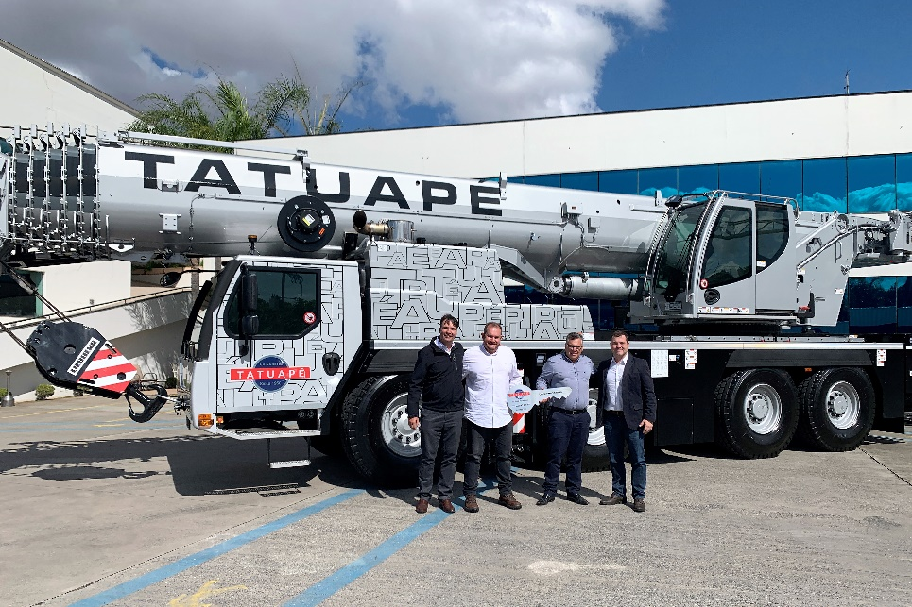

liebherr-ltm-1120-4-1-handover-tatuape.jpg  
Handover of the LTM 1120-4.1 crane to Tatuapé (from left to right): Fabio Azevedo (Liebherr Brasil), Daniel Garzon Rodrigues, Denys Garzon Rodrigues (both Guindastes Tatuapé) and Rene Porto (Liebherr Brasil). The crane will be exhibit at M&T Expo, in São Paulo.

Contact

Wolfgang Beringer  
Marketing and Communication  
Phone: +49 7391/502 - 3663  
Email: wolfgang.beringer@liebherr.com

Published by

Liebherr-Werk Ehingen GmbH  
Ehingen (Donau), Germany  
[www.liebherr.com](http://www.liebherr.com)