Press release

Wind main bearing: new single-row tapered roller bearing

⸺

Liebherr expands its portfolio with single-row tapered roller bearings as main bearings for wind turbines

The induction-hardened and superfinished raceway surface increases the service life

Liebherr is a development partner with many years of experience in the manufacturing of slip-free hardened main bearings for various on- and offshore turbines

**Turning one into two: The new single-row tapered roller bearings for the main bearing arrangement in wind turbines expand Liebherr's product range. Two single-row tapered roller bearings find their use in yet another type of wind turbines. Mounted with some distance from each other on the shaft, the single-row tapered roller bearings have a lower moment effect. They are also significantly smaller in design. With these newly developed main bearings, Liebherr is specifically responding to the customer demand.**

Nussbaumen (Switzerland), September 12, 2022 –With the new type of main bearing for wind turbines a fresh wind is literally blowing in Liebherr's components product segment. For the first time, Liebherr develops and produces a main bearing arrangement, consisting of two single-row tapered roller bearings. Optimum rolling characteristics and ideal force distribution are ensured by the layout and design of the bearing. In addition, the precise rolling elements combined with the narrow manufacturing tolerances of the two single-row tapered roller bearings provide for an exact preloading in the installed condition. Liebherr ensures that the preload is determined during development by finite element calculations, as well as by the dimensional accuracy of the machines in production. The two single-row tapered roller bearings thus enable ideal load distribution.

**High complexity in production: inductive hardening process and superfinishing**

"Setting the filigree rings in the slip-free hardening process was a challenge," explains Stefan Milotzke, head of technical sales of the business unit slewing bearings at Liebherr in Biberach (Germany). "Our several years of experience enable us to make a perfectly coordinated adjustment of the four inductors. This is particularly important, because it enables us to meet the high requirements put on the hardening depth and surface hardness," says Milotzke. Superfinishing further refines the raceway surface: In this process, the surface of the raceway is processed in such a way, that wear, friction and lubrication are optimised. This ensures extremely high surface quality and a longer component service life.

About Liebherr-Components AG

In this segment, the Liebherr Group specialises in the development, design, manufacturing of high-performance components in the field of mechanical, hydraulic and electric drive and control technology. Liebherr-Component Technologies AG, based in Bulle (Switzerland), coordinates all activities in the Components product segment.

The extensive product range includes combustion engines, injection systems, engine control units, axial piston pumps and motors, hydraulic cylinders, slewing bearings, gearboxes and winches, switchgear, electronic and power electronics components, and software. The high-quality components are used in cranes and earthmoving machinery, in the mining industry, maritime applications, wind turbines, automotive engineering or in aviation and transport technology. Synergy effects in s other product segments of the Liebherr Group are used to drive continuous technological development.

About the Liebherr Group

The Liebherr Group is a family-run technology company with a highly diversified product portfolio. The company is one of the largest construction equipment manufacturers in the world. It also provides high-quality and user-oriented products and services in a wide range of other areas. The Liebherr Group includes over 140 companies across all continents. In 2021, it employed more than 49,000 staff and achieved combined revenues of over 11.6 billion euros. Liebherr was founded in Kirchdorf an der Iller in Southern Germany in 1949. Since then, the employees have been pursuing the goal of achieving continuous technological innovation, and bringing industry-leading solutions to its customers.

Images

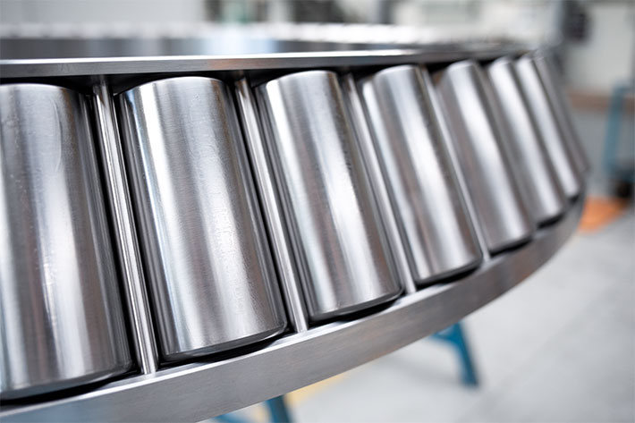

liebherr-single-row-tapered-roller-bearing-as-main-bearing.jpg  
Liebherr expands its portfolio with single-row tapered roller bearings as main bearings for wind turbines.

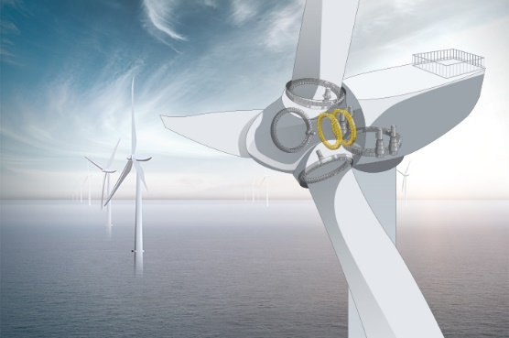

liebherr-single-row-tapered-roller-bearings-installation-wind-turbine.jpg  
Two single row tapered roller bearings find their application in another type of wind turbine.

Contact

Alexandra Nolde  
Senior Communication & Media Specialist  
Phone: +41 56 296 4326  
E-mail: alexandra.nolde@liebherr.com

Published by

Liebherr-Components AG  
Nussbaumen / Switzerland  
[www.liebherr.com](http://www.liebherr.com)  
[Main bearings for wind turbines - Liebherr](https://www.liebherr.com/en/deu/products/components/large-diameter-bearing/main-bearings-for-wind-turbines/main-bearings-for-wind-turbines.html)