Press release

Active personnel detection for Liebherr wheel loaders receives 2022 VDBUM Award

⸺

Active personnel detection: Assistance system for wheel loaders to prevent accidents

Assistance system awarded in the “Developments from Industry” category

Liebherr had its own stand and gave technical presentations at the VDBUM grand seminar

The German Association of Construction, Environmental and Mechanical Engineering (VDBUM) awarded active personnel detection with the 2022 VDBUM Award. Active personnel detection is an intelligent assistance system developed by Liebherr for the Group’s wheel loaders. Dr.-Ing. Manuel Bös, Head of Emerging Technologies at Liebherr-Werk Bischofshofen GmbH, accepted the prestigious award in person at the 50th VDBUM grand seminar in Willingen. Liebherr was represented at the event with three technical presentations and its own exhibition stand.

Bischofshofen (Austria), 13 September 2022 – In July, the expert jury awarded active personnel detection in the category “Developments from Industry”. Active personnel detection uses sensors and artificial intelligence to automatically distinguish between persons and objects in order to specifically warn the machine operator of an accident that may result in personal injury. If a person moves into the rear area of the wheel loader, the system alerts the operator at a greater distance than for static objects such as walls or columns. This intelligent classification reduces the number of unnecessary warning signals to make the machine operator’s work easier.

Brake assistant and incident map as important functions of active personnel detection

In addition to the targeted warning signals, the brake assistant and the incident map are further functions of the active personnel detection system that help to prevent accidents. As soon as the sensors detect a potential danger, the brake assistant automatically slows down the wheel loader. This eliminates the human reaction time required for conventional braking. This shortens the stopping distance by potentially crucial metres, further reducing the frequency and severity of accidents.

With each warning signal, the assistance system transmits a GPS signal to Liebherr’s LiDAT data transmission and positioning system. Based on this, Liebherr provides the incident map, a visualisation of risk zones and potential accident sources on the plant site, for every operator of a wheel loader with active personnel detection in LiDAT. This allows the plant operator to take action to prevent accidents and thus increase safety.

Liebherr participates with various technical presentations at the VDBUM grand seminar

In addition, Liebherr presented three interesting technical lectures as part of the 50th VDBUM grand seminar. “Strong partnership between the building contractor and the manufacturer”, was the title of one of them, a joint presentation by Rudolf Arnold (Liebherr-Hydraulikbagger GmbH), Thorsten Hesselbein (Liebherr-Werk Biberach GmbH) and Martin Philipp (STRABAG BMTI GmbH & Co. KG). The speakers gave an insight into the decades of successful cooperation between STRABAG, a leading European technology partner for construction services, and Liebherr based on projects they have implemented together, as well as an outlook on how foundations for the future are built together with customers. The public was also able to learn about current topics of the Liebherr Group at the Liebherr stand.

The German Association of Construction, Environmental and Mechanical Engineering (VDBUM) is a professional interest group that represents its members in all matters of everyday work and provides a forum for construction professionals. The membership includes both users and manufacturers of construction machinery with their sales and service partners. In 2013, the VDBUM launched its award to drive innovation and technical progress in the construction industry.

About Liebherr-Werk Bischofshofen GmbH

Liebherr-Werk Bischofshofen GmbH develops, produces and sells wheel loaders from the Liebherr Group. The plant in Salzburger Land (Austria) has grown steadily over the decades thanks to sustainable innovations, creative solutions and high quality standards. The wheel loader range is constantly being expanded and includes various models in four different product groups: compact loaders, stereo loaders, and mid-sized and large wheel loaders with impressive, innovative drive designs.

About the Liebherr Group

The Liebherr Group is a family-run technology company with a highly diverse product portfolio. The company is not only one of the largest construction equipment manufacturers in the world, but also provides high-quality and user-oriented products and services in a wide range of other areas. The Liebherr Group now includes over 140 companies across all continents. In 2021, the group employed more than 49,000 staff and achieved combined revenues of over € 11.6 billion. Liebherr was founded in 1949 in Kirchdorf an der Iller. Since then, staff have pursued the goal of contributing to technological advancement and bringing industry-leading solutions to its customers.

Images

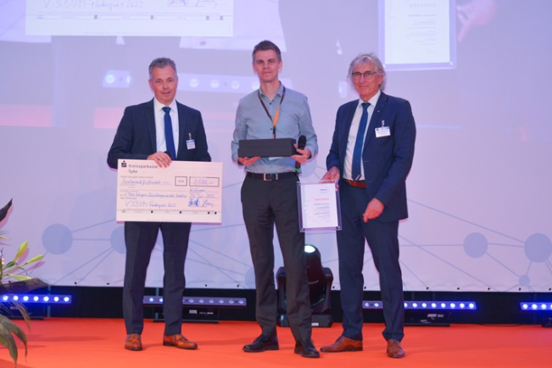

liebherr-aktive-personenerkennung-vdbum-foerderpreis-2022.jpg  
Dr.-Ing. Manuel Bös (middle), head of Emerging Technologies at Liebherr-Werk Bischofshofen GmbH, accepts the 2022 VDBUM Award.

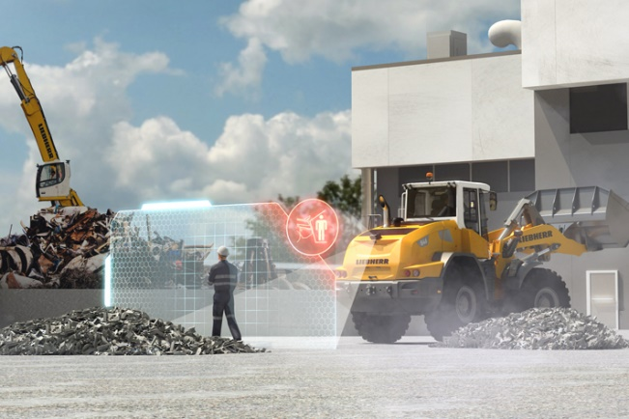

liebherr-aktive-personenerkennung-radlader.jpg  
The active personnel detection brake assistant automatically reduces the speed as soon as the sensors detect a source of danger.

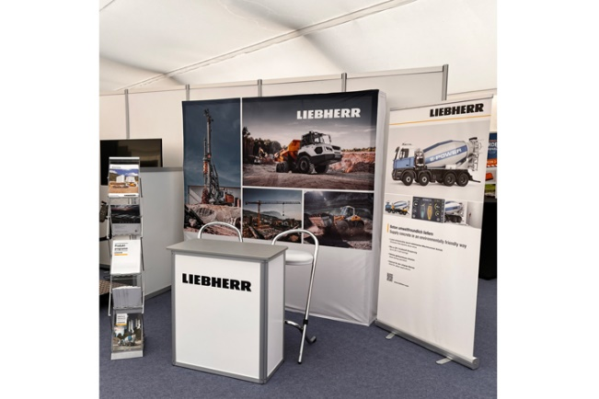

liebherr-stand-at-vdbum-seminar-2022.jpg  
Liebherr was represented at the VDBUM grand seminar with its own stand.

Contact

Martin Koller  
Marketing and Public Relations  
Phone: +43 50809 11475  
E-mail: [martin.koller.lbh@liebherr.com](mailto:martin.koller.lbh@liebherr.com)

Published by

Liebherr-Werk Bischofshofen GmbH  
Bischofshofen/Austria  
[www.liebherr.com](http://www.liebherr.com)