Press release

Simply strong: safe and efficient force-measurement within Liebherr hydraulic cylinders

⸺

* Classic hydraulic cylinders equipped with a force-measuring element allow precise and dynamic measurement of static and dynamic tensile and compressive loads.
* Indirect force-measurement via strain offers a smart alternative.
* The new force sensor offers higher efficiency and safety during daily use, as well as digital condition monitoring of hydraulic cylinders for automation solutions.

The new type of force measurement within hydraulic cylinders helps to measure static, as well as dynamic tensile and compressive loads precisely and dynamically. A dedicated sensor is currently in prototype status. The results enable greater efficiency and safety in a wide range of mobile and stationary applications.

Nussbaumen (Switzerland), 14. September 2022 - At its site in Kirchdorf an der Iller (Germany), Liebherr's components product segment is increasingly focusing on sensor solutions and their efficient use in hydraulic cylinders. One driver, for example, is force-measurement within the cylinder. It is always advantageous, when precise and dynamic values of the forces prevailing within the hydraulic cylinder are required. This is the case, when monitoring loads in excavators and cranes. In this way, dangerous situations during crane operation can be avoided and the efficiency of the machine can be improved. The prevailing force in the cylinder is conventionally determined indirectly via the oil pressure. These measured values are prone to error due to internal friction, for example. This is why Liebherr relies on direct force-measurement via strain with the force-measurement sensor.

The internal measuring points track both tensile and compressive forces regardless of lateral forces and torques. "The measuring method ensures significantly more precise and dynamic measurement results,'' explains Hans-Peter Laverne, Head of Advanced Development at Liebherr-Components Kirchdorf GmbH. “This establishes the conditions for higher productivity and safety in daily use in various applications.''

Intelligent setup, many possibilities

At this point, Liebherr force-measurement on the hydraulic cylinder is a functioning sensor prototype. It stands out in particular due to its high diversity in application. During the design phase, Liebherr's development team checks and takes into account individual adaptations with regard to the operator’s wishes and needs. This allows Liebherr to offer customised solutions.

Small sensor, huge advantages

The improved force-measurement brings further advantages. These include, for example, an increased performance of assistance systems through optimised sensitivity. Thanks to highly dynamic and precise measurement, longer service life is also possible in the future. This will play a decisive role not only in condition monitoring, but also in downsizing.

About Liebherr-Components

In this segment, the Liebherr Group specialises in the development, design, manufacturing of high-performance components in the field of mechanical, hydraulic and electric drive and control technology. Liebherr-Component Technologies AG, based in Bulle (Switzerland), coordinates all activities in the components product segment.

The extensive product range includes combustion engines, injection systems, engine control units, axial piston pumps and motors, hydraulic cylinders, slewing bearings, gearboxes and winches, switchgear, electronic and power electronics components, and software. The high-quality components are used in cranes and earthmoving machinery, in the mining industry, maritime applications, wind turbines, automotive engineering or in aviation and transport technology. Synergy effects in s other product segments of the Liebherr Group are used to drive continuous technological development.

About the Liebherr Group

The Liebherr Group is a family-run technology company with a highly diversified product portfolio. The company is one of the largest construction equipment manufacturers in the world. It also provides high-quality and user-oriented products and services in a wide range of other areas. The Liebherr Group includes over 140 companies across all continents. In 2021, it employed more than 49,000 staff and achieved combined revenues of over 11.6 billion euros. Liebherr was founded in Kirchdorf an der Iller in Southern Germany in 1949. Since then, the employees have been pursuing the goal of achieving continuous technological innovation, and bringing industry-leading solutions to its customers.

Image

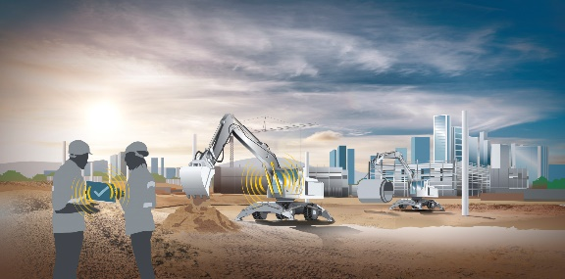

liebherr-force-measurement-in-hydraulic-cylinders.jpg

The Liebherr force-measurement ensures more safety and higher productivity in diverse applications every day.

Contact

Alexandra Nolde

Senior Communication & Media Specialist

Phone: +41 56 295 / 4326

E-mail: [alexandra.nolde@liebherr.com](mailto:alexandra.nolde@liebherr.com)

Published by

Liebherr-Components AG

Nussbaumen/ Schweiz

[www.liebherr.com](http://www.liebherr.com)