Press release

Electrification and lower emissions: Exhibits of Liebherr at InnoTrans

⸺

New air-free brake actuator based on "brake-by-wire" principle

Liebherr Controlled Axle Steering "LiCAS" system reduces wear of rails and wheels

Demonstrator of a propane-based air-conditioning system

Powerful turbo compressor for fuel cell drives

As a highlight exhibit, Liebherr will present an air-free brake actuator for the first time at InnoTrans 2022 in Berlin. The actuator is part of Siemens Mobility's air-free brake system. Liebherr is also exhibiting other technologies and systems for rail vehicles - including a system for positioning wheelsets, a technology demonstrator for propane-based air-conditioning systems and a turbo compressor for fuel cell propulsion.

Berlin (Germany), September 2022 – At InnoTrans 2022, Liebherr will be unveiling for the first time a new development for rail vehicle brake operations: The Siemens Mobility air-free brake system and its essential component, the air-free brake actuator. Liebherr and Siemens Mobility jointly developed the electro-hydraulic brake actuator that provides the brake force for the brake system.

**Air-free brake actuator with "brake-by-wire" ready for series production**

In contrast to a conventional pneumatic brake, the brake control in the new air-free brake system from Siemens is completely electrical. This system, also known as "brake-by-wire," therefore eliminates the need for all piping and all pneumatic components for controlling the brake. Siemens Mobility is using the new brake technology for the first time in the "X-Wagen" metro project in Vienna (Austria). There, it will go into passenger service at the end of 2022. In operation, the new system leads to lower costs in several areas: in maintenance, for example, and it also reduces the time required for train commissioning as well as cycle time.

153 years after development of the Westinghouse air brake, there is a real alternative available, which is ready for serial application. This innovation impresses with its decentralized architecture, compact design and various braking modes in one unit. Piping, compressors, and valve panels are no longer required for braking and can therefore be omitted entirely. Only a 24 V power supply and a CAN interface are used to control the brake actuator. Electronics and software are integrated in the actuator and were developed by Liebherr according to the highest safety requirements (SIL4).

Less wear on rails: Liebherr’s controlled axle steering

In addition to the innovation for braking technology, Liebherr is also showing its pioneering solution for active wheelset control. The active wheelset steering system "LiCAS" (Liebherr Controlled Axle Steering) significantly reduces wear on rails and wheels. LiCAS thus contributes to the longevity of rail infrastructure and the conservation of resources.

The system was developed by Liebherr-Transportation Systems and successfully subjected to an initial field test in cooperation with the British railroad company Grand Central (part of the Arriva Group) and NewRail (the center for rail transport research at Newcastle University).

Air-conditioning system with natural refrigerant propane

Liebherr-Transportation Systems is committed to making sustainable air-conditioning systems using natural refrigerants available to the global rail market. In addition to the existing technologies with the refrigerants R729 (air) or R744 (CO2), the company is currently focusing on solutions with R290 (propane).

Liebherr will be presenting a demonstrator for this purpose at the trade show. The corresponding technical concept, which takes into account all relevant safety requirements, was developed in cooperation with TÜV Süd. It is being implemented and verified on an existing passenger compartment air-conditioning system. A first series production-ready version will be available for the market from mid-2023.

Turbo compressor for fuel cells in rail traffic

Liebherr is also further expanding its expertise in solutions for zero-emission transport. Through cooperations with major car, truck and bus manufacturers, the range of electrically powered turbo compressors is growing. These can be used not only in maritime applications, long-distance buses, trucks and off-road vehicles, but also in fuel cells on board rail vehicles. The current versions cover the 25 kW, 35 kW and 55 kW power ranges.

The compressors and power electronics are designed, developed and produced by Liebherr: The two competence centers – Liebherr-Aerospace Toulouse (France), the specialist for air and thermal management systems, and Liebherr-Elektronik GmbH (Germany), the specialist for controls and power electronics – have joined forces for this purpose. The first series production of electric compressors is planned for the end of 2022.

About Liebherr-Transportation Systems

Liebherr-Transportation Systems provides the rail transport sector with heating, ventilation and air-conditioning (HVAC) systems for driver cabs and the passenger area, various cooling systems for e-mobility applications without overhead lines, thermal management systems for electronics, as well as hydraulic drive systems, bogie steering systems, dampers and equipment for hydraulic load leveling for rail vehicles of all types. Liebherr looks back on many years of experience in the development, manufacture and maintenance of these technical systems and offers comprehensive support throughout the entire product life cycle. The company continuously invests in research and development to provide new generations of different transport system solutions for its customers.

Liebherr-Transportation Systems operates three production facilities in Korneuburg (Austria), Marica (Bulgaria) and Pinghu (China). In addition to its own sales and service centers, the Transport Systems product division utilizes the Liebherr Group's advanced and unique technologies as well as its development and service facilities located around the globe. Thanks to the company's global presence, Liebherr-Transportation Systems is there for its customers - anytime, anywhere.

About the Liebherr Group

The Liebherr Group is a family-run technology company with a highly diversified product portfolio. The company is one of the largest construction equipment manufacturers in the world. It also provides high-quality and user-oriented products and services in a wide range of other areas. The Liebherr Group includes over 140 companies across all continents. In 2021, it employed more than 49,000 staff and achieved combined revenues of over 11.6 billion euros. Liebherr was founded in Kirchdorf an der Iller in Southern Germany in 1949. Since then, the employees have been pursuing the goal of achieving continuous technological innovation, and bringing industry-leading solutions to its customers.

Images

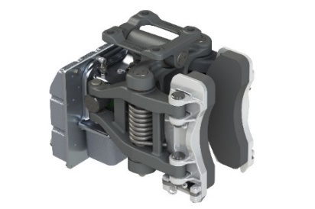

air-free-brake-actuator-copyright-liebherr.jpg

Ready for series production - the air-free brake system from Siemens Mobility and its key component, the air-free brake actuator developed by Liebherr together with Siemens Mobility. © Liebherr

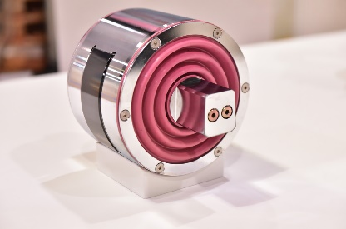

liebherr-transportation-systems-licas-actuator.jpg  
  
LiCAS actuator © Liebherr

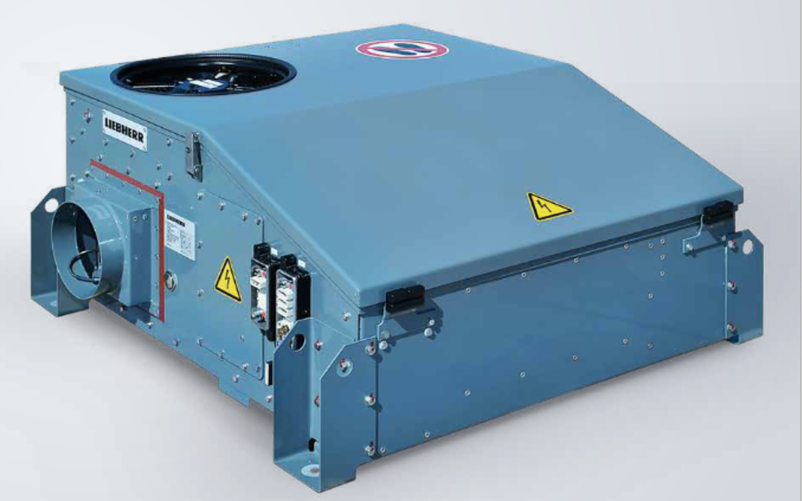

liebherr-roof-mounted-emu-cabin-unit-copyright-liebherr.jpg

The air-conditioning system is based on R290 refrigerant. A first series production-ready version will be available for the market from mid-2023. © Liebherr

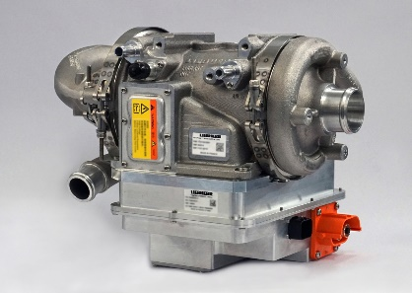

liebherr-compressor-copyright-liebherr.jpg

Turbo compressors from Liebherr can also be used in rail vehicles. © Liebherr

Contact

Ute Braam  
Corporate Communication  
Tel.: +49 8381 / 46 - 4403  
E-Mail: ute.braam@liebherr.com

Published by

Liebherr-Aerospace & Transportation SAS   
Toulouse / France  
www.liebherr.com