Press release

Liebherr shows rail-road excavator for track construction at InnoTrans

⸺

Liebherr rail-road excavator A 924 Rail Litronic as representative of the new generation at InnoTrans

Liebherr attachments and quick coupling system as supplement to the multifunctional machine

ECM certification at Liebherr

Liebherr is presenting the A 924 Rail Litronic, a representative of the new generation of its successful rail-road excavators, at InnoTrans 2022 in Berlin. The machine can be used both on rail and on road. To complement the versatile machine, Liebherr will be showing numerous attachments as well as a quick coupling system for a wide range of applications. In addition, trade fair visitors can obtain comprehensive information about ECM certification on site.

Berlin (Germany), September 2022 – The trade fair exhibit A 924 Rail Litronic has an operating weight of 21,800 kg to 25,000 kg. The machine is equipped with a 120 kW / 163 hp strong and robust engine. In combination with the optimally coordinated hydraulic system, the machine reach constantly high work speeds with the usual fluid working movements. For exhaust emission stage V Liebherr uses a newly developed SCRT system comprising a SCR catalytic converter and a standard particulate filter. The innovative hydraulic concept consists of a Liebherr variable displacement double pump with independent control circuits. High-performance, hydraulic attachments can thus be operated independently of the working and travel movements of the machines.

The rail travel drive is mounted on either side of the undercarriage. During unloading the rail guide is lowered in axle pairs until the inner wheels of the dual tyres are at the track wheel and ensure a frictional connection of the travel drive.

The service-orientated layout of the machine guarantees short maintenance periods and minimises the associated costs thanks to the time savings. All maintenance points are easily accessed from the ground.

As occupational safety plays an important role in track construction, Liebherr offers safety systems specially developed in-house for rail applications. Numerous equipment features such as the pipe break protection on the lifting and stick cylinders, electronic height and turning radius limitation, load moment limitation i.a.w. EN 15746-2, impact-resistant roof panel made of laminated safety glass, rollover protection system (ROPS) and an emergency exit through the rear window provide maximum safety in all operations.

Numerous Liebherr attachments and quick coupling system

Liebherr offers a comprehensive portfolio of attachments to meet the various construction site requirements economically and reliably. With the fully hydraulic Liebherr quick coupling system LIKUFIX® both mechanical and hydraulic attachments can be changed quickly and safely from the operator's cab. The A 924 Rail exhibited at InnoTrans is equipped with LIKUFIX®. Liebherr will also be presenting a wide range of attachments on its stand.

Liebherr tilt unit LiTiU and LS 12 stick extension

One of these, for example, is the Liebherr LiTiU slewing unit. This increases the functionality of attachments by providing an additional slewing angle of up to 2 x 50°. This is a huge advantage especially in track construction where there are generally more restrictions due to the rail infrastructure. LiTiU extends the working range of the machines, because even hard-to-reach places can be worked with the additionally generated swivel angle.

At the trade fair LiTiU 33 is showcased as a sandwich attachment, i.e. the connection between the end of the stick and LiTiU, and the connection between the bottom of the LiTiU and the attachment are made via LIKUFIX® .This means the entire unit can be set down quickly and a different attachment, such as the Liebherr stick extension, attached and operational within seconds. The 2.25 metre long Liebherr LS 12 arm extension, which can also be used to extend the working radius of the rail-road excavator, will be on display at InnoTrans. In combination with the stick extension, the machine achieves a reach of about 10 metres and can thus also work on distant sites.

GMZ 22 clamshell bucket and TR 20 pivot rotator

The Liebherr GMZ 22 clamshell buckets are also designed for track construction. The new generation will be presented at the trade fair: for example, hydraulic lines that are tightly fitted to the sides and laid in a protected manner ensure a reduced risk of damage. The new lean design of the ejectors with improved linkage for the grapples, combination and track construction buckets as well as the tilted side plates, lead to more efficient and less resistant grabbing as well as optimised loading and unloading operations. Liebherr will be exhibiting the GMZ 22 with digging shells at the fair. The cutting width of the attachment is 600 mm and the grab capacity is 0.30 m³.

Pivot rotators are also indispensable for track construction work today. Liebherr will be exhibiting the TR 20 pivot rotator at the fair. With its endless 360° rotatability, the patented slewing mechanism and the tilt angle of 2 x 50°, it offers maximum flexibility, especially for shaft work.

ECM certification at Liebherr

In order to be able to operate in rail transport, compliance with strict rules and regulations is required in addition to the comprehensive machine safety systems. In 2019, the EU Commission initiated a new directive intended to further enhance safety in railway traffic and to improve interoperability. The new EU ECM directive (Entity in Charge of Maintenance) now places responsibility on the owners of rail-road excavators. The DVO (EU) 2019/779, also called the ECM directive, applies to railway vehicles, which operate on the higher-level network. Liebherr rail-road excavators will also fall under this new certification requirement in the future

Successful ECM certification will enable Liebherr-Hydraulikbagger GmbH to continue giving customers competent consultation and support. Successful certification also means that Liebherr sales and service partners will remain authorised and trained to perform repairs, annual inspections and revisions on Liebherr rail-road excavators. Liebherr-Mietpartner GmbH and Carl Beutlhauser Baumaschinen GmbH are also certified as official ECM entities. This will ensure that Liebherr rail-road excavators also remain available to customers for rental.

About the Liebherr Group

The Liebherr Group is a family-run technology company with a highly diversified product portfolio. The company is one of the largest construction equipment manufacturers in the world. It also provides high-quality and user-oriented products and services in a wide range of other areas. The Liebherr Group includes over 140 companies across all continents. In 2021, it employed more than 49,000 staff and achieved combined revenues of over 11.6 billion euros. Liebherr was founded in Kirchdorf an der Iller in Southern Germany in 1949. Since then, the employees have been pursuing the goal of achieving continuous technological innovation, and bringing industry-leading solutions to its customers.

Images

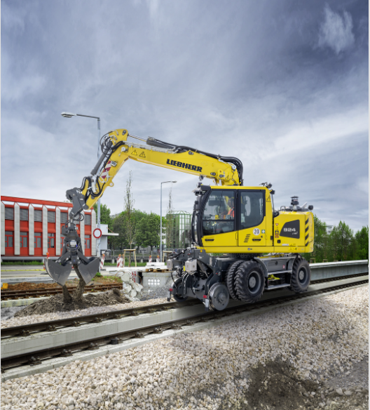

liebherr-a924rail-innotrans.jpg  
Liebherr is presenting the A 924 Rail Litronic at InnoTrans, a representative of the new generation of its successful rail-road excavators.

Contact

Nadine Willbuger  
Marketing  
Phone: +49 7354 / 80 - 7332  
E-Mail: nadine.willlburger@liebherr.com

Published by

Liebherr-Hydraulikbagger GmbH   
Kirchdorf an der Iller / Germany  
www.liebherr.com