Press release

Liebherr presents new 55 kW compressor

⸺

* Liebherr introduces a new electric compressor for hydrogen-powered commercial and construction vehicles.
* The newly development provides a higher oxygen partial pressure as compared to compressors for combustion engines.

**Liebherr’s new 55 kW compressor is based on a mature system with an optimised cost-effective and standardised design that can be tailored to specific requirements at reduced costs.**

Nussbaumen (Schweiz), September 22, 2022 – Liebherr’s two centres of excellence - Liebherr-Aerospace Toulouse (France), the specialist for air and thermal management systems, and Liebherr-Elektronik GmbH (Germany), the specialist for controllers and power electronics, have joined forces to develop the new 55 kW electrical compressor. Thereby, both product segments cooperate with major automotive, truck and bus manufacturers. The compressor finds its use in railway, ships, long haul buses, trucks, off road vehicles or stationary applications.

The compressor offers several benefits: durability, high reliability, optimised operating performance and versatility. “Our compressor offers an outstanding performance with a guaranteed pressure ratio of more than 3:1 and an airflow of 500 g to 600 g per second with a nominal input voltage range of 700 VDC to 760 VDC”, says Herve Barthelemy, Turbomachinery Manager, Liebherr-Aerospace Toulouse. In addition, the generic design of the 55 kW compressor can be customised to meet specific user requirements.

Series production in planning

The first serial production of electrical compressors is planned to start in early 2023. Following the market growth, Liebherr has prepared its product line and processes for higher production volumes. The company has fully integrated production capacity, allowing the highest flexibility during the production phases.

“Our customer support facilities are located in Europe, North and South America, the Middle East and Asia. This allows us to sustain the dynamic growth of the market and to be as close as possible to the customers”, explains Willem de Grooth, Business Development Manager, Liebherr-Aerospace Toulouse.

About Liebherr-Aerospace & Transportation

Liebherr-Aerospace & Transportation SAS, Toulouse (France), is one of eleven divisional control companies within the Liebherr Group and coordinates all activities in the aerospace and transportation systems sectors.

Liebherr-Aerospace is a leading supplier of systems for the aviation industry and has more than six decades of experience in this field. The range of aviation equipment produced by Liebherr for the civil and defense sectors includes flight control and actuation systems, gears and gearboxes, landing gear and air management systems as well as electronics. These systems are deployed in wide-bodied aircraft, single aisle and regional aircraft, business jets, defense aircraft, defense transporters, defense training aircraft and civil and defense helicopters.

Liebherr’s aerospace and transportation systems division employs around 6,000 people. It has four aviation equipment production plants at Lindenberg (Germany), Toulouse (France), Guaratinguetá (Brazil) and Nizhny Novgorod (Russia). These production sites offer a worldwide service with additional customer service centers in – among others - Saline (Michigan/USA), Seattle (Washington/USA), Montreal (Canada), Hamburg (Germany), Dubai (UAE), Bangalore (India), Singapore and Shanghai (People’s Republic of China).

About Liebherr-Components

In this segment, the Liebherr Group specialises in the development, design, manufacturing of high-performance components in the field of mechanical, hydraulic and electric drive and control technology. Liebherr-Component Technologies AG, based in Bulle (Switzerland), coordinates all activities in the Components product segment.

The extensive product range includes combustion engines, injection systems, engine control units, axial piston pumps and motors, hydraulic cylinders, slewing bearings, gearboxes and winches, switchgear, electronic and power electronics components, and software. The high-quality components are used in cranes and earthmoving machinery, in the mining industry, maritime applications, wind turbines, automotive engineering or in aviation and transport technology. Synergy effects in s other product segments of the Liebherr Group are used to drive continuous technological development.

About the Liebherr Group

The Liebherr Group is a family-run technology company with a highly diversified product portfolio. The company is one of the largest construction equipment manufacturers in the world. It also provides high-quality and user-oriented products and services in a wide range of other areas. The Liebherr Group includes over 140 companies across all continents. In 2021, it employed more than 49,000 staff and achieved combined revenues of over 11.6 billion euros. Liebherr was founded in Kirchdorf an der Iller in Southern Germany in 1949. Since then, the employees have been pursuing the goal of achieving continuous technological innovation, and bringing industry-leading solutions to its customers.

Image

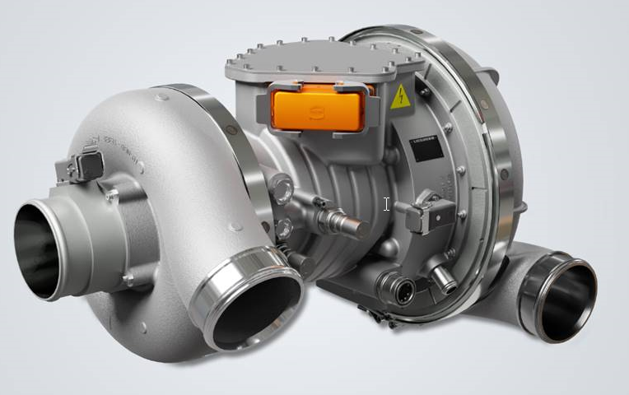

liebherr-compressor-55kw-april2022.jpg  
Liebherr’s 55 kW compressor can be tailored to specific requirements.

Contact

Ute Braam

Corporate Communication

Phone: +49 8381 / 46 – 4403

E-mail: [ute.braam@liebherr.com](mailto:ute.braam@liebherr.com)

Alexandra Nolde

Senior Communication & Media Specialist

Phone: +41 56 296 4326

E-mail: [alexandra.nolde@liebherr.com](mailto:alexandra.nolde@liebherr.com)

Published by

Liebherr-Aerospace & Transportation SAS

Toulouse / France

[www.liebherr.com](http://www.liebherr.com)

Liebherr-Components AG  
Nussbaumen / Switzerland  
[www.liebherr.com/components](http://www.liebherr.com/components)