Press release

Liebherr sending three additional LHMs to Noatum terminals in Spain

⸺

Two LHM 420 and one LHM 550 are being shipped to Noatum Terminals in the West Mediterranean

The three LHM models are joining an LHM 420 that was deployed earlier in the year and is operating at Noatum Terminal Sagunto

With the flexibility to handle bulk, containers, project cargo, and more, Liebherr’s LHM mobile harbour cranes are among the most popular in the portfolio due to their adaptability in handling the most common cargo types at port terminals

The first crane arrived on January 5, 2022. Three new Liebherr mobile harbour cranes are joining the fleet at Noatum port terminals in Castellon, Sagunto and Tarragona. The cranes will enable the terminals to improve their handling efficiency for various cargo types.

Rostock (Germany), 26 September 2022 – Boarding the Heavy Load Carrier MERI in the morning hours of September 5, three Liebherr mobile harbour cranes were prepared for their journey to Spain. Three terminals operated by the Spanish company will benefit from the performance of the LHM 420 and LHM 550 models.

**Operations for a variety of cargo, supported by Liebherr cranes**

Port terminals operated by Noatum support a variety of commodities around their global supply chain. Agricultural goods, minerals in bulk, steel, project cargo, and, containers, and more are all part of their logistic network. With their carrying capacity of 124 and 144 tonnes, respectively, the LHM 420 and LHM 550 can lift and handle a variety of cargo.

**Improved productivity and reduced energy consumption part of hallmark outcomes**

Liebherr mobile harbour cranes offer effective solutions for reduced energy consumption while improving cargo handling productivity. This is in part achieved by Liebherr’s proprietary hydrostatic drive, in which closed hydraulic loops are used for all main functions such as lifting, turning and luffing. The hydrostatic drive allows the operator extremely precise control. Additionally, service personnel benefit from a minimum number of components, and the operating company benefits from reduced fuel consumption.

Juan Carlos Jiménez, Divisional Manager Maritime Cranes in Liebherr Ibérica, remarks: “Liebherr is pleased to contribute to our customers’ strategic value to provide continuous improvements. For our Spanish client Noatum, this includes supporting them in their aim to reduce their overall environmental footprint while still meeting the demands of increased global cargo traffic both in terms of volume and mass. The LHM 420 and LHM 550 meet their specific tonnage and diverse cargo needs at their Castellon, Sagunto and Tarragona terminals. With the LHM 420 model alone, they anticipate an improvement in productivity of up to 38 containers per hour.”

About Liebherr-MCCtec Rostock GmbH

Liebherr-MCCtec Rostock GmbH is one of the leading European manufacturers of maritime handling solutions. The product range includes ship, mobile harbour and offshore cranes. Reach stackers and components for container cranes are also included in the product portfolio.

About the Liebherr Group

The Liebherr Group is a family-run technology company with a broadly diversified product range. The company is one of the largest construction machinery manufacturers in the world. However, it also offers high-quality, user-oriented products and services in many other areas. Today, the group comprises more than 140 companies on all continents. In 2021, it employed more than 49,000 people and generated a total consolidated turnover of over 11.6 billion euros. Liebherr was founded in 1949 in Kirchdorf an der Iller in southern Germany. Since then, the employees have pursued the goal of convincing their customers with sophisticated solutions and contributing to technological progress.

Images

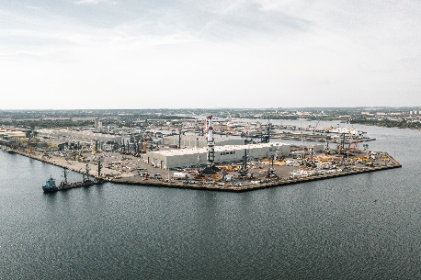

liebherr-lhm-rostock-port-noatum-spain-1.jpg  
The port of Rostock serves as one of Liebherr’s central maritime production locations, effectively connected to global water shipping lanes.

Ein Bild, das Wasser, Boot, Himmel, draußen enthält.

liebherr-lhm-rostock-port-noatum-spain-2.jpg  
Two Liebherr LHM 420 and one LHM 550 are being loaded onto the Heavy Load Carrier MERI for transport to Spain.

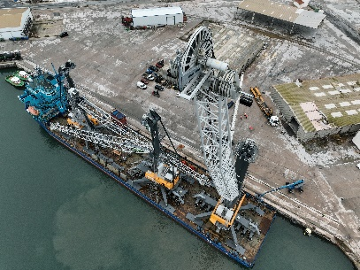

liebherr-lhm-castellon-port-noatum-spain-1.jpg  
Arriving at the port in Castellon, the three Liebherr mobile harbour cranes get ready to be unloaded in Spain.

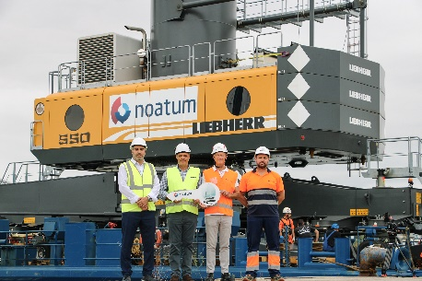

liebherr-lhm-castellon-port-noatum-spain-2.jpg  
The two LHM 420 and one LHM 550 join a fleet that will be operating at three different Noatum terminals in Spain (f.l.t.r. Marco Gonzalez, Liebherr Sales Manager for Maritime Cranes at LIB; Juan Carlos Jiménez, Liebherr Divisional Manager for Maritime Cranes at LIB; Oscar Magdalena, Noatum Terminal Manager in Castellon Port; David Jiménez, Noatum Maintenance Manager in Castellon Port).

Contact

Mathias Haugner

Tel: +49 381 6006 5036

Email: mathias.haugner@liebherr.com

Published by

Liebherr-MCCtec Rostock GmbH

Rostock / Germany

www.liebherr.com