Press release

360° for 100% comfort: Liebherr surround view system for mobile machines

⸺

* Liebherr-Components introduces LiXplore® as the new range of digital camera-monitor solutions
* LiXplore Bird’s Eye as 360° variant offers machine operators an ideal surround view and allows users an easy and fast calibration
* Key component of the systems is the MDC3 digital smart camera, which stands out with its consistently high image quality

**At Bauma 2022, Liebherr's components product segment will be introducing LiXplore®, its new range of digital camera-monitor system. Depending on their needs, users can choose between different versions and intelligent additional functions. The proven components - the digital smart camera MDC3 and display controller DC5 – DC5 ensure the robustness and quality of the entire system.**

Nussbaumen (Switzerland), 26. September 2022 - The permanent and precise monitoring of work processes and routes is a challenge for the operators of mobile machines. Whether construction equipment, agricultural machinery or forklifts, blind spots due to the size of the machine, as well as obstacles in the field of vision impair the view from the cab. Demanding environmental conditions, such as vibration, strong temperature fluctuations and humidity add to the difficulty.

Camera-monitor systems are an ideal solution, when it comes to monitoring work processes at several operating sites simultaneously. They can display multiple views on one single monitor, for example the rear and boom of a harvesting machine. The advantage of digital camera technology over the analogue one is image quality and sharpness. High-resolution cameras by Liebherr provide detailed images and result in more efficiency and comfort for the operator.

"For more than ten years, we have been producing digital Ethernet cameras and displays for mobile machinery. We are now merging our experience and expertise into the LiXplore® product line," says Alexander Bertsch, Head of the Sensor Product Line at Liebherr-Elektronik GmbH in Lindau (Germany). Liebherr’s camera-monitor systems offer a high degree of flexibility. From the number of digital cameras, the field of view angles to the size of the display - users can put together their system according to their requirements.

**360° variant as an intelligent assistance system**

The 360° variant LiXplore® Bird's Eye variant offers operators a complete surround view of their machine's working environment. The system seamlessly merges the images from four mounted cameras into one single bird's-eye view. Compared to conventional, mostly analogue, surround view solutions that require an additional electronic control unit (ECU), the system is thus simple in design and economically wired.

In addition to the the classical bird's eye view, the system allows users to define detailed views and overlays according to their requirements and to assign the corresponding function keys to the display. Operators can switch between views quickly and intuitively at the touch of a button.

**Simple and time-saving calibration**

Prior to operation, users first have to adjust or calibrate their surround view system - a time-consuming task that should not be underestimated, especially with a large fleet of machines. When developing Bird's Eye, Liebherr's components product segment, therefore, attached great importance to a simple system that can be calibrated within a few minutes. The calibration mats do not have to be precisely placed, nor do the distances to other objects have to be measured. Bird's Eye is thus ideal for anyone, who wants to save time and money with a streamlined commissioning process.

**MDC3 digital smart camera: the heart of the system**

For the LiXplore product series, Liebherr relies on the high-performance MDC3 camera. The HDR functionality continuously ensures high-contrast images without overexposure or underexposure, even in very dark working environments and in volatile light conditions from bright to dark. The highly robust cameras are based on years of experience derived from operation in challenging industries, such as construction or agricultural machinery.

Liebherr will present the new range of camera-monitor systems from 24 to 30 October at Bauma 2022 in Munich (hall A4, booth 326).

About Liebherr-Components

In this segment, the Liebherr Group specialises in the development, design, manufacturing of high-performance components in the field of mechanical, hydraulic and electric drive and control technology. Liebherr-Component Technologies AG, based in Bulle (Switzerland), coordinates all activities in the components product segment.

The extensive product range includes combustion engines, injection systems, engine control units, axial piston pumps and motors, hydraulic cylinders, slewing bearings, gearboxes and winches, switchgear, electronic and power electronics components, and software. The high-quality components are used in cranes and earthmoving machinery, in the mining industry, maritime applications, wind turbines, automotive engineering or in aviation and transport technology. Synergy effects in s other product segments of the Liebherr Group are used to drive continuous technological development.

About the Liebherr Group

The Liebherr Group is a family-run technology company with a highly diversified product portfolio. The company is one of the largest construction equipment manufacturers in the world. It also provides high-quality and user-oriented products and services in a wide range of other areas. The Liebherr Group includes over 140 companies across all continents. In 2021, it employed more than 49,000 staff and achieved combined revenues of over 11.6 billion euros. Liebherr was founded in Kirchdorf an der Iller in Southern Germany in 1949. Since then, the employees have been pursuing the goal of achieving continuous technological innovation, and bringing industry-leading solutions to its customers.

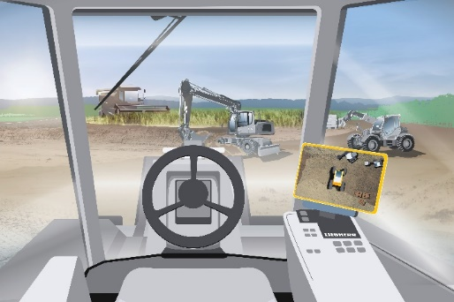**Image**

liebherr-lixplore-birds eye.jpg

All around in the picture: The LiXplore Bird's Eye 360° digital camera system offers more comfort to machine operators by providing a complete surround view of the working environment of their machines.

Contact

Alexandra Nolde

Senior Communication & Media Specialist

Phone: +41 56 296 4326

E-mail: [alexandra.nolde@liebherr.com](mailto:alexandra.nolde@liebherr.com)

Published by

Liebherr-Components AG

Nussbaumen / Switzerland

[www.liebherr.com](http://www.liebherr.com/lixplore)