Press release

HLC 295000:
Swift and capable

⸺
Heavy-lift crane HLC 295000 successfully completes first offshore projects
Installation of XXL-monopiles possible in less than 24 hours
First jacket foundation and platform installations completed

With the installation of the largest monopiles ever produced in Europe and the lifting of a substation platform, the heavy lift crane HLC 295000 has successfully completed its first two offshore missions in the wind energy sector. The jobs took place at the german wind farm Arcadis Ost 1 and the french wind farm Fécamp.
Rostock (Germany), September 2022 - With the offshore crane HLC 295000 and its modern technologies, the Orion is currently considered the most innovative vessel in the offshore wind industry. Now ship and crane have successfully completed its first missions.
In mid-August, the Orion first set down the 1,300-tonne jacket foundation on the prepared seabed with its HLC 295000 for the French offshore wind farm Fécamp. Then a 2,200-tonne transformer platform was successfully installed on the foundation. It was particularly important not to lose sight of the tight schedule and the weather conditions in Normandy, which was achieved not least thanks to the good dynamic positional (DP) system of the Orion and the high precision in the control of the
HLC 295000.
Monopile installation in record time
Only a few weeks earlier, the offshore insatallation vessel and its Liebherr heavy lift crane crane were able to demonstrate their flexibility and performance in the wind energy sector for the first time. At the Arcadis Ost 1 wind farm in the German Baltic Sea, the HLC 295000 was used to install 28 monopile foundations. There, monopiles with lengths of up to 110 metres and a weight of up to 2,100 tonnes had to be moved and positioned for installation in the seabed. The innovation of the Orion is the ability to install the monopiles floating. This means that no time-consuming jack-up process of the ship out of the water is necessary, as it has been the case up to now with so-called jack-up units. Right from the start, it became evident how reliable and powerful the HLC 295000 is. It was often in use for 24 hours continuously.

"We are very proud of this lighthouse project and look forward to seeing the HLC 295000 in action. Our initial experience indicates that the installation times of previous vessels of about 3 to 3.5 days per monopile can be significantly reduced to about 0.9 to 1 day per monopile with the use of the Orion and our HLC," says Robert Pitschmann, Global Application Manager, Liebherr-MCCtec Rostock GmbH.
Engagement at both ends of the energy transition
With a maximum lifting capacity of up to 5,000 tonnes and a maximum lifting height of 175 metres above deck, the HLC 295000 is the largest offshore crane Liebherr has ever manufactured. The
HLC series and the expansion of the heavy-duty crane range are firmly anchored in Liebherr's strategy, not least because of the energy transition. In order to ensure a sustainable energy supply for present and future generations, significantly more and larger offshore wind turbines are being built. For the construction of these modern wind turbines, the lifting height of the HLC 295000 is a decisive factor. In addition, there is a trend towards decommissioning disused offshore oil and gas platforms. This involves dismantling large and heavy parts on the open sea - an important task for Liebherr's new HLC series, which it can handle thanks to its lifting capacities. By dismantling the old and building up the new energy, the HLC series can promote the energy transition "at both ends of development" for a more sustainable future.

About Liebherr-MCCtec Rostock GmbH
Liebherr-MCCtec Rostock GmbH is one of the leading European manufacturers of maritime material handling solutions. The product range includes ship cranes, mobile harbour canes and offshore cranes. In addition, components for container cranes are included in the product portfolio.
About the Liebherr Group
he Liebherr Group is a family-run technology company with a highly diversified product portfolio. The company is one of the largest construction equipment manufacturers in the world. It also provides high-quality and user-oriented products and services in a wide range of other areas. The Liebherr Group includes over 140 companies across all continents. In 2021, it employed more than 49,000 staff and achieved combined revenues of over 11.6 billion euros. Liebherr was founded in Kirchdorf an der Iller in Southern Germany in 1949. Since then, the employees have been pursuing the goal of achieving continuous technological innovation, and bringing industry-leading solutions to its customers.

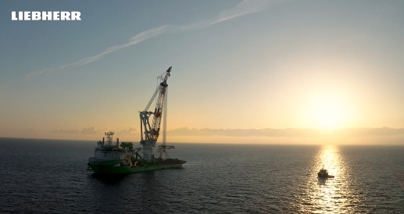
Movie-Link:

Rise of a giant: https://youtu.be/xfJLsm6bIIw
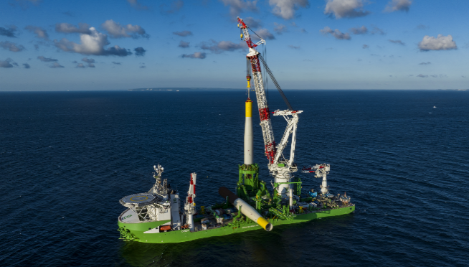
Images

liebherr-deme-orion-installation-monopiles-arcadis-ost-germany.jpg
Floating monopile installation at the German wind farm Arcadis Ost 1. Photo: Deme
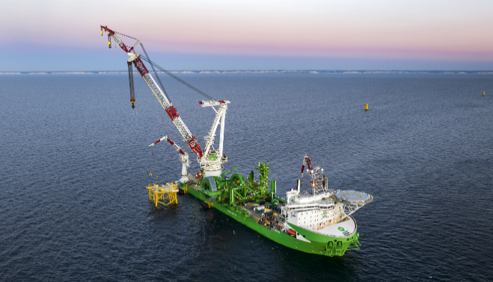

liebherr-deme-orion-installation-substation-fecamp-france.jpg
Installation of a substation at the French wind farm Fècamp. Photo: Deme

Contact
Dieter Schmidt
Public Relations Manager
Phone: +49 381 6006 5021
E-Mail: dieter.schmidt@liebherr.com

Published by
Liebherr-MCCtec Rostock GmbH
Rostock / Germany
www.liebherr.com

