Press release

Liebherr presents new LH 26 M Timber Litronic timber truck

⸺
Powerful machine for efficient timber handling
Thanks to its compact design, it is predestined for use in sawmills and woodworking shops with limited space
As the smallest representative, complements the existing portfolio of timber tractors in the 25-tonne range
Liebherr presents the LH 26 M Timber Litronic, a new special machine for efficient timber handling. Thanks to its extremely compact design and exceptional manoeuvrability, the LH 26 M Timber is predestined for work in sawmills and timber operations with limited space. The handling machine impresses with extremely low fuel consumption and maximum performance at the same time.
Kirchdorf an der Iller (Germany), 29 September 2022 - Whether as fuel, construction element or piece of furniture: wood is a climate-friendly and popular all-rounder. For efficient timber handling, Liebherr offers a wide portfolio of powerful and efficient special machines that are ideally suited for typical work processes such as loading and unloading trucks and trailers, sorting logs or transport. For these activities, good driving performance, high payloads as well as fast working cycles are particularly in demand. With the LH 26 M Timber Litronic, Liebherr is presenting a new timber truck that extends the existing portfolio downwards with an operating weight of between 23,500 and 26,000 kg.
Machine combines high driving performance, compact dimensions and manoeuvrability
The engine power of 125 kW provides the system with a high torque. This means that the machine can be accelerated quickly. In combination with the high pump flow rate, fast and dynamic working movements and thus the highest handling performance are guaranteed.
Thanks to its compact design, the machine is ideally suited for use especially in confined spaces. Due to the extremely small front and rear swing radius, the machine can be completely swivelled even in tight locations. The minimal contour of the right front in particular means that work can be carried out very close to the sorting string or pile, as this is always within the width of the undercarriage. This provides an excellent view of the working area, ensures additional safety and prevents collisions.
For high manoeuvrability, the LH 26 M Timber is equipped with all-wheel steering as standard. The all-wheel steering increases driving stability and thus improves directional stability. The automatic steering reversal, which is also standard, guarantees the correct steering direction at all times when driving forwards or backwards.
Optimised undercarriage concept and efficient driving operation for trailer operation
The electric swing angle adjustment in the traction motor provides more torque, maximum acceleration and higher tractive effort. This ensures a constantly high driving performance even on slopes. The optimal adjustment of speed and flow rate ensures convincing fuel efficiency even at maximum speed.
For longer distances, the combination of timber tractor and trailer is the optimal choice. Thanks to the powerful drive and the robust axles, trailers weighing up to 60 tonnes can be towed. The new undercarriage concept with 2-point blade support significantly increases the handling performance in trailer operation. The 2-point blade support guarantees maximum stability as well as high payloads when loading and unloading the trailer over the entire swivel range. This allows more timber to be handled per loading cycle and thus increases productivity. The blade can additionally be used for clearing work and thus increases safety in the timber yard.
About the Liebherr Group
The Liebherr Group is a family-run technology company with a highly diversified product portfolio. The company is one of the largest construction equipment manufacturers in the world. It also provides high-quality and user-oriented products and services in a wide range of other areas. The Liebherr Group includes over 140 companies across all continents. In 2021, it employed more than 49,000 staff and achieved combined revenues of over 11.6 billion euros. Liebherr was founded in Kirchdorf an der Iller in Southern Germany in 1949. Since then, the employees have been pursuing the goal of achieving continuous technological innovation, and bringing industry-leading solutions to its customers.
Images
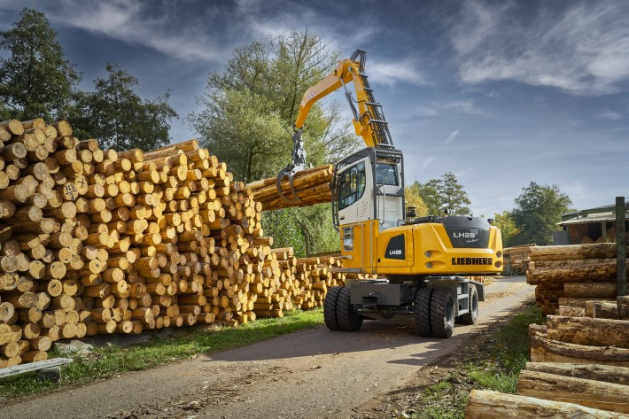
liebherr-lh-26-m-timber-litronic.jpg
Liebherr is expanding its portfolio in the field of timber tractors and presents the new LH 26 M Timber Litronic.

Contact
Nadine Willburger
Marketing
Phone: +49 7354 / 80 - 7332
E-mail: nadine.willburger@liebherr.com
Published by
Liebherr-Hydraulic Excavator GmbH
Kirchdorf an der Iller / Germany
www.liebherr.com

