Press release

Liebherr to premiere its hydrogen prototype engines at Bauma 2022

⸺

The Liebherr components product segment introduces the first prototypes of hydrogen combustion engines, the H964 and H966, at this year’s Bauma

The H966 prototype powers Liebherr’s first hydrogen-driven crawler excavator

At Bauma 2022, the Liebherr components product segment is introducing two prototypes of its hydrogen engine for tomorrow’s construction sites. Each prototype employs different hydrogen injection technologies, a direct injection (DI) and a port fuel injection (PFI).

Nussbaumen (Switzerland), 10. October, 2022 - In the future, combustion engines will no longer be powered solely by fossil diesel. In order to achieve climate neutrality by 2050, fuels from sustainable energy sources will have to be used. Green hydrogen is one of them, since it is a promising carbon-free fuel, which does not cause any CO2 emissions whilst burning inside the internal combustion engine (ICE). Liebherr’s expertise in the development of ICEs will furthermore facilitate a quick introduction of hydrogen technologies to the market.

Hydrogen engines: a promising future

The Liebherr components product segment has recently made a significant investment into the development of its hydrogen engine and test facilities. Prototype engines have been tested since 2020. Meanwhile, the prototypes have shown encouraging results in terms of performance and emissions, both on test benches and in the field. Different injection and combustion technologies, such as port fuel injection (PFI) and direct injection (DI), have also been assessed in the process. The first prototype construction machines equipped with these engines have been running since 2021.

PFI technology: a starting point in the development

Initial efforts in the development of a hydrogen engine have considered PFI as a first suitable technology. The first machine running with a 100% hydrogen-fuelled ICE is the Liebherr R 9XX H2 crawler excavator. In it, the zero-emission 6-cylinder engine H966 fulfils the specific requirements in terms of power and dynamics. The R 9XX H2 with the H966 engine in its port fuel injection configuration

will be on display at booth 809 – 810 and 812 – 813. Up close, the H966 will be presented there in the InnoLab.

DI: a step towards efficient hydrogen engines

Encouraged by the results achieved with the PFI technology, Liebherr further pursues its research and development activities in the field of DI. The 4-cylinder engine prototype H964 exhibited at the components’ booth 326 in hall A4 is equipped with said technology. In this case, hydrogen is injected directly into the combustion chamber, whereas with the PFI solution it is blown into the air intake port. The DI offers increased potential in terms of combustion efficiency and power density, which makes hydrogen engines an attractive alternative to diesel engines when it comes to more demanding applications.

What is next to come?

The components segment expects to kick off series production of hydrogen engines by 2025. In the meantime, the company sets forth its research activities in fuel injection to further optimise combustion and to ensure maximum power density.

In addition to 100% hydrogen-fuelled engines, several research endeavours in the area of alternative fuels are currently in progress. One example is a dual fuel engine that can run on hydrogen ignited by HVO injection or fully on HVO. This technology will allow for more flexibility in vehicle operation with different configurations.

About Liebherr Machines Bulle SA

Liebherr Machines Bulle SA is the competence centre for combustion engines, as well as hydraulic components (axial piston pumps and motors). The company is part of the Liebherr Group's Components product segment. Located in the canton of Fribourg in Switzerland, the company develops and manufactures high-quality components and systems that are used not only within the Liebherr Group, but also in machines of other manufacturers. Target applications range from earthmoving and civil engineering machines, mining excavators, mobile and crawler cranes, maritime applications, material handling machines to biogas, as well as combined heat and power plants. The focus is highest quality and tailor-made solutions for different requirements.

**About Liebherr-Components**

In this segment, the Liebherr Group specialises in the development, design, manufacturing of high-performance components in the field of mechanical, hydraulic and electric drive and control technology. Liebherr-Component Technologies AG, based in Bulle (Switzerland), coordinates all activities in the Components product segment.

The extensive product range includes combustion engines, injection systems, engine control units, axial piston pumps and motors, hydraulic cylinders, slewing bearings, gearboxes and winches, switchgear, electronic and power electronics components, and software The high-quality components are used in cranes and earthmoving machinery, in the mining industry, maritime applications, wind turbines, automotive engineering or in aviation and transport technology. Synergy effects in other product segments of the Liebherr Group are used to drive continuous technological development.

About the Liebherr Group

The Liebherr Group is a family-run technology company with a highly diversified product portfolio. The company is one of the largest construction equipment manufacturers in the world. It also provides high-quality and user-oriented products and services in a wide range of other areas. The Liebherr Group includes over 140 companies across all continents. In 2021, it employed more than 49,000 staff and achieved combined revenues of over 11.6 billion euros. Liebherr was founded in Kirchdorf an der Iller in Southern Germany in 1949. Since then, the employees have been pursuing the goal of achieving continuous technological innovation, and bringing industry-leading solutions to its customers.

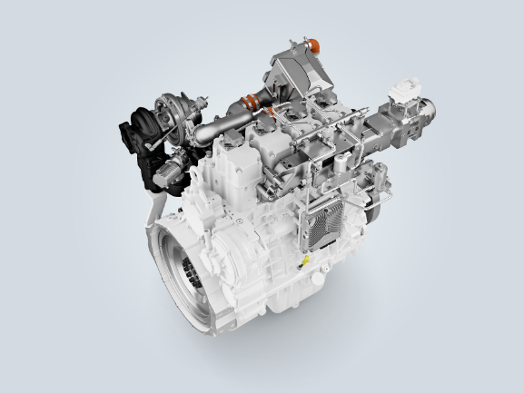Images

liebherr-d964-DI-hydrogen-engine-in-development.jpg  
Liebherr presents its 4-cylinder engine H964 equipped with DI technology at booth 326 in hall A4.

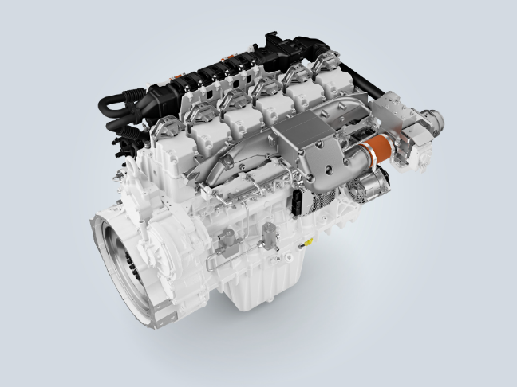

liebherr-h966-PFI-hydrogen-engine-in-development.jpg  
The 6-cylinder prototype of the hydrogen engine H966 is the heart of the first hydrogen-fuelled crawler excavator by Liebherr.

Contact

Alexandra Nolde  
Senior Communication & Media Specialist  
Phone: +41 56 296 4326  
E-mail: alexandra.nolde@liebherr.com

Published by

Liebherr-Components AG  
Nussbaumen / Switzerland  
www.liebherr.com/components