Press release

Liebherr: Technology-neutral drive concepts for the future

⸺

What is the drive technology of the future? Which one will save the most emissions? And is there even one single silver bullet? In fact, there are various technological options for reducing pollutant emissions, which are researched by Liebherr. In its technology-neutral approach, the company takes into account both environmental and the most diverse customer requirements in equal measure, in order to be able to serve different markets and industries. The Liebherr Group presents some of its solutions at this year’s Bauma in Munich.

Biberach / Riss (Germany), 11. October 2022 – The Liebherr Group focuses on the energy carriers available today and in the foreseeable future, as well as their associated low carbon power train solutions – i.e. combustion engines, fuel cell power trains, energy storage systems, power electronics and electric drives. The energy carriers include electrical energy, hydrogen, ammonia, e-fuels, methanol, hydrogenated vegetable oil (HVO), biodiesel and fossil diesel. Liebherr intentionally pursues an approach that is neutral to all technologies, since the choice of the most practical and possibly emission-free solution depends on multiple factors. These include the size, the degree of mobility, the duty cycle of the machine, its use and the available infrastructure to name but a few. Liebherr provides the respective drive train specifically for the application and in accordance with customer needs.

The combustion engine – ready for conventional and alternative fuels

The internal combustion engine (ICE) has been powering a wide variety of stationary and mobile applications since the 19th century. In four steps or cycles, it converts chemical energy into mechanical work by burning a fuel inside its combustion chamber. This technology is particularly suitable for industries and applications requesting high power density, flexibility, reliability, and easy serviceability, in addition to working in harsh environments like earthmoving, construction and mining.

However, when running with diesel, internal combustion engines emit greenhouse gases. These can be reduced, compensated or even avoided e.g. by replacing diesel with renewable fuels produced from sustainable energy sources – provided that they are readily available on the construction site and that the power train can offer a similar power density as the diesel version. The wide range of applications served by diesel-powered machinery today makes it highly probable that there will not be one single alternative fuel that will replace diesel in the future.

When studying the use of various alternative fuels, the Group’s Swiss and French centres of excellence for engine development, Liebherr Machines Bulle SA and Liebherr-Components Colmar, are following a technology-neutral approach. As a first step, both companies already started using biofuels a few years ago, which was closely followed last year by the release of HVO, enabling a reduction of greenhouse gas emissions by up to 90 %. Moreover, synthetic fuels based on renewable energy sources can already save up to 100% CO2. “Today, our customers’ existing fleets are almost exclusively powered by diesel engines. They can refuel their machines with HVO or, in the future, with e-fuels, and thus save emissions without having to replace their fleet,” explains Ulrich Weiss, Managing Director for Research and Development of Combustion Engines at Liebherr Machines Bulle SA.

Liebherr currently develops hydrogen injection systems, as well as complete hydrogen combustion engines, which are planned to be ready for serial production starting from 2025. A demonstration model, the H966, will be presented at Bauma 2022 as part of the R 9XX H2 crawler excavator. Other fuels, such as ammonia and methanol, are seen as promising, given their higher energy density and carbon neutrality as compared to H2. In future, the experience gained from the development and field trials of the hydrogen engine will bring significant benefits to the further development of engines based on specific alternative fuels, or a combination of fuels.

The fuel cell – hydrogen for the electric motor

Hydrogen does not only play a role in combustion engines but is also used for fuel cells. The fuel cell itself contains two electrode plates made of carbon or metal. The plates are coated with a precious metal that serves as a catalyst. Between the electrode plates is an ion conductor, such as ceramic, alkali or acid. Oxygen and fuel – e.g. hydrogen – are continuously supplied via the electrodes. These react with each other, producing water, heat and electricity. This energy is stored and then used to power the electric motors and devices in the machine. Hydrogen-powered fuel cells operate without emissions and come with a higher degree of technical maturity than hydrogen combustion engines. However, such fuel cells have not yet been sufficiently tested for use in construction machinery operating under very demanding environmental conditions.

Since the early 2000’s, Liebherr has been cooperating with major automotive manufacturers to use motorised compressors, including the dedicated power electronics, to provide clean compressed air to the vehicle fuel cell stacks. Liebherr develops this technology e.g. for commercial and construction vehicles, heavy-duty railway vehicles or aerospace applications.

The e-drive – on the road with and without cable

A fully-electric powertrain draws its energy from the grid or from energy and power storage, for example, a battery. Mains-powered machines, such as the new crawler excavator R 976-E, are constantly supplied with electricity via a cable. Such machines can be operated in a climate-neutral manner, if the electricity required is generated from renewable energy sources. However, they reach their limits when machines exceed their operating radius or high mains power is required at short notice.

To enable the energy supply of mobile machines on construction sites with limited or no mains supply, Liebherr develops mobile energy storage systems. These include, for example, the Liduro Power Port. From 2024, the energy storage system will be available in serial production. It will supply machines on construction sites with the required power, charge them during breaks and compensate for peak loads. The energy storage system can be transported as a mobile complete system to construction sites located in urban areas and peripheries. There, it can supplement grid connections or be used autonomously as an island network. At Bauma, the Liduro Power Port will supply power to the LTC and MK mobile cranes as a functional demonstrator.

Challenges for the future

Liebherr has always attached importance to a high degree of vertical integration while concentrating on core processes. For the components product segment, which covers the entire drive train, the technological changes, therefore, have various implications: “On the one hand, we have a broad product portfolio in the Liebherr Group. From the beginning, it has included not only electrically driven machines, but also machines that can be converted relatively quickly to alternative drives. On the other hand, we are also dealing with operating conditions and areas, in which it is currently still very difficult to replace the combustion engine,” explains Gebhard Schwarz, Managing Director for Development and Production at Liebherr-Component Technolgies AG.

His colleague Pietro Iemmi, Managing Director for Sales and Customer Service, adds: “Despite certain indicators, it is difficult to predict exactly, which future technologies will be needed for the machines of tomorrow. For us, as for many other companies, this means understanding the new developments and pushing them in different directions. We see it as our responsibility to develop the necessary technical expertise and bring technologies to market to help our customers design their machines in the best possible way."

The Liebherr Group will be exhibiting some of those drive solutions and their applications at this year’s Bauma in Munich: for example, the electric version of the LTC 1050-3.1 compact crane, which delivers full power electrically or conventionally; the ETM 1205 T and ETM 905 hybrid electric truck mixers; the unplugged versions of the LB 30 and LRH 200 deep foundation machines; the MK 140 5.1 mobile construction crane, which has no emissions in electric construction site operation; the Liduro Power Port or the H966 hydrogen engine, which is presented for the first time in conjunction with a construction machine, the R 9XX H2 crawler excavator.

About Liebherr-Components

In this segment, the Liebherr Group specialises in the development, design, manufacturing of high-performance components in the field of mechanical, hydraulic and electric drive and control technology. Liebherr-Component Technologies AG, based in Bulle (Switzerland), coordinates all activities in the components product segment.

The extensive product range includes combustion engines, injection systems, engine control units, axial piston pumps and motors, hydraulic cylinders, slewing bearings, gearboxes and winches, switchgear, electronic and power electronics components, and software. The high-quality components are used in cranes and earthmoving machinery, in the mining industry, maritime applications, wind turbines, automotive engineering or in aviation and transport technology. Synergy effects in s other product segments of the Liebherr Group are used to drive continuous technological development.

About the Liebherr Group

The Liebherr Group is a family-run technology company with a highly diversified product portfolio. The company is one of the largest construction equipment manufacturers in the world. It also provides high-quality and user-oriented products and services in a wide range of other areas. The Liebherr Group includes over 140 companies across all continents. In 2021, it employed more than 49,000 staff and achieved combined revenues of over 11.6 billion euros. Liebherr was founded in Kirchdorf an der Iller in Southern Germany in 1949. Since then, the employees have been pursuing the goal of achieving continuous technological innovation, and bringing industry-leading solutions to its customers.

Images

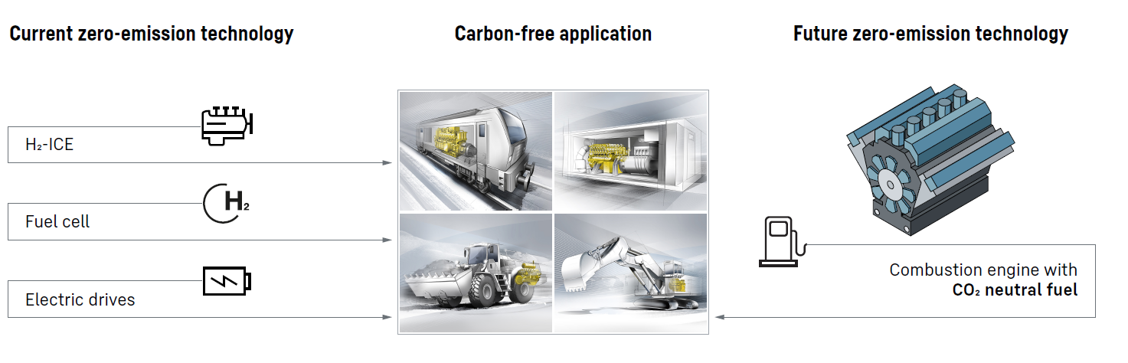

liebherr-file-name.jpg  
In the future, there will be different technologies to achieve the long-term climate goal.

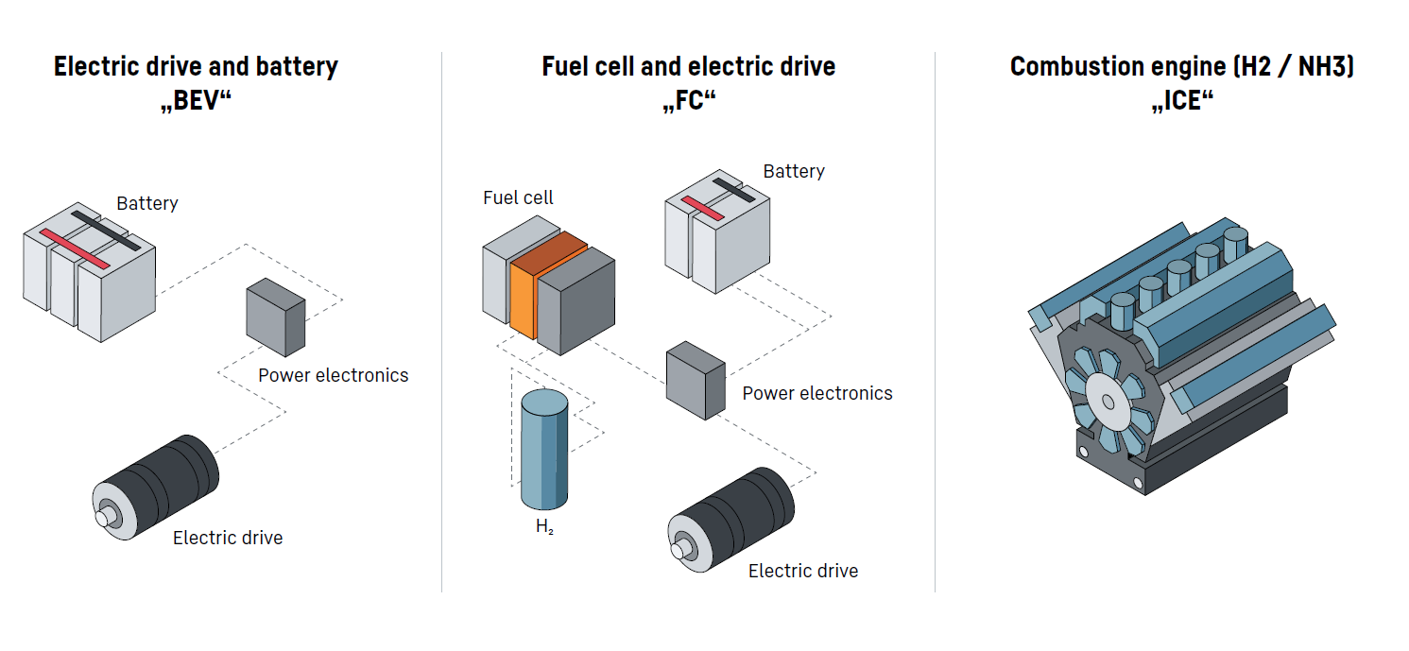

liebherr-drives.jpg  
Three drive solutions that comply with the current CO2 regulations.

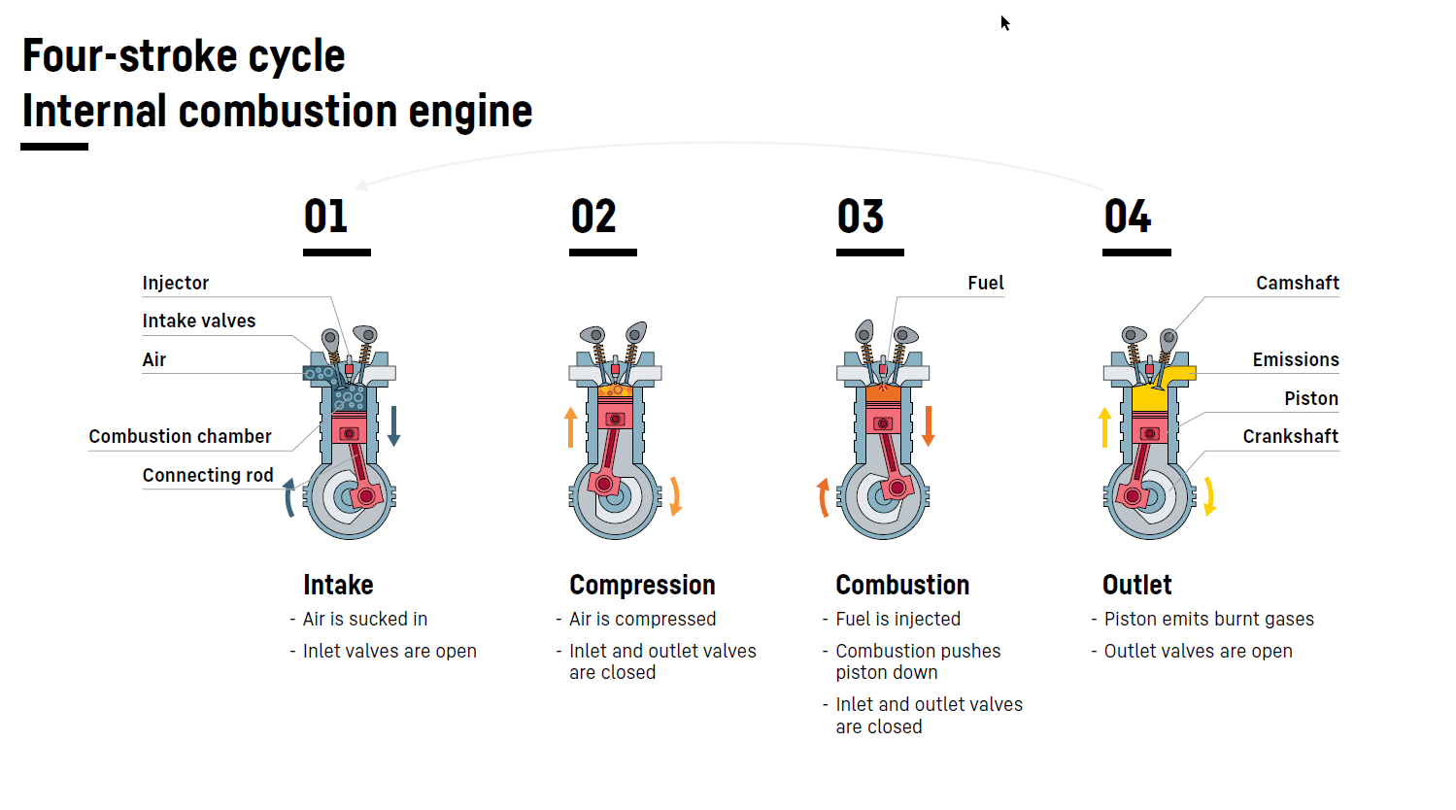

liebherr-combustion-engine.jpg  
Functioning of an internal combustion engine with four-stroke cycle.

Contact

Alexandra Nolde  
Senior Communication & Media Specialist  
Phone: +41 56 296 4326  
email: alexandra.nolde@liebherr.com

Ute Braam  
Leitung Corporate Communications  
Phone: +49 8381 4644-03  
email: ute.braam@liebherr.com

Published by

Liebherr-International Deutschland GmbH   
Biberach an der Riss / Germany  
www.liebherr.com