Press release

Liebherr hydraulic cylinders: just a mouse click away

⸺

* Liebherr offers an online product configurator for the first time
* The configurator is suitable for all three proven series of hydraulic cylinders
* Innovation and further development are always on the forefront

For the first time, Liebherr has made it possible to individually and easily configure all hydraulic cylinder series via an online-based configurator on the company’s website. Depending on the application and requirements, the configurator offers all kinds of variations: from the 380 bar series for mobile applications, the ISO 6022 series for industrial use all the way to the 260 bar series as a link between mobile and stationary applications. While the tool will already be available a couple of weeks before Bauma 2022, its detailed presentation to the public will take place for the first time at the show.

Nussbaumen (Switzerland), 12. October 2022 - The Liebherr-Components’ site in Kirchdorf an der Iller (Germany) has been working specifically on the development and construction of standardised series for quite some time. In doing so, Liebherr experts offer a versatile selection of easily combinable and modular solutions for a wide range of applications. A milestone is the digitalisation of options and features in the form of an online configurator.

**Smart solutions for the right product**

Liebherr-Components Kirchdorf GmbH makes dedicated use of digitisation options to support technicians, buyers and product managers who are specifically looking for a product and need a quick solution. "When it comes to selecting and assembling the right product, the configurator offers assistance through stored logic and targeted user guidance," explains Jan Winter, product manager at Liebherr-Components Kirchdorf GmbH. A corresponding 3D simulation provides the user with an up-to-date visual representation of the result. Should the requirement lie outside the range of the construction series, corresponding options are stored in order to be able to make a special inquiry.

The product configuration is completely anonymous: By means of a self-generating product key, each variation receives its individual "code", which can simply be copied and used for recall. Those who wish to process their configurations further, are able to manage the results in the personal login area, send an inquiry or receive further information about the product. In addition to a clear data sheet, 3D models of the individually configured cylinder can be downloaded immediately to allow the hydraulic cylinder be installed directly in the customer's application.

**Available at any time - no matter where and when**

The configurator is currently available in two languages, German and English, and can be accessed anywhere and at any time via the Liebherr website. In the future, Liebherr intends to make the configurator available in other languages, as well. "If a customer requests a created configuration, this is easily possible via the tool. An offer with the corresponding price is made within one working day of the request," explains Simon Ebner, team leader in sales.

**Looking towards the future**

Last year, the components segment further expanded its product portfolio in the hydraulics sector. In addition to hydraulic cylinders, Liebherr has recently started offering piston accumulators as a standardised series. This creates the ideal conditions for the integration of these products into the configurator and offering them online in the future.

However, the development of the well-known series is ongoing steadily. Liebherr has already ventured into the future by offering products of the 380 bar series in the form of a hybrid cylinder as a separate option - i.e. the classic cylinder in combination with carbon fibre-reinforced plastic. "What was previously not part of the series for mobile applications is now real and fully configurable. This allows users to take advantage of lightweight components in the standard portfolio," summarises Dominic Gottwald, Head of Fiber Composites. "This offering in the form of a configurator is completely new and has not been previously available on the market." An actual hybrid cylinder will also be exhibited at this year's Bauma at booth 326 in hall A4.

About Liebherr-Components

In this segment, the Liebherr Group specialises in the development, design, manufacturing of high-performance components in the field of mechanical, hydraulic and electric drive and control technology. Liebherr-Component Technologies AG, based in Bulle (Switzerland), coordinates all activities in the components product segment.

The extensive product range includes combustion engines, injection systems, engine control units, axial piston pumps and motors, hydraulic cylinders, slewing bearings, gearboxes and winches, switchgear, electronic and power electronics components, and software. The high-quality components are used in cranes and earthmoving machinery, in the mining industry, maritime applications, wind turbines, automotive engineering or in aviation and transport technology. Synergy effects in s other product segments of the Liebherr Group are used to drive continuous technological development.

About the Liebherr Group

The Liebherr Group is a family-run technology company with a highly diversified product portfolio. The company is one of the largest construction equipment manufacturers in the world. It also provides high-quality and user-oriented products and services in a wide range of other areas. The Liebherr Group includes over 140 companies across all continents. In 2021, it employed more than 49,000 staff and achieved combined revenues of over 11.6 billion euros. Liebherr was founded in Kirchdorf an der Iller in Southern Germany in 1949. Since then, the employees have been pursuing the goal of achieving continuous technological innovation, and bringing industry-leading solutions to its customers.

Images

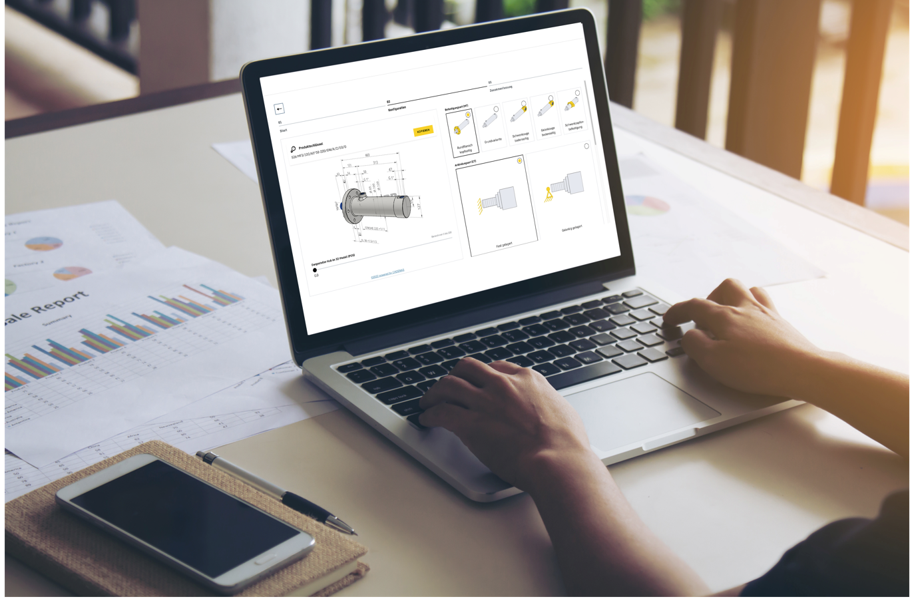

liebherr-hydraulic-cylinder-configurator.jpg

The online configurator for hydraulic cylinders allows for a quick and easy configuration off all standardised series.

Contact

Alexandra Nolde

Senior Communication & Media Specialist

Phone: +41 56 295 / 4326

E-mail: [alexandra.nolde@liebherr.com](mailto:alexandra.nolde@liebherr.com)

Published by

Liebherr-Components AG

Nussbaumen/ Switzerland

[www.liebherr.com](http://www.liebherr.com)