Press release

All-electric LS 800 E ship cranes for SAL "Orca" project

⸺

Liebherr secures order for eight all-electric heavy lift ship cranes type LS 800 E from SAL Heavy Lift

The completely new developed cranes have a maximum lifting capacity of up to 800 tonnes and a radius of up to 39 metres

Continuation of a trusting partnership between the two companies Harren Group and Liebherr that has lasted for decades

SAL Heavy Lift orders eight all-electric heavy lift ship cranes type LS 800 E. As part of the future-oriented "Orca" project, two cranes will be installed on each of SAL's four vessel newbuildings. By combining the capacity of both cranes in tandem mode, cargoes of up to 1,600 tonnes can be handled. The innovative ship cranes will make it possible to lift components of the future project cargo while being prepared for the increasing environmental protection requirements.

Rostock (Germany), October 2022 – The LS 800 E is the latest innovation of Liebherr’s heavy lift ship crane portfolio. The recently launched crane is designed for the ever heavier and larger cargo. Moreover, the all-electric drive concept supports vessel operators in saving CO2 emissions. The order of the first   
LS 800 E ship cranes marks the beginning of a new phase in the long-term partnership between the Harren Group and Liebherr. At the same time, it is SAL Heavy Lift's first newbuilding project with Liebherr. The two family-run companies have been cooperating since the start of this new project for four multipurpose heavy lift vessels. The crane manufacturer was actively involved in the development from day 1. Since the "Orca" class of ship breaks new ground in many respects and will significantly raise the bar in the relevant transport segment, the crane developers were also challenged to rethink many details in addition to general requirements, and performance parameters and to make their contribution to the efficiency and innovation of the ship concept. The result is a perfectly coordinated unit of crane and vessel that enables maximum efficiency and performance.

**All-electric energy efficiency**

Apart from fulfilling the demanding operational requirements and different cargo scenarios, the new Liebherr Ship Cranes enable significant savings in smart interaction with the innovations on the ship side. The new LS 800 E actively communicates with the ship's power management system and thus enables intelligent energy utilisation. Recovered energy is fed back into the ship's energy system and stored so that it can be released when energy consumption is high again. This leads to a noticeably reduced fuel consumption and a considerable reduction of CO2 emissions on the "ORCA" ships. The entire power electronics of the drive system are installed inside the cranes. This allows the limited space below deck to be used for other purposes and noticeable facilitates the integration of the crane into the ship's design.

**Compact design for high durability**

The integration of the entire drive concept inside the crane also significantly increases the durability of the components, as they are protected from the weather. "The reliability of the cranes is extremely important for heavy lift vessels. They must function for the entire life of the vessel. The family-run company Liebherr offers a convincing overall package for this, thanks to its wide-ranging product and technology knowledge as well as its worldwide service network”, explains Dr Martin Harren, CEO of the Harren Group.

Ready for future requirements

The LS 800 E ship cranes expand Liebherr's product portfolio and enter a new segment. They are the largest ship cranes Liebherr has built to date. The cranes are aimed for a growing market of shipping large wind industry components. In the future, these will not be manageable with the lifting capacities and dimensions that have been common in the market so far. Moreover, the supply of heavy lift vessels with cranes of 800 tonnes capacity is lower than the expected future demand. Liebherr has claimed the resulting growth market for itself with the development of the LS 800 E ship crane.

The all-electric drives are already preparing the cranes for future environmental protection requirements in terms of energy efficiency an emissions regulation. "The development of the new cranes combines SAL's user experience and Liebherr's crane construction expertise. The LS 800 E will be the most advanced ship crane in its segment”, comments Gregor Levold, General Manager Sales for Liebherr Offshore, Ship and Port Cranes. "The all-electric heavy lift cranes feature a variety of innovations that simplify maintenance and reduce operating costs. At the same time, they are characterised by innovative as well as environmentally friendly drive technology”, adds Levold.

Cooperation with history

The cooperation between Liebherr and the Bremer Harren Group began back in the late 1990s with the delivery of the first 40-tonne ship cranes for container vessels. This was followed by a large order for 24 Liebherr heavy lift cranes for use on multipurpose vessels in 2006 and 2007. Since then, a trusting partnership has developed between the two companies on an equal footing, which was further expanded in the transport sector with Harren's acquisition of SAL Heavy Lift. Dr Martin Harren comments as follows: "The cooperation between SAL and Liebherr is characterised by great commitment and mutual trust." Jan Breckling, Senior Sales Manager at Liebherr Maritime Cranes, adds: "SAL is a reliable and competent partner with whom we work intensively in all areas and maintain close contact between the people involved. By ordering the LS 800 E ship cranes, we can jointly shape the future of heavy lift and project shipping."

About SAL Heavy Lift

SAL Heavy Lift, a member of the Harren Group and part of the Jumbo SAL Alliance, is one of the world's leading heavy lift shipping companies headquartered in Hamburg. Specialising in the shipment of project and heavy lift cargo, SAL offers tailor-made transport solutions worldwide. Jumbo-SAL-Alliance owns and operates a versatile fleet of 30 modern project cargo vessels with a lifting capacity of up to 3,000 t SWL.

About Liebherr-MCCtec Rostock GmbH

Liebherr-MCCtec Rostock GmbH is one of the leading European manufacturers of maritime handling solutions. The product range includes ship, mobile harbour and offshore cranes. Reach stackers and components for container cranes are also included in the product portfolio.

About the Liebherr Group

The Liebherr Group is a family-run technology company with a highly diversified product portfolio. The company is one of the largest construction machinery manufacturers in the world. It also offers high-quality and user-oriented products and services in a wide range of other areas. The Liebherr Group includes more than 140 companies on all continents. In 2021, it employed more than 49,000 people and achieved a total turnover of over 11.6 billion euros. Liebherr was founded in 1949 in Kirchdorf an der Iller in southern Germany. Since then, its employees have pursued the goal of continuous technological innovation and providing customers with industry-leading solutions.

Images

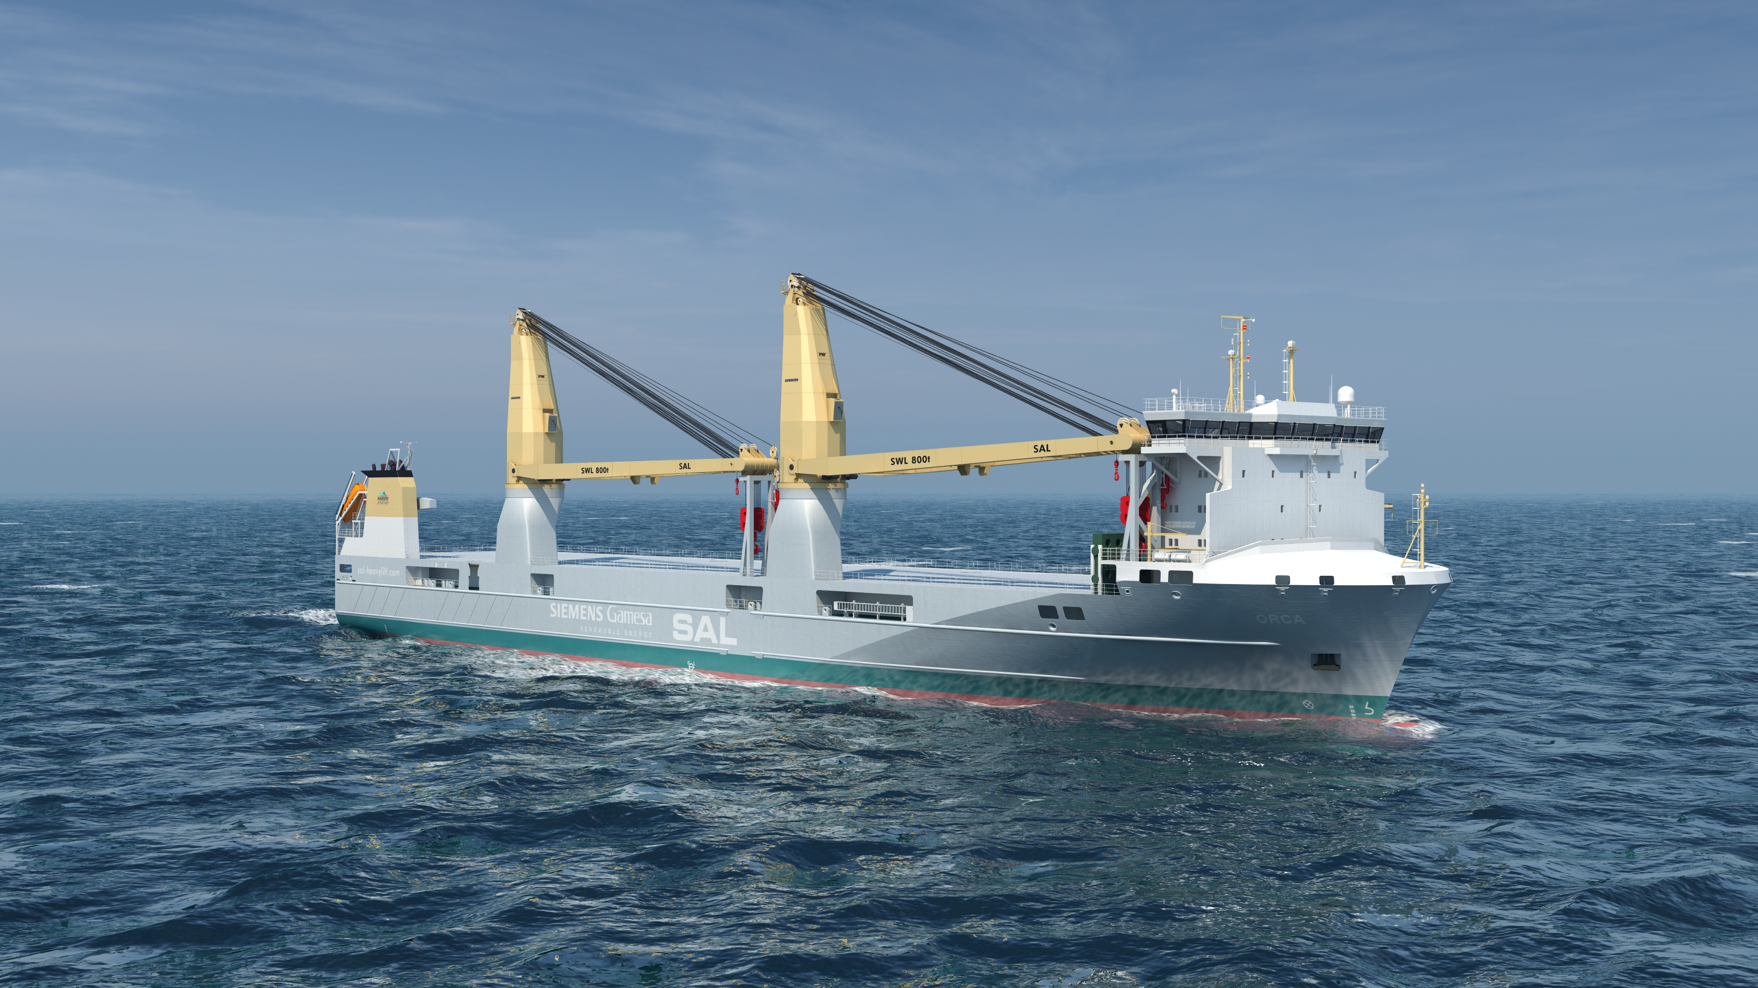

liebherr-ship-cranes-LS-800-E-SAL-Orca-project. jpg   
The four multipurpose heavy lift vessels of the "Orca" project will each be completed with two all-electric Liebherr LS 800 E ship cranes.

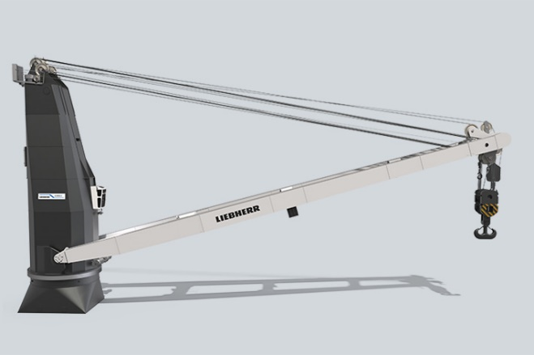

liebherr-ship-crane-LS-800-E-1.jpg  
The LS 800 E has a lifting capacity of up to 800 tonnes and a total radius of 39 metres.

Contact

Philipp Helberg   
Phone: +49 381 6006 5024   
email: Philipp.Helberg@liebherr.com

Published by

Liebherr-MCCtec Rostock GmbH   
Rostock / Germany   
www.liebherr.com