Press release

Seghetti adds a used Liebherr LTM 1100-4.2 mobile crane to its fleet

⸺⸺

* Seghetti S.r.l. acquires a used LTM 1100-4.2 crane built in 2009
* Inspection and reconditioning with original Liebherr spare parts and lubricants took place at the Liebherr Italia S.p.a. repair centre
* Liebherr's leading role in the industry and fast availability were decisive factors behind the purchase

Seghetti S.r.l. has taken delivery of a used Liebherr LTM 1100-4.2 mobile crane. The Liebherr Italia S.p.a. repair centre carried out the inspection and reconditioning of the 100-tonne machine built in 2009 with professional staff and original Liebherr spare parts before delivery. The high lifting height of the LTM 1100-4.2, its fast availability and Liebherr's leading role in the crane industry played a key role in the purchase decision.

Ehingen (Donau) (Germany), 17 October 2022 – Italian crane company Seghetti S.r.l. is expanding its crane line-up by purchasing a Liebherr LTM 1100-4.2 used crane. "We chose a Liebherr crane because Liebherr is a leader in the industry. In addition, the rapid availability of this used mobile crane was an important factor. The LTM 1100-4.2 will enable us to optimally cover the requirements of our market," explains Managing Director Luigi Seghetti.

Liebherr is also a market leader and a reliable partner for used cranes. For the resale to Seghetti, the used LTM 1100-4.2 was inspected and reconditioned by qualified specialists at the Liebherr Italia S.p.a. repair centre, which is directly attached to the Liebherr plant in Ehingen. This included maintenance and overhaul of the main undercarriage and superstructure components as well as adjustment and calibration of the control systems. During such repair works, original Liebherr spare parts and lubricants are used.

Powerful, compact and manoeuvrable crane

"The decisive factor for buying the LTM 1100-4.2 was its large lifting heights," says Seghetti. The 100-tonne crane has a 60-metre telescopic boom – with lattice extensions, it can achieve lifting heights of up to 91 metres and radii of up to 58 metres. Furthermore, this compact and manoeuvrable 4-axle vehicle combines a good load capacity with high safety standards. The main areas of application for the LTM 1100-4.2 at Seghetti will be in industry as well as construction.

Seghetti S.r.l. was founded in the nineteen seventies. The company, which is based in central Italy and has grown continuously since its early days as a small artisan family business, has been managed by the second generation of the Seghetti family since 2000. Seghetti focuses on qualified, competent and reliable personnel, as well as vehicles that comply with the strictest guidelines in order to provide a high-quality service that meets as many of its customers' needs as possible.

About Liebherr-Werk Ehingen GmbH

Liebherr-Werk Ehingen GmbH is a leading manufacturer of mobile and crawler cranes. Its range of mobile cranes extends from 2-axle 35 tonne cranes to heavy duty cranes with a lifting capacity of 1200 tonnes and a 9-axle chassis. Its lattice boom cranes on mobile or crawler crane chassis deliver lifting capacities of up to 3000 tonnes. With universal boom systems and extensive additional equipment, they can be seen in action on construction sites throughout the world. The Ehingen site has a workforce of 3,800. Extensive, global service guarantees the high availability of Liebherr mobile and crawler cranes. In 2021, the Liebherr plant in Ehingen recorded a turnover of 2.33 billion euros.

About the Liebherr Group

The Liebherr Group is a family-run technology company with a highly diversified product portfolio. The company is one of the largest construction equipment manufacturers in the world. It also provides high-quality and user-oriented products and services in a wide range of other areas. The Liebherr Group includes over 140 companies across all continents. In 2021, it employed more than 49,000 staff and achieved combined revenues of over 11.6 billion euros. Liebherr was founded in Kirchdorf an der Iller in Southern Germany in 1949. Since then, the employees have been pursuing the goal of achieving continuous technological innovation, and bringing industry-leading solutions to its customers.

**Images**

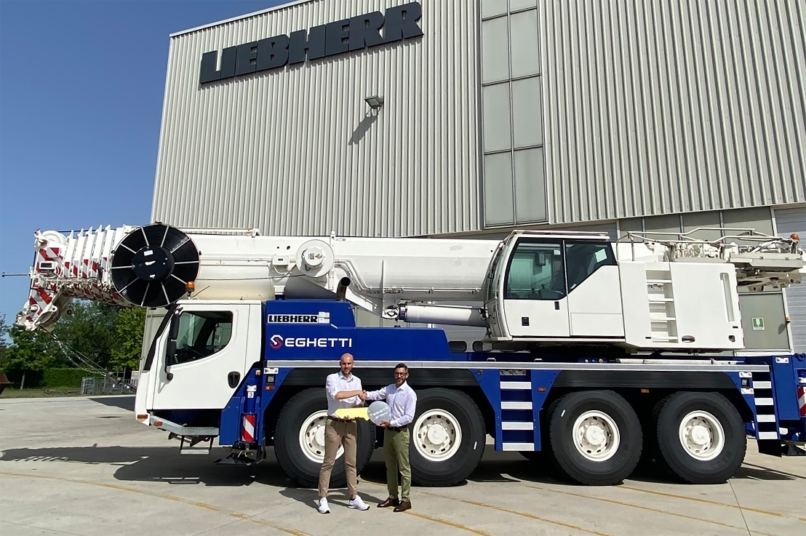

liebherr-ltm-1100-4-2-handover-seghetti.jpg  
Handing over the LTM 1100-4.2 to Seghetti S.r.l.: (from left to right) Emanuele Perrone (Liebherr-Italia S.p.A.) and Luigi Seghetti (Seghetti S.r.l.).

Contact

Wolfgang Beringer  
Marketing and Communication  
Phone: +49 7391 / 502 - 3663  
Email: wolfgang.beringer@liebherr.com

Published by

Liebherr-Werk Ehingen GmbH  
Ehingen (Donau), Germany  
[www.liebherr.com](http://www.liebherr.com)