Press release

Liebherr hydrogen excavator receives Bauma Innovation Award

⸺

The jury have made their decision: The 2022 Bauma Innovation Award in the climate protection category goes to the R 9XX H2 hydrogen excavator. This is the first Liebherr hydraulic excavator to be powered by a hydrogen engine.

Munich (Germany), 23 October 2022 – Working on alternative drive solutions, Liebherr takes a technology-neutral approach. Hydrogen combustion engines are one technology being explored by the Group. The R 9XX H2, Liebherr’s first hydrogen-powered crawler excavator, has now won the Bauma Innovation Award. The prototype was developed by Liebherr-France SAS, based in Colmar, France. The machine is powered by an H966 hydrogen combustion engine. It was produced at Liebherr Machines Bulle SA, the Liebherr Group’s engine competence centre in the Swiss canton of Fribourg.

In terms of power, dynamics and responsiveness, the R 9XX H2 hydrogen excavator gives nothing away to any conventionally powered machine. Nor is it dependent on a continuous energy supply either. The emissions make the difference: On a “tank to wheel” basis, i.e. when used on a construction site, a hydrogen excavator emits almost no CO2. “Cradle to grave” or from production to decommissioning, CO2 emissions are 70% lower than those of comparable conventionally powered excavators. Suitable for use under extreme temperatures, shock, and high-dust conditions on construction sites, the 50 tonne-operating weight R 9XX H2 may in future offer a robust solution for earthworks and quarrying applications.

The R 9XX H2 is powered by a Liebherr H966 hydrogen combustion engine. The engine has six cylinders and uses port fuel injection (PFI), which Liebherr employs along with direct injection (DI) for its hydrogen engines. Liebherr’s components product segment plans to start with the series production of hydrogen motors by 2025.

Visitors to the Bauma fair in Munich can experience the Liebherr R9XX H2 hydrogen excavator live from 24 to 30 October 2022. The excavator is part of a machine show at the Liebherr booth in the outdoor area, where the company is exhibiting a variety of machines and prototypes with alternative drive systems. The booth even offers a hands-on encounter with the second prototype of the H966 hydrogen combustion engine. It can be found in the “InnovationLab”, an exhibition area devoted to Liebherr's open approach to alternative drive concepts. Another four-cylinder prototype of a 4-cylinder hydrogen engine, the H964 with direct injection (DI), can be seen at the Liebherr Components booth 326 in hall A4.

The Bauma Innovation Award rewarding innovation

2022 sees the thirteenth presentation of the Bauma Innovation Award. Its five categories – climate protection, digitalisation, mechanical engineering, building and research – reflect political, social, economic and ecological challenges. The expert jury’s focus on criteria such as practical orientation, economic potential, environmental protection aspects, resource conservation, efficiency and humanisation the workplace. The prize is awarded by Messe München and the German Mechanical Engineering Industry Association (VDMA), together with the Federation of the German Construction Industry (HDB), the German Construction Confederation (ZDB) and the German Building Materials Federation (bbs).

About Liebherr-France SAS

Liebherr-France SAS, founded in 1961, is responsible for the development and production of Liebherr Group crawler excavators in Colmar, France. The current product range includes around 30 crawler excavator models, from the R 914 Compact to the R 980 SME, for use in earthworks and quarries. Production also includes a range of special equipment for specific tasks such as demolition, material handling and bridge or tunnel applications, as well as electric excavators. The crawler excavators with an operating weight of 14 to 100 tonnes are equipped with Liebherr engines with an output of 90 to 420 kW. Liebherr-France SAS employs more than 1,400 people and generates a turnover of EUR 692 million.

About Liebherr Machines Bulle SA

Liebherr Machines Bulle SA is the competence centre for combustion engines and hydraulic components (axial piston pumps and motors). The company is part of the Liebherr Group’s components product segment. Based in the Swiss canton of Fribourg, the company develops and manufactures high-quality components and systems, which are used not only within the Liebherr Group, but also in other manufacturers’ machines. The application area ranges from earth-moving and deep foundation machines to mining excavators, mobile cranes, crawler cranes, maritime applications and material handling machines, up to biogas plants and combined heat and power units. The company’s focus is on offering best quality and customised solutions for different requirements.

About the Liebherr Group

The Liebherr Group is a family-run technology company with a highly diversified product portfolio. The company is one of the largest construction equipment manufacturers in the world. It also provides high-quality and user-oriented products and services in a wide range of other areas. The Liebherr Group includes over 140 companies across all continents. In 2021, it employed more than 49,000 staff and achieved combined revenues of over 11.6 billion euros. Liebherr was founded in Kirchdorf an der Iller in Southern Germany in 1949. Since then, the employees have been pursuing the goal of achieving continuous technological innovation, and bringing industry-leading solutions to its customers.

Images

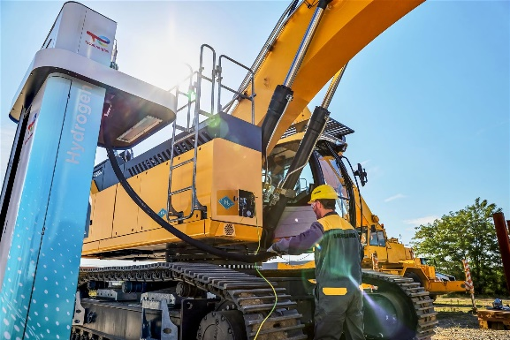

liebherr-r9xx-h2-hydrogen-crawler-excavator.jpg

Suitable for use under extreme temperatures, shock, and high-dust conditions on construction sites, the 50 tonne-operating weight R 9XX H2 may in future offer a robust solution for earthworks and quarrying applications.

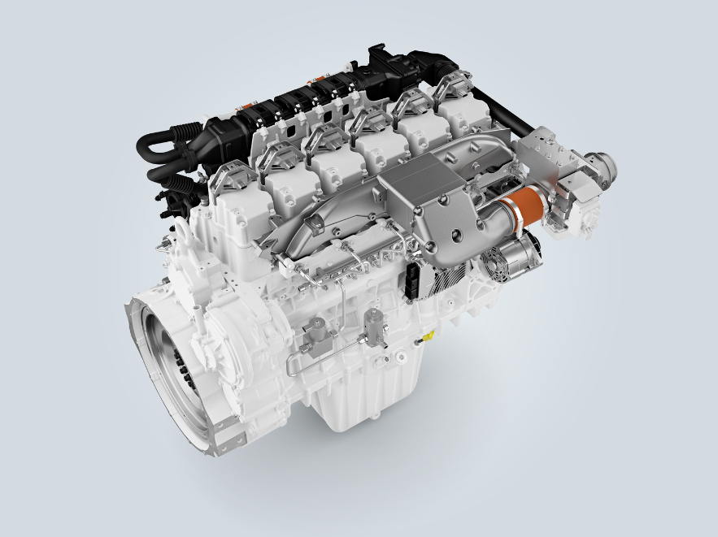

liebherr-h966-PFI-hydrogen-engine-in-development.jpg

The prototype six-cylinder H966 hydrogen engine is the heart of Liebherr’s first hydrogen-powered crawler excavator.

Contact

Alban Villaumé  
Marketing & Communication  
Telephone: 3 +33 89 21 36 09  
Email: alban.villaume@liebherr.com

Alexandra Nolde

Senior Communication & Media Specialist  
Telephone: +41 56 296 4326  
Email: alexandra.nolde@liebherr.com

Published by

Liebherr-France SAS  
Colmar, France

Liebherr-Components AG

Nussbaumen, Switzerland  
www.liebherr.com