Press information

Liebherr at Bauma 2022: Digital solutions and smart assistance systems

⸺

Comprehensive crane information models help with custom-fit crane selection

Future-focused teleoperations project set to strengthen processes on site

Relevant data provides reliable overview of quality and construction progress

Digitalisation offers the construction industry diverse opportunities for further increasing performance, reliability and safety on site. As a holistic solutions provider, Liebherr Tower Cranes is sharing insights into new digital developments around crane operation at the construction machinery trade fair in Munich. Comprehensive planning, efficient processes and spot-on analysis – all this will be made possible by Liebherr’s new tools and assistance systems.

Munich (Germany), 24 October 2022 – Liebherr is launching comprehensive Crane Information Models (CIM models) for precise construction site planning over the coming months. These models make the work of architects and construction planners easier, as they allow key information regarding crane deployment to be taken into account early on in the process, and therefore ensure the right choice of crane for the job at hand. With decades of accumulated expertise, Liebherr’s Tower Crane Solutions project department also provides support with cost-effective construction site planning.

Quick communication, intuitive operation

Further improvements for more efficient load handling are also in the spotlight. Thanks to the interface of the Tower Crane Operating System, which a number of cranes already feature, crane operators and service technicians are able to navigate their way through a needs-based menu structure via touch display. The LiReCon teleoperation unit for tower cranes offers insight into what future machine operation will look like and the opportunities this will bring. The LiReCon teleoperation stand can, for example, be stationed directly where the site supervisor works. This means that crane operators and site supervisors will be able to interact with each other in future and discuss changes in person without delay. LiReCon will also offer the option of switching between different tower cranes, which will enable a flexible response to situations on site as they happen.

In addition, intelligent assistance systems are there to make work easier for crane operators. These assistance systems also contribute to safety on site, which is why Liebherr is committed to their ongoing further development. The new Tower Crane OS offers new possibilities in this context. The new assistance systems actively counteract dangerous situations, such as excessive swinging of loads. Liebherr is showing the first prototypes as part of an interactive experience at the construction machinery trade fair.

Digital “Site Monitoring” solution

The right data is useful in evaluating the success of a construction project on its completion. Although every construction site is different, it is nevertheless possible to learn from processes for subsequent projects. This is where Liebherr’s digital “Site Monitoring” solution comes into play. Relevant crane data can be easily recorded, displayed and analysed. Such information also provides site supervisors and construction planners with a reliable overview of efficiency and construction progress.

“We are continuing to see significant efforts being made to increase efficiency on construction sites. In terms of Liebherr tower crane products, this means supporting construction processes with transparent information during planning, execution and downstream analysis,” says Tobias Scholz, Global Market Manager, Liebherr-Werk Biberach GmbH. Liebherr is at its customers’ side when it comes to digitalisation and offers tailored solutions for ensuring the successful use of tower cranes.

About the Liebherr Tower Cranes Division

More than seven decades of experience have made Liebherr a recognised specialist for lifting technology on all types of construction sites. The range of Liebherr Tower Cranes encompasses an extensive selection of high-quality tower cranes that are used worldwide. This includes fast-erecting, top-slewing, luffing jib and special-purpose cranes as well as mobile construction cranes. In addition to these products, Liebherr also offers a wide range of services that complete the company’s portfolio: Tower Crane Solutions, the Tower Crane Center and Tower Crane Customer Service.

About the Liebherr Group

The Liebherr Group is a family-run technology company with a highly diversified product portfolio. The company is one of the world's largest manufacturers of construction machinery. It also offers high-quality, user-oriented products and services in multiple other areas. Today, the group consists of more than 140 companies across all continents. In 2021, it employed more than 49,000 people and achieved combined revenues of over 11.6 billion euros. Liebherr was founded in 1949, in Kirchdorf an der Iller in southern Germany. Ever since then, its employees have been committed to providing customers with industry-leading solutions and to help drive technological innovation.

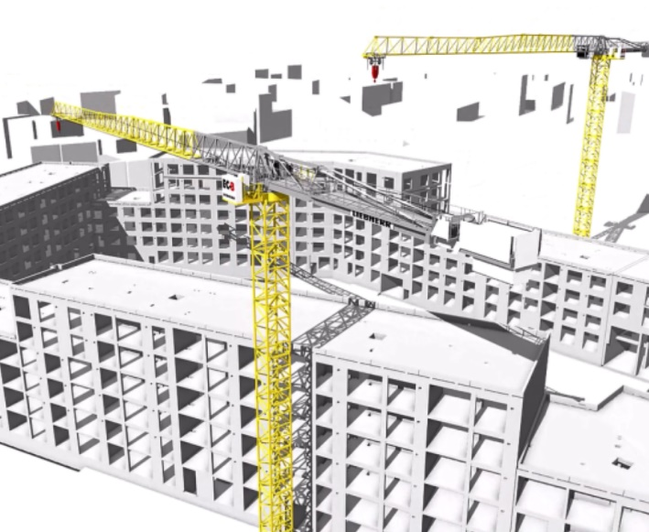Image

liebherr-digital-solution-01.jpg  
IFC models of a Liebherr 370 EC-B Fibre support construction site set-up as a digital product.

Contact

Daniel Haefele  
Global Communication  
Phone: +49 7351 / 41 - 2330  
Email: daniel.haefele@liebherr.com

Published by

Liebherr-Werk Biberach GmbH  
Biberach / Germany  
www.liebherr.com