Press information

Liebherr presents upgraded MK 140-5.1 at Bauma 2022

⸺

The MK 140-5.1 is now available for order

Hybrid power concept and HVO refuelling enable environmentally responsible operation

Transport, assembly and operation require just one person

Liebherr's most powerful mobile construction crane, the optimised MK 140-5.1, is making its first public appearance at the construction machinery trade fair in Munich. Construction firms, timber frame companies and crane rental businesses alike can put the five-axle crane to flexible use, from short jobs in densely built-up inner city areas to work on plants such as refineries. Customers benefit from familiar operation across all machines in the MK series. Future normative regulations will be met through further development.

Munich (Germany), 24 October 2022 – The MK 140-5.1 offers lifting capacities of up to 8,000 kilograms. What makes the MK particularly special is that, alongside its standard use as a trolley jib crane, it also features the VarioJib concept. This makes operation in luffing mode and a reach of up to 65 metres possible. As a result, the crane is ideal for installing air-conditioning systems, balconies and windows, as well as for supporting overhaul work at chemical plants and refineries. “Thanks to its compact size and minimal space requirements in terms of assembly, operation and dismantling, the MK 140-5.1 is perfect for use in urban areas,” says Daniel Nötzel, Product Manager, Liebherr-Werk Biberach GmbH. “Through the integration of Trolley-Plus, it has been possible to achieve a load capacity increase of up to 50 percent in luffed position, which makes the crane even more flexible.”

All-electric crane operation

The crane’s ecological and future-oriented hybrid power concept enables all-electric operation with site power or another external power source. This means that the crane is extremely quiet when working, something which is a particular advantage for sites that are active at night. The MK cranes are compatible with [Liebherr’s Liduro Power Port (LPO)](https://www.liebherr.com/de/deu/aktuelles/news-pressemitteilungen/detail/energiespeichersystem-von-liebherr-ermöglicht-lokal-emissionsfreie-baustellen.html?news.category=CP), a mobile energy storage system for supplying power to construction sites. Hybrid and all-electric construction machines can be operated or charged locally with zero emissions using the mobile energy storage system. If an external power source isn’t available, an efficient diesel generator ensures the MK’s self-sufficient operation.

Both the superstructure and undercarriage drives of these cranes can be powered by HVO (Hydrogenated Vegetable Oils). HVO is fuel produced from hydrogenated vegetable oils, and preferably from waste. Our production sites have been shipping mobile construction cranes with this fuel since January 2022. All-electric operation and refuelling with HVO helps to reduce emissions and promotes climate neutrality on construction sites in the long term.

Ready to start work in a matter of minutes

The MK series, which also includes the MK 73-3.1 and the MK 88-4.1, makes it easy to manage multiple jobs in different locations on the same day. MK cranes are ready to work within a matter of minutes and only need one person for transport, assembly and operation. No additional transport vehicles are needed, saving both time and costs. Thanks to a vertical tower, the taxi cranes can work directly at buildings, require little space and can achieve extensive working radii with considerable performance capacity.

About the Liebherr Tower Cranes Division

More than seven decades of experience have made Liebherr a recognised specialist for lifting technology on all types of construction sites. The range of Liebherr Tower Cranes encompasses an extensive selection of high-quality tower cranes that are used worldwide. This includes fast-erecting, top-slewing, luffing jib and special-purpose cranes as well as mobile construction cranes. In addition to these products, Liebherr also offers a wide range of services that complete the company’s portfolio: Tower Crane Solutions, the Tower Crane Center and Tower Crane Customer Service.

About the Liebherr Group

The Liebherr Group is a family-run technology company with a highly diversified product portfolio. The company is one of the world's largest manufacturers of construction machinery. It also offers high-quality, user-oriented products and services in multiple other areas. Today, the group consists of more than 140 companies across all continents. In 2021, it employed more than 49,000 people and achieved combined revenues of over 11.6 billion euros. Liebherr was founded in 1949, in Kirchdorf an der Iller in southern Germany. Ever since then, its employees have been committed to providing customers with industry-leading solutions and to help drive technological innovation.

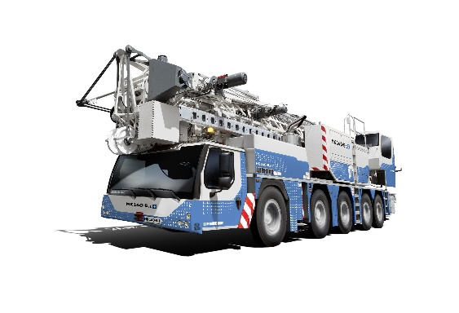Image

liebherr-mk140-01.jpg  
Liebherr's MK 140-5.1 has undergone a facelift and is being shown at Bauma with a special paint finish.

Contact

Daniel Haefele  
Global Communication  
Phone: +49 7351 / 41 - 2330  
Email: daniel.haefele@liebherr.com

Published by

Liebherr-Werk Biberach GmbH  
Biberach / Germany  
www.liebherr.com