Press release

The new 70 to 100 tonne crawler excavators from Liebherr

⸺

The R 972, R 978 SME, R 992 and R 998 SME crawler excavators replace the R 966, R 970 SME, R 976 and R 980 SME models

Reduced fuel consumption

Liebherr Bucket Fill Assist system - an important step towards machine automation

Production start: April 2023

As part of the revision of the model range, the Liebherr crawler excavators of the 5.2 and 6.2 generations weighing between 70 and 100 tonnes will be presented to the public for the first time at Bauma 2022 in Munich. The new crawler excavator models include numerous improvements and are characterised in particular by their optimised performance data, high level of comfort, new assistance systems and lower fuel consumption.

Munich (Germany), 24 October 2022 - The new Liebherr crawler excavators R 972, R 978 SME, R 992 and R 998 SME replace the R 966, R 970 SME, R 976 and R 980 SME models. The new designation is directly related to the operating weight of the machines. A modernisation of the design language accompanies the renaming and underlines the relationship to the upcoming Generation 8 crawler excavators.

Lower fuel consumption and thus fewer emissions

The new crawler excavators were developed at Liebherr's long-standing site in Colmar (France) with the aim of significantly reducing overall energy consumption. The new, patented Liebherr Power Efficiency (PE) - Engine Control system in particular contributed to this.

In concrete terms, the new "PE" function is represented by a work mode that complements the existing modes of the crawler excavator (P+/P/E). This significant innovation allows a 10-15% reduction in fuel consumption compared to previous models.

Machine automation: Liebherr's Bucket Fill Assist system

The new excavator model range is available with the Bucket Fill Assist function. This assistance system has an "anti-stalling" mode that prevents the bucket jamming when penetrating digging material. In this way, this option provides the operator with additional support when using the machine and ensures higher productivity and more comfort. The assist function also enables semi-automatic bucket filling, providing an automated and faster cycle through easier bucket filling, higher bucket filling level and better penetration into the digging material. In addition to reducing fuel consumption by 10 %, the Liebherr Bucket Fill Assist system also reduces vibrations that would otherwise occur during operation, improving operator comfort. The resulting reduced wear on the bucket also helps to reduce operating costs.

New operating modes for individual work needs

All Liebherr hydraulic crawler excavators in the G5.2 and G6.2 model series are equipped with the Modetronic function, which proved its worth in Generation 8. This further development allows the operator to adapt the hydraulic characteristics of their excavator to the respective application and to their individual habits.

The Modetronic control system thus offers even more comfort and productivity by assisting the machine operator when driving as well as during rotary motion and facilitating control of the boom, stick and bucket. In addition, the Modetronic function enables a more dynamic behaviour of the machine in "Dynamic" mode and increased machine stability in "Efficient" mode. The "Custom" mode supplements the working modes with the facility to perform precision work with greater ease. In "Fine" mode, the machine operator can use the display to make individual adjustments to the machine movements to suit their own preferences.

For even more demanding work: Higher performance and more comfort

The new G5.2 and G6.2 generation excavators presented at Bauma 2022 incorporate the further developments in the cab area known from the excavator generation 8. The main screen grows from seven to nine inches and the new hand and foot control units ensure more precise machine movements.

To ensure that all hydraulic crawler excavators meet customers' needs in the best possible way, improvements have been made to each model that are both innovative and performance-enhancing. A continuous chain guide is available as an option on all new excavator models in the range. In addition, the machines benefit from increased engine power. The R 998 SME with an operating weight of more than 100 tonnes gets a new chassis with larger dimensions with a track of 3900 mm and a wheelbase of 5000 mm. The model thus gains stability and as a result is ideally suited for demanding working environments, such as quarrying and mining.

At the Liebherr stand, the R 992 model will be presented with a 7.20 m gooseneck boom and a 2.90 m stick. The R 992, which replaces the R 976, guarantees 5% more engine power. The crawler excavator, which weighs more than 94 tonnes, is powered by a powerful diesel engine with 420 kW / 544 hp. It is equipped with an LC-V chassis, a counterweight of 16 tonnes and a 600 mm track pad.

About the Liebherr Group

The Liebherr Group is a family owned technology company with a broadly diversified product range. The company is one of the largest manufacturers of construction machinery in the world. However, it also offers high-quality, user-oriented products and services in many other areas. Today, the group comprises more than 140 companies on all continents. In 2021, it employed more than 49,000 people and generated a total consolidated turnover of over 11.6 billion euros. Liebherr was founded in 1949 in Kirchdorf an der Iller in southern Germany. Since then, the employees have pursued the goal of convincing their customers with sophisticated solutions and contributing to technological progress.

Images

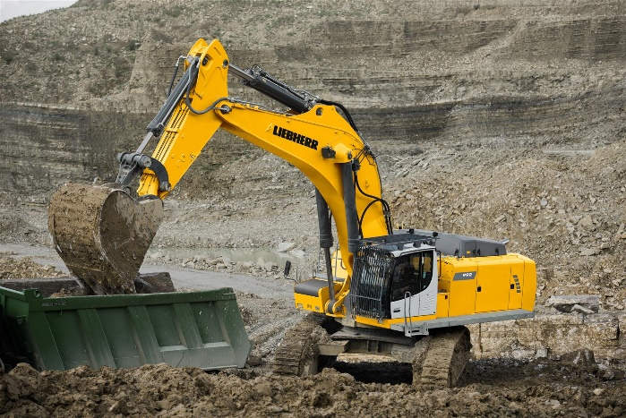

liebherr-r992-bauma-2022.jpg  
At the Liebherr stand, the R 992 model will be presented with a 7.20 m gooseneck boom and a 2.90 m stick.

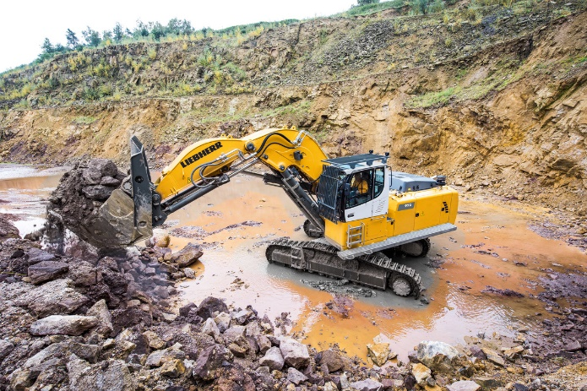

liebherr-r972-bauma2022.jpg  
The new Liebherr crawler excavators R 972, R 978 SME, R 992 and R 998 SME replace the R 966, R 970 SME, R 976 and R 980 SME models.

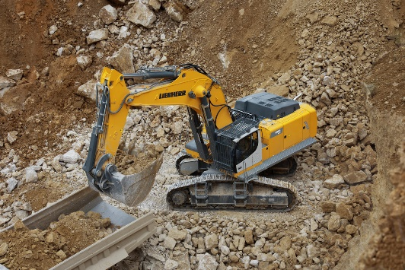

liebherr-r998sme-bauma-2022.jpg  
The R 998 SME with an operating weight of more than 100 tonnes gets a new chassis with larger dimensions with a track of 3900 mm and a wheelbase of 5000 mm.

Contact

Alban Villaumé  
Marketing & Communication  
Telephone: +33 3 89 21 36 09  
E-mail: alban.villaume@liebherr.com

Published by

Liebherr-France SAS  
Colmar, France  
www.liebherr.com