Press release

World premiere: Liebherr debuts crawler excavator with a hydrogen engine

⸺

R 9XX H2 is the first Liebherr excavator powered by a hydrogen combustion engine

Significant reduction of CO2 emissions, as well as easy and fast refuelling

No power difference between Liebherr H966 hydrogen engine and a diesel-powered internal combustion engine

Versatile use even under most demanding conditions

In times of climate change, which calls for extensive measures to protect the environment and in particular to reduce pollutant emissions, it is one of the tasks of construction machinery manufacturers to develop low-emission solutions. Liebherr is also working on various drive alternatives in different product segments in the interests of its customers, with an open approach to technology, in order to make a contribution to the reduction of emissions. These include internal combustion engines that run on hydrogen.

Munich (Germany), 24th October 2022 - At Bauma 2022, Liebherr will debut a crawler excavator developed by Liebherr-France SAS in Colmar, equipped with an integrated hydrogen combustion engine. The model on display of the installed H966 engine comes from Liebherr Machines Bulle SA in Switzerland.

Significant reduction of pollutant emissions

The H2 drive in the crawler excavator on display does not require a permanent energy supply and emits extremely low levels of NOx and CO2. Depending on the assessment method used in each case, and whether the entire life cycle of the machine is taken into account, the hydrogen combustion engine can reduce CO2 emissions by almost 100%, when considering "tank to wheel” or by 70%, when considering the "cradle to grave" principle.

The H966 engine – heart of the machine

The first Liebherr hydrogen engine, the H966, is the heart of the new R 9XX H2 excavator. This is an engine designed for both demonstration and field trials and is based on an intake manifold injection technology (also known as PFI). The achieved results offer evidence of a great potential in hydrogen propulsion and argue in favour of using such drives for off-road applications as well.

The group is now presenting its extensive expertise along with the first resulting product. In addition, the components division is working on further hydrogen-based drive technologies, such as H2 direct injection. The latter enables a higher power density than the established H2 intake manifold injection and is, thus, particularly suitable for heavy-duty applications in demanding working environments, such as the construction and mining industries.

The R 9XX H2 crawler excavator: a powerful, safe and environmentally friendly solution

The R 9XX H2 meets highest quality standards as all crawler excavators by Liebherr-France SAS do. Its design is based on the current and future generation 8 of crawler excavators. With it, the R 9XX H2 shares a focus on a more comfortable and efficient application. The excavator reaches the same overall performance as its diesel engine counterpart, both in terms of power output, engine dynamics and response. Suitable for extreme temperatures, shock and dust-intensive site operations, the R 9XX H2, with its operating weight of 50 tons, can become as robust a solution for earthmoving and quarrying applications in the future as the conventionally powered Liebherr crawler excavators in the same class already are. The only differences are in refuelling the machines: Fast and safe refuelling is ensured via infrared communication between the excavator and the refuelling station, where users benefit from the standardised high-speed protocol.

Henrik Weitze, project manager at Liebherr-France SAS, also emphasises: "The tests carried out in Colmar were extremely convincing. This technology promises many advantages for us in the future, especially in the most challenging applications."

Images

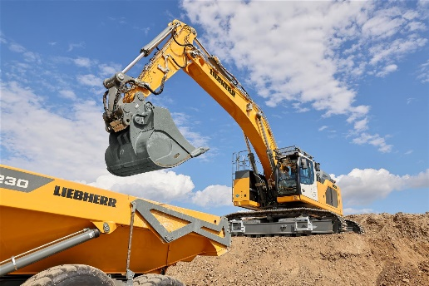liebherr-r9h2-hydrogen-crawler-excavator-1.jpg  
The abilities of the R 9XX H2 crawler excavator will be presented at the Liebherr stand at Bauma 2022.

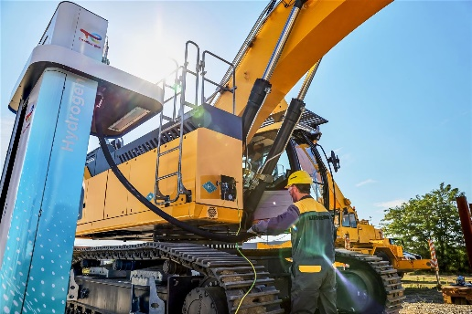liebherr-r9xx-h2-hydrogen-crawler-excavator-2.jpg  
The R 9XX H2 crawler excavator guarantees a significant reduction in CO2 emissions on the construction site, thanks to its fast and safe filling.

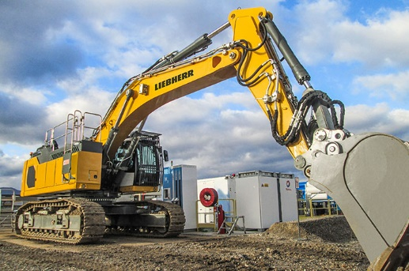

liebherr-r9xx-h2-hydrogen-crawler-excavator-3.jpg  
The R 9XX H2 crawler excavator guarantees a significant reduction in CO2 emissions on the construction site, thanks to its fast and safe filling.

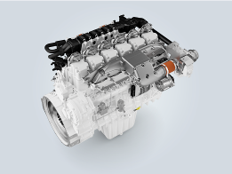

liebherr-h966-PFI-engine.jpg  
The H966 engine is developed and produced at Liebherr Machines Bulle SA in Switzerland.

About Liebherr-France SAS

Liebherr-France SAS, founded in 1961, is responsible for the development and production of the Liebherr Group’s crawler excavators in Colmar. The current product range includes around 30 models, from the R 914 Compact to the R 980 SME, for use in earthworks and quarries. Production also includes a range of attachments for specific tasks such as demolition, material handling, bridge or tunnel applications, as well as electric excavators. The crawler excavators with an operating weight of 14 to 100 tonnes are equipped with Liebherr engines with an output of 90 to 420 kW. Liebherr-France SAS employs more than 1,400 people and generates a turnover of EUR 692 million.

About Liebherr Machines Bulle SA

Liebherr Machines Bulle SA is the competence center for combustion engines, as well as hydraulic components (axial piston pumps and motors). The company is part of the Liebherr Group's Components product segment. Located in the canton of Fribourg in Switzerland, the company develops and manufactures high-quality components and systems that are used not only within the Liebherr Group, but also in machines of other manufacturers. Target applications range from earthmoving and civil engineering machines, mining excavators, mobile and crawler cranes, maritime applications, material handling machines to biogas, as well as combined heat and power plants. The focus is highest quality and tailor-made solutions for different requirements.

About the Liebherr Group

The Liebherr Group is a family-run technology company with a highly diversified product portfolio. The company is one of the largest construction equipment manufacturers in the world. It also provides high-quality and user-oriented products and services in a wide range of other areas. The Liebherr Group includes over 140 companies across all continents. In 2021, it employed more than 49,000 staff and achieved combined revenues of over 11.6 billion euros. Liebherr was founded in Kirchdorf an der Iller in Southern Germany in 1949. Since then, the employees have been pursuing the goal of achieving continuous technological innovation, and bringing industry-leading solutions to its customers.

Contact

Alban Villaumé  
Marketing & Communication  
Phone: +33 3 89 21 36 09  
E-Mail: alban.villaume@liebherr.com

Published by

Liebherr-France SAS  
Colmar, France  
www.liebherr.com