Press release

Liebherr unveils fleet data management for mobile and crawler cranes

⸺⸺

* Liebherr launches a fleet data management solution for its mobile and crawler cranes
* Modem becomes standard equipment in various crane types in 2023
* Retrofit solutions are available for older cranes
* Liebherr will cover the telecommunication costs for the data transmission via the modem

At Bauma 2022, Liebherr will unveil a fleet data management solution for its mobile and crawler cranes. In addition to the machine's location, the system displays a range of additional real-time data, such as the fuel consumption, the current wind speed, the weight of the load on the hook and even when the crane's next service is due. Customers can also use the system to generate custom reports for specially defined construction sites, such as the fuel consumption or CO2 emissions. Many new cranes now have the necessary wireless modem on board as standard. Cranes in the field can be easily retrofitted in the future. In each case, Liebherr will cover the telecommunication costs.

Munich (Germany), 24. October 2022 – The new Liebherr solution is an easy introduction to the world of telemetry, a technology that is already widespread in modern cars, dishwashers and even robotic lawnmowers. It allows the user of the corresponding device to monitor its operating parameters from anywhere in the world. While this is more of a gimmick for domestic appliances, remote telemetry generates significant benefits for customers with mobile and crawler cranes. The Liebherr fleet data management solution enables customers to also monitor in real time – from the office or while on the road – the current location of specific machines, to determine whether the current prevailing wind force allows safe working, and even to see the weight of the load currently hanging from the hook. The remaining quantity and consumption of fuel and AdBlue are also displayed – if the level falls below certain limits, the system informs the user.

Fast job site reports - thanks to geofencing and MyLiebherr

The user can define an area on a map, such as a construction site. Whenever the crane moves within this area, all data is assigned to it (geofencing). By selecting a construction site and a time period, the user can then analyse (for example) the number of operating hours for a particular crane at the selected site within the defined period, how much fuel it has consumed, and can even see the quantity of CO2 emissions generated by the crane. This data forms the basis for the billing process and the creation of certain reports, which crane operators are increasingly required to send to their customers. Liebherr Product Manager Wolfgang Boos explains: "It is important to us not to display arbitrary data just because a corresponding sensor is installed. We want to provide the customer with data that helps them manage their machine fleet and thus operate it as economically as possible."

The right solution for almost every crane

Starting in 2023, a future-proof modem will be gradually installed in the various new crane types as standard. For Liebherr, the fleet data management system launched at Bauma is just the beginning of a whole series of further planned digital services. If a customer's crane is already in the field, Liebherr offers retrofit solutions – even for models produced up to ten years ago. Modern cranes generate more data than older models, which generally have fewer sensors installed – Liebherr's customer service team is on hand to inform the customer exactly what kind of data can be expected from the crane in question.   
Regardless of whether a series modem or a retrofit solution is installed, a modem requires a mobile phone SIM card with a data plan to send the data to the client application. To ensure that customers can enter this new data-driven world without any hurdles, all Liebherr modems for Liebherr cranes are equipped with a data SIM card for which Liebherr covers the costs – regardless of the country in which the crane is operated. Therefore, Liebherr customers need not worry about expensive roaming charges.

Your fleet – your data

The entire system is based on the proven "MyLiebherr" customer portal. Having registered their cranes in the portal, customers can then (for example) download operating instructions or order spare parts. The portal also opens up the world of crane data. "MyLiebherr" has been thoroughly modernised – on the start page, customers can already clearly see the machines in their fleet and navigate directly to the desired model. The new system is currently being tested with selected customers and will be rolled out successively to all operators from the beginning of 2023.

By choosing the "Performance" application, as the service is called, the customer receives a fleet data management system in the form of an all-round carefree package. This is the customer's opportunity to use their machines even more efficiently and thus to operate them more economically. The new package is also further proof that Liebherr's customers not only get outstanding cranes, but also have access to a constantly growing portfolio of services and offers to help ensure optimised use of their crane fleet.

**About Liebherr-Werk Ehingen GmbH**

Liebherr-Werk Ehingen GmbH is a leading manufacturer of mobile and crawler cranes. Its range of mobile cranes extends from 2-axle 35 tonne cranes to heavy duty cranes with a lifting capacity of 1200 tonnes and a 9-axle chassis. Its lattice boom cranes on mobile or crawler crane chassis deliver lifting capacities of up to 3000 tonnes. With universal boom systems and extensive additional equipment, they can be seen in action on construction sites throughout the world. The Ehingen site has a workforce of 3,800. Extensive, global service guarantees the high availability of Liebherr mobile and crawler cranes. In 2021, the Liebherr plant in Ehingen recorded a turnover of 2.33 billion euros.

About the Liebherr Group

The Liebherr Group is a family-run technology company with a highly diversified product portfolio. The company is one of the largest construction equipment manufacturers in the world. It also provides high-quality and user-oriented products and services in a wide range of other areas. The Liebherr Group includes over 140 companies across all continents. In 2021, it employed more than 49,000 staff and achieved combined revenues of over 11.6 billion euros. Liebherr was founded in Kirchdorf an der Iller in Southern Germany in 1949. Since then, the employees have been pursuing the goal of achieving continuous technological innovation, and bringing industry-leading solutions to its customers.

Image

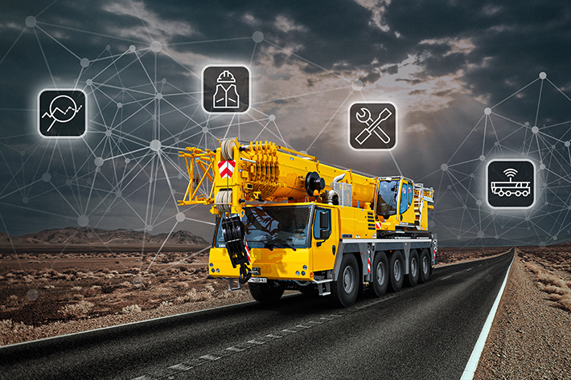

liebherr-telemetry-key-visual.jpg

Liebherr unveils a fleet data management solution for its mobile and crawler cranes.

Contact

Wolfgang Beringer  
Marketing and Communication  
Phone: +49 7391/502 - 3663  
Email: wolfgang.beringer@liebherr.com

Published by

Liebherr-Werk Ehingen GmbH  
Ehingen (Donau), Germany  
[www.liebherr.com](http://www.liebherr.com)