Press release

The new all-rounder from Liebherr: duty cycle crawler crane HS 8070.1

⸺

* Particularly suited for material handling, deep foundation work and lifting work
* Modular counterweight system for various applications
* New A-frame system for dynamic operations

Versatile, flexible and compact: these attributes are combined in the new duty cycle crawler crane HS 8070.1. It represents the all-rounder qualities of Liebherr’s HS series and is equipped for an especially wide range of applications. Thanks to the new design it can be individually fitted depending on the application and customer requirements.

Munich (Germany), 24 October 2022 - Liebherr reveals the latest generation of duty cycle crawler cranes with the brand-new HS 8070.1. The machine has a lifting capacity of 70 tonnes and is the first choice for a multitude of applications: material handling, deep foundation or lifting work.

Using the new jack-up system, the crawlers can be easily disassembled for transportation, so reducing the transport weight to less than 35 tonnes. The platforms and railings must no longer be removed before transportation.

Flexible design

Instead of a single counterweight, the new model is fitted with a modular system. Thus, the customer can mount the counterweights individually as required, depending on the operation. Further, the boom of the HS 8070.1 is compatible with the HS 8100.1. Therefore, customers can use attachments such as the slurry wall grab HSG 5-18 on both machines and install thicker slurry walls with a more compact machine.

As opposed to the fixed system, the new floating A-frame system ensures higher performance in dynamic applications. It also simplifies and speeds up the assembly and transportation of the machine. The user-friendly design extends to the tank neck, which is easily accessible via a platform on the uppercarriage - a perfect example of the modern and individual design strategy.

About the Liebherr Group

The Liebherr Group is a family-run technology company with a highly diversified product portfolio. The company is one of the largest construction equipment manufacturers in the world. It also provides high-quality and user-oriented products and services in a wide range of other areas. The Liebherr Group includes over 140 companies across all continents. In 2021, it employed more than 49,000 staff and achieved combined revenues of over 11.6 billion euros. Liebherr was founded in Kirchdorf an der Iller in Southern Germany in 1949. Since then, the employees have been pursuing the goal of achieving continuous technological innovation, and bringing industry-leading solutions to its customers.

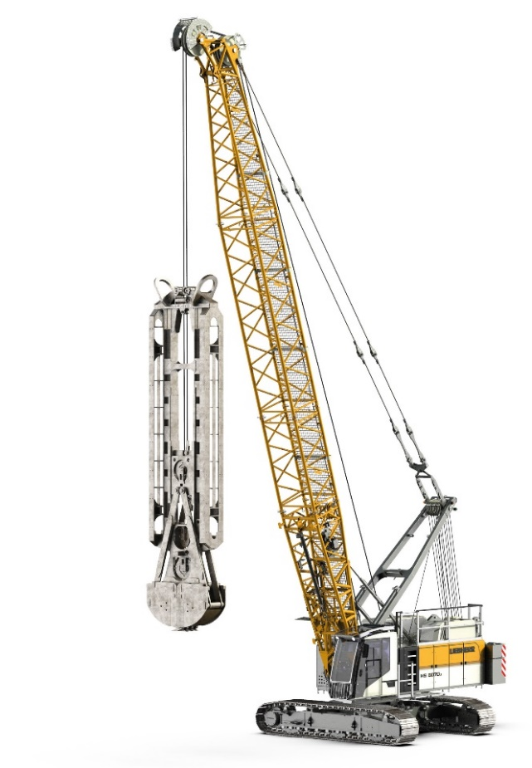Images

liebherr-hs-8070.1.jpg  
Liebherr’s HS series has a new all-rounder: HS 8070.1.

Contact

Gregor Griesser  
Strategic Marketing and Communications  
Email: [gregor.griesser@liebherr.com](mailto:gregor.griesser@liebherr.com)

Wolfgang Pfister  
Head of Strategic Marketing & Communications  
Tel.: +43 50809 41444  
Email: [wolfgang.pfister@liebherr.com](mailto:wolfgang.pfister@liebherr.com)

Published by

Liebherr-Werk Nenzing GmbH  
Nenzing/Austria  
[www.liebherr.com](http://www.liebherr.com)