Press release

Outstanding: the LR 1400 SX is the tallest exhibit at the Liebherr stand

⸺

* Maximum safety through Gradient Travel Aid, Boom Up-and-Down Assistant, and Ground Pressure Visualization
* Modular rear counterweight for various applications depending on customer requirements
* More flexibility through radio remote control

It is a big step for Liebherr in Nenzing and a response to the needs of the market. With the new LR 1400 SX, Liebherr-Werk Nenzing GmbH extends its range of crawler cranes to include lifting capacities of up to 400 t.

Munich (Germany), 24 October 2022 - It towers over the Statue of Liberty in New York, is as high as a football pitch is long, and with a height of 116 metres, the tallest exhibit at the Liebherr stand. Although the crawler crane at the Bauma is not even configured with the maximum boom length. If that was the case, it could lift loads onto the 170-metre-high Opernturm in Frankfurt, for example. For the Bauma, the crane is fitted with a 68-metre main boom and a 62-metre luffing jib. Gerhard Frainer, Managing Director Sales at the Austrian site, describes the machine as “a big step for the factory,” and adds, “The wish for a bigger crane came from the market.”

Compact design for flexible operation and transportation

With the compact transport weight of 46 tonnes, the complete crane can be transported easily between jobsites. Platform and railings remain attached to the uppercarriage during transportation and only need to be folded down. Thanks to the crane’s self-assembly system, the boom sections, the carbody counterweight, crawlers, and hoist winches can be easily assembled and disassembled without the need for an auxiliary crane. The crane can even hydraulically lift, lower, and secure the 150-tonne rear counterweight without assistance. The rear counterweight itself is modular and can be equipped with 5 or 10-tonne counterweight slabs, depending on requirements.

Just how flexible and mobile the crane is, can be seen when space is restricted. The four crawler drives make it easier to manoeuvre the LR 1400 SX on jobsites where space is tight. Thanks to the track width adjustment, access on narrow roads is enormously simplified.

Maximum safety through assistance systems

Liebherr paid particular attention to the safety concept while designing the crane. One highlight is the Gradient Travel Aid for the safe negotiation of slopes. The crane’s control system automatically calculates the centre of gravity and warns the operator before the crane leaves the safe area. While travelling, the operator constantly receives information about the permissible and actual gradient, and the crane's overall centre of gravity. If necessary, the boom angle can be altered so that the machine remains in the safe area.

The Ground Pressure Visualization of the LR 1400 SX calculates the current ground pressure of the crane in real time and compares it with the specified safety limits of the relevant position. The ground pressure is displayed in the operator’s cabin. This means the operator is permanently aware of whether the machine is situated in, or is approaching, a critical area. The ground pressure of the crane can also be reduced using the ground pressure reduction plates. During lifting work, the operator can lower these plates to significantly increase the crane's ground contact area. The ground pressure under the crane can thus be reduced by more than half. This safety feature is also particularly useful when lifting long booms from the ground.

The Boom Up-and-Down Assistant is also part of the safety concept. When erecting or lowering the boom, this assistance system indicates the approach to the tipping border and automatically stops operation before the operator unintentionally enters an unsafe zone. The operator no longer has to move the winches of the main boom and luffing jib separately. Controlled folding of the luffing jib begins at the press of a button. The speed of the laying down procedure is controlled with a single joystick. The Boom-Up-and-Down Assistant chooses the safest method for laying down the jib.

Flexible and safe operation

Radio remote control gives the crane operator a high degree of flexibility and additional safety also during operation. The crane can be operated from outside the cabin and so allow for a better overview of the construction site. So-called blind spots can thus be avoided. Depending on the application, a second person is no longer required to assist with hand signals during lifting operations.

While developing the LR 1400 SX, special attention was paid to customer needs. The simple switching of the boom is very much appreciated. This means that various fixed and luffing jibs from the LR 1300 can also be installed on this crane.

As a multi-purpose crane, the LR 1400 SX is used in a wide variety of projects. Whether expanding the infrastructure with bridges or tunnels, constructing stadiums or factories with steel or precast concrete elements, working in the energy sector, lifting work on high buildings, or barge applications - anything is possible.

The animation shows the LR 1400 SX from transportation to the jobsite up to lifting operation:  
[Liebherr - Crawler Crane LR 1400 SX - YouTube](https://www.youtube.com/watch?v=6Jwj7af-m4c&t=2s)

About the Liebherr Group

The Liebherr Group is a family-run technology company with a highly diversified product portfolio. The company is one of the largest construction equipment manufacturers in the world. It also provides high-quality and user-oriented products and services in a wide range of other areas. The Liebherr Group includes over 140 companies across all continents. In 2021, it employed more than 49,000 staff and achieved combined revenues of over 11.6 billion euros. Liebherr was founded in Kirchdorf an der Iller in Southern Germany in 1949. Since then, the employees have been pursuing the goal of achieving continuous technological innovation, and bringing industry-leading solutions to its customers.

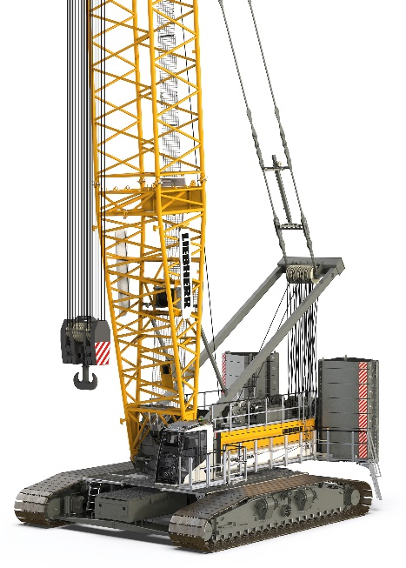Images

liebherr-lr1400sx_1.jpg  
The new weightlifter from Liebherr in the 400-tonne range.

Contact

Gregor Griesser  
Strategic Marketing and Communications  
Email: [gregor.griesser@liebherr.com](mailto:gregor.griesser@liebherr.com)

Wolfgang Pfister  
Head of Strategic Marketing & Communications  
Tel.: +43 50809 41444  
Email: [wolfgang.pfister@liebherr.com](mailto:wolfgang.pfister@liebherr.com)

Published by:

Liebherr-Werk Nenzing GmbH  
Nenzing/Austria  
[www.liebherr.com](http://www.liebherr.com)