Press release

MyJobsite - the digital solution from Liebherr for the deep foundation sector

⸺

Collection, consolidation, evaluation, and interpretation of data for a more efficient daily routine in deep foundation work

All jobsite data are permanently accessible for all relevant players

Tool for the quick and uncomplicated processing of administrative procedures

Particularly in deep foundation work, the requirements for standard-conform reports are very high. With MyJobsite, Liebherr has created a digital platform that significantly simplifies complicated data processing. The jobsite data collected every working day from the most various of sources can be consolidated, saved, individually prepared, and automatically split. The tool will also be presented at Bauma 2022 as part of Liebherr’s comprehensive range of digital services.

Munich (Germany), October 24, 2022 - Construction machines from Liebherr move in a digitalized world. At the Bauma, Liebherr is presenting MyJobsite for deep foundation machines. The tool allows a clear digital view and simplified documentation of data from the most varied of sources, as well as the processing, evaluation, and interpretation of these in relevant information (e.g., performance parameters, construction progress, machine capacity). Based on this information, quality control of certain processes on the jobsite can be carried out. This creates the basis for the optimization of working processes and ultimately for saving time and money.

View jobsite progress at the press of a button

A list of all work processes can be stored in MyJobsite with the help of planning data. In this way work steps can be systematically completed. Machine and process data can be called up live and are continuously updated. Thus, the user always has a full overview of planned, active, and completed processes, as well as the current progress of the jobsite. In accordance with ISO 27001, all collected data are enciphered and securely stored following highest security standards. The data can be completely deleted at any time upon customer request.

Clarity and user-friendliness through intuitive interface

The software interface is attractive and the handling extremely simple and intuitive. With the jobsite dashboard you always keep up-to-date. All relevant jobsite figures and machine data are clearly prepared. Thus, MyJobsite delivers information about progress, usage, actual events, and much more.

Work results automatically documented and shared

It is not only in the deep foundation sector that all performances must be documented for the client. However, precisely in this sector, most of the work results cannot be seen and inspected following completion, as they are below the surface and outside the field of vision. With MyJobsite the quality of all work carried out can be verified and documented in accordance with DIN 1536. Based on standardized protocols, all necessary documents can be quickly created with only a few clicks and entries. Furthermore, live emails or SMS messages inform defined persons about the actual progress of the jobsite.

Conclusively, MyJobsite is a very valuable instrument for quality control and documentation in the deep foundation sector. It contributes significantly to the transparency and efficiency of all jobsite processes.

About the Liebherr Group

The Liebherr Group is a family-run technology company with a highly diversified product portfolio. The company is one of the largest construction equipment manufacturers in the world. It also provides high-quality and user-oriented products and services in a wide range of other areas. The Liebherr Group includes over 140 companies across all continents. In 2021, it employed more than 49,000 staff and achieved combined revenues of over 11.6 billion euros. Liebherr was founded in Kirchdorf an der Iller in Southern Germany in 1949. Since then, the employees have been pursuing the goal of achieving continuous technological innovation, and bringing industry-leading solutions to its customers.

Images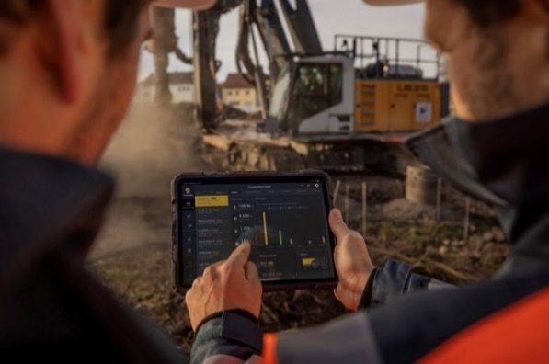

liebherr-myjobsite-01.jpg  
An overview of all jobsite data at the press of a button.

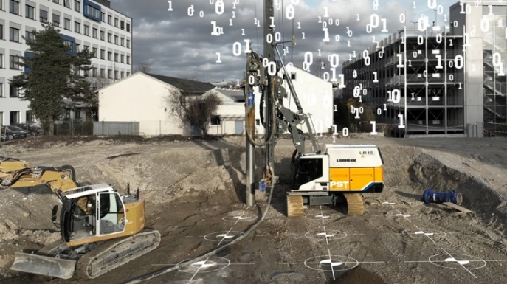

liebherr-myjobsite-02.jpg  
Different data sources are pooled in one platform.

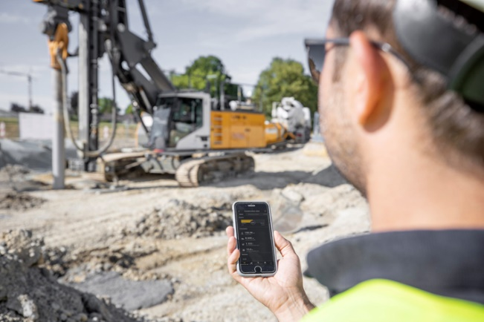liebherr-myjobsite-03.jpg  
Maintain an overview of jobsites and machines.

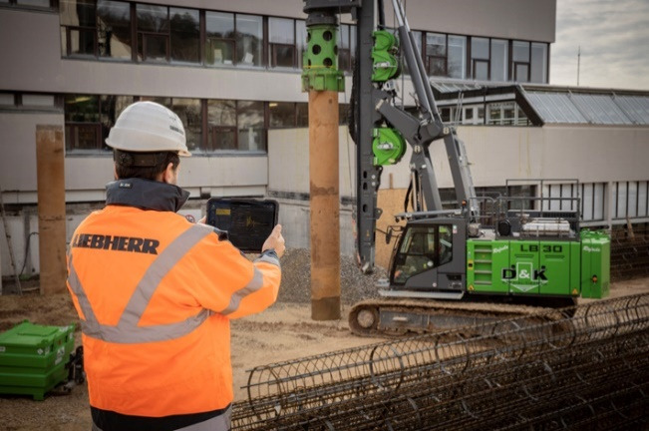

liebherr-myjobsite-04.jpg  
A helpful support in the everyday work of deep foundation specialists.

Contact

Johannes Rauch  
Strategic Marketing and Communications  
Email: [johannes.rauch@liebherr.com](mailto:johannes.rauch@liebherr.com)

Wolfgang Pfister  
Head of Strategic Marketing & Communications  
Tel.: +43 50809 41444  
Email: [wolfgang.pfister@liebherr.com](mailto:wolfgang.pfister@liebherr.com)

Published by

Liebherr-Werk Nenzing GmbH  
Nenzing/Austria  
[www.liebherr.com](http://www.liebherr.com)