Press release

Future alternatives:

Three types of low-emission drive for Liebherr telescopic handlers

⸺

Three alternative drive concepts based on practical experience with telescopic handlers

Hydrogenated vegetable oil (HVO) is a quick switch solution using an environmentally friendly, alternative fuel

The electric battery drive offers zero-emission operation in the future

The hybrid concept can be used indoors and outdoors

There is hardly any other product in the Liebherr earthmoving segment, where the portfolio of international customer applications is as diverse as with telescopic handlers. The various machine applications, combined with ranging local environmental regulations and subsidy programs, the availability of primary energy sources and infrastructural requirements, make a standardised low-emission drive all but impossible. In line with its open technology approach, the presentations from Liebherrat Bauma 2022 will include three telescopic handler drive concepts optimised for applications and markets: Hydrogenated vegetable oils (HVO) as a low-emission substitute or supplement to fossil fuels, an electric battery model and a hybrid drive consisting of a combustion engine and electric motor.

Munich (Germany), 24.10.2022 – Regardless of application, be it for a construction site or event logistics, horticulture or industrial materials handling, daily municipal use or disaster control: Telescopic handlers offer the greatest possible flexibility for lifting and transporting a wide variety of loads for customers all over the world. In addition to already supplying a wide range of application requirements, with a total of eight telescopic handler models in 26 versions, Liebherr continues to pursue further development of this type of machine with a primary focus on “maximising performance with the greatest possible environmental compatibility”.

Compatibility of customer and environmental demands

For telescopic handler applications, selection of the correct model is traditionally influenced by a variety of factors, such as lifting height, load capacity, drive and operating hydraulics speeds, desired handling capacity, single or multi-shift operation, ease of use and driver comfort, together with the number and functionality of the work tools to be operated.

Within the goal of maximising performance with the greatest possible environmental compatibility, other parameters are becoming increasingly important. These include, the location and the respective environmental regulations (inside or outside, local environmental zones with regulations for air and noise emissions, etc.), movement distances of the machine, availability of energy sources (electricity, “green fuel” etc.) and the necessary infrastructure (power quality, charging stations, fuel stations, etc.).

Liebherr is concerned with the technologies of energy conversion (engines), which are available today and in the foreseeable future, and suitable energy carriers (fuels) for these engines. With this in mind, the following three telescopic handler drive concepts, optimised for type of customer and/or application, will be outlined at Bauma 2022.

Existing hydrostatic drive, new environmentally friendly fuel - made from hydrogenated vegetable oil (HVO)

HVO is a synthetic, but sustainable fuel that is growing in importance at Liebherr. It is the first fuel available commercially that can be used with conventional combustion engines in an almost climate-neutral manner. Its production is climate-neutral if electricity from renewable energy sources is used exclusively during production. In addition, it produces lower emissions in actual use than a machine running on fossil diesel fuel.

Due to the good compatibility with all engine components and the miscibility with fossil diesel, the barrier to entry or conversion is low for customers. It is even possible to switch back to fossil diesel during operation, for example, in the event of procurement bottlenecks. Basic processes at the end customer do not have to change either: The drive concept remains in place without loss of performance, there are no other maintenance steps and no additional technical training is required.

In combination with the highly efficient Liebherr hydrostatic drive, HVO offers enormous potential for construction or mixed-use customers to reduce their CO2 footprint, as quickly as possible, without new investment, and is ready for use in low emission zones (e.g. urban operating zones).

The extent to which HVO will prevail in the market place, over the long term, depends primarily on the development of global production volumes and the associated availability. Despite significantly increasing production, HVO is only widely accessible in a few countries in Europe. For Liebherr, it is clear that the HVO solution is only environmentally and socially acceptable if palm oil is not used in production and rainforests are not cleared to gain new cultivation areas. The Group ensures this together with its HVO suppliers.

Local zero emissions based on electric battery drive telescopic handler

In addition to low-emission solutions, completely emission-free alternatives will soon be in demand in some countries and regions: For example, in Norway, all municipal construction sites, from 2025 onwards, and in general all public and private construction sites, from 2030 onwards, will be required to be operated emission-free. The local emission-free solution for the Liebherr telescopic handler is a modular high-voltage battery design paired with an electric drive, which can be scaled according to customer requirements and application, and is equipped with on-board charging electronics.

This drive is particularly suitable for indoor applications, such as recycling, and offers an impressive increase in driver comfort, low noise emissions and optimised vibration behaviour. This new “quiet power” drive also allows problem free night shift operation, and, with the battery capacities available today, an average single-shift can be completed before recharging. Recharging occurs without a special power charger and is therefore possible at any location. The overall efficiency of the system can be further increased thanks to the option of energy recovery.

Due to the charging times, switch over to an electric machine requires certain organisational changes for the customer. But equally, this drive uses electricity, the most widely available source for self-generated primary energy, and offers control and regulation advantages in use. This advantage also applies to the hybrid drive concept described below.

20 percent and above: Fuel savings with the Liebherr hybrid concept

The third potential telescopic handler drive concept - a serial hybrid with "plug-in" - guarantees customers are not restricted by range and also allows operation without a battery. Of the three systems presented, it has the highest overall efficiency and the ability to recuperate energy when braking and lowering the boom. This means fuel savings of more than 20 percent are achievable.

Fundamentally, though, this drive version has a larger number of components and, like the electric battery model, it requires personnel specially trained in high-voltage electronics. On the other hand, this design offers a higher performance capacity (boost), which can be called up through two energy sources and be drawn off in parallel. This will prove particularly useful in mixed industrial indoor/outdoor operation. It is currently possible to operate the telescopic handler purely electrically for up to two hours, for example in a hall, and to work in hybrid mode outdoors.

The three drive concepts at Bauma 2022: Presentation and Discussion

As part of the live shows taking place, several times a day, during Bauma 2022, Liebherr will provide an insight into their open technology work in the field of alternative drive concepts. Included in the range of presentations will be the electric battery version of the Liebherr telescopic handler. All three drive concepts can be seen in the Innovation Lab. All interested parties, customers and industry representatives are invited to join a detailed discussion.

About Liebherr-Werk Telfs GmbH

Liebherr-Werk Telfs GmbH has been producing and developing an ever-growing range of construction machines with hydrostatic drives since 1976. The company is able to draw on the many years of experience of the Liebherr Group with this type of drive. Whether bulldozers or crawler loaders, telescopic handlers or pipe layers - construction machines from Telfs are consistently designed for highest efficiency and effectiveness. Increasing efficiency and reducing fuel consumption and CO2 emissions are a central focus. The latest computer-aided technologies are used both in development and production: from design engineering to welding robot processes, right through to computerised quality management.

About the Liebherr Group

The Liebherr Group is a family-run technology company with a highly diversified product portfolio. The company is one of the largest construction equipment manufacturers in the world. It also provides high-quality and user-oriented products and services in a wide range of other areas. The Liebherr Group includes over 140 companies across all continents. In 2021, it employed more than 49,000 staff and achieved combined revenues of over 11.6 billion euros. Liebherr was founded in Kirchdorf an der Iller in Southern Germany in 1949. Since then, the employees have been pursuing the goal of achieving continuous technological innovation, and bringing industry-leading solutions to its customers.

Images

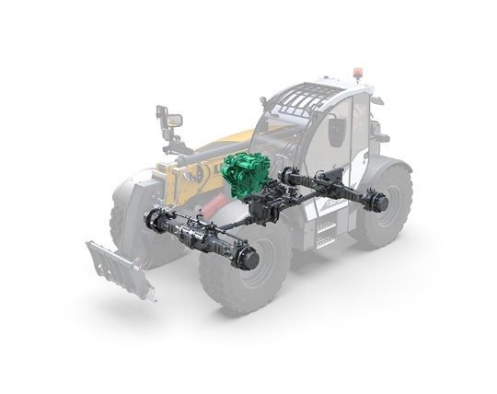

liebherr-t-hvo_96dpi.jpg  
The proven low-emission Liebherr telehandler drive can be operated alternatively with hydrogenated vegetable oil (HVO).

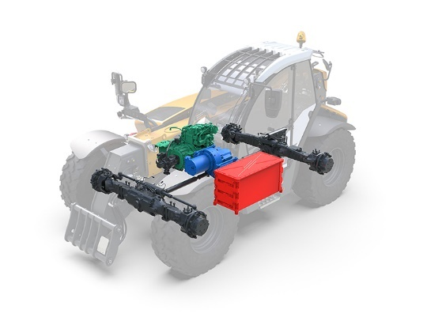

liebherr-t-hev_96dpi.jpg  
The hybrid concept – consisting of a conventional diesel engine, electric drive and electric intermediate storage

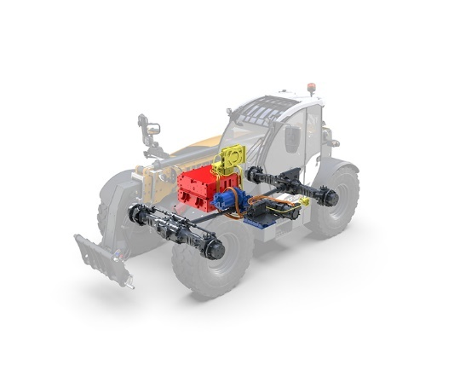

liebherr-t-bev_96dpi.jpg  
Electric Battery Zero Emission drive design with main components from a modular system

Contact

Johannes Wiedorfer  
Content Manager  
Telephone: +43 (0)508096 / 1413  
E-Mail: johannes.wiedorfer@liebherr.com

Published by

Liebherr-Werk Telfs GmbH  
Telfs / Austria  
[www.liebherr.com](http://www.liebherr.com)