Press release

Bauma 2022: Live Première of the Liebherr PR 766 G8

⸺

Equipped with High Drive, the PR 766 G8 is fully optimised for heavy-duty mining operations

Advanced efficiency: the only hydrostatic drive dozer in the 50-tonne class

Increased productivity built around safety and operator comfort

Sales Launch: Bauma 2022

The PR 766 G8 further expands the Liebherr fleet of Generation 8 earthmoving crawlers, with an operating weight of up to 55 tonnes. At the same time, the application range for this machine has been extended into the mining sector: Just like the largest Liebherr PR 776 dozer, the Liebherr PR 766 G8 now has High Drive, the proven and tested running gear for heavy-duty mining applications.

Munich (Germany), 24 October 2022 – A multifunctional bulldozer for materials handling and mining operation: The Liebherr PR 766 G8 is the latest machine generation, specifically developed to let customers take full advantage of its enormous potential in key applications. The newly designed running gear works in combination with all the advantages of cab and operating comfort to maximise man/machine performance and productivity - even on rough, stony ground over long operating periods. The diesel-hydraulic drive design sets the Liebherr crawler dozer a league ahead of the competition, with conventional torque converters. Particularly in diesel consumption, this gives the down-to-earth advantages in efficiency shown by previous generations as well as larger and smaller sister machines.

Performance and Economy: advanced, infinitely variable drive design

The new PR 766 G8 is powered by a Liebherr 8-cylinder diesel engine with a maximum output of 360 kW (490 hp) and meets Stage V and Tier 4f emission standards. The operating weight of the hydrostatic dozer is up to 54.3 t, with available blade capacities of 13.6 m³ (Semi-U blade) or 17 m³ (U-blade).

The infinitely variable hydrostatic Liebherr drive design allows customers to operate the PR 766 G8 to maximise utilisation and savings in resources: The drive components and the intelligent Liebherr engine management system are perfectly synchronised, so that diesel engine is kept at constant speed, within the optimum fuel-efficiency range (~ 1,600 rpm), by the hydrostatic drive. This really sets the Liebherr propulsion drive apart from similar D9 class drive designs available on the market, where the engine speed fluctuates significantly during use.

All Generation 8 Liebherr crawler dozers have the ECO function fitted as standard. The driver can select between high performance (including automatic Power Boost) and maximum economy, to ensure further fuel savings in light to medium-duty applications.

The complete Liebherr drive train, therefore, contributes to high efficiency and significantly lower fuel consumption compared to the industry standard for the same pushing performance.

Reliability: tough components from in-house production

Liebherr engines have been proving themselves in construction machinery applications, all over the world, for decades. Developed for the harshest of operating conditions, the robust build and state-of-art technology of these engines assure optimum operational safety and length of service life. The proven and tested hydrostatic Liebherr drive does away with the need for high-wear components, such as manual transmissions, steering clutches or service brakes. Instead, it operates with high-quality hydraulic pumps and motors that are virtually wear-free and highly reliable in service.

For highly demanding, special applications, such as in the desert, at low temperatures or in special industry operation (mining, wood, paper, etc.), Liebherr offers a wide range of tried and tested modifications ex works.

Drive design optimised and fit for purpose: High Drive for heavy mining operations

To match the heavy operating demands of rocky terrain more closely, the drive design of the larger 70-tonne dozer has been specifically adapted for the PR 766 G8.

Swivel bearing guide wheels and track rollers absorb shocks and maintain very good track chain traction. This allows the running gear to adapt more closely to the ground surface when driving over rocky terrain, but a more critical factor is the raised position of the final drive: High Drive reduces wear on sprockets and bearing bushes and protects the final drive and its seals from damage and dirt.

Driver comfort: advanced cab design with intuitive controls

The driver’s stand has been specially developed for this class of equipment so that the operator can readily find his way around. Using the Liebherr proven joystick function, he is able to control all driving and steering movements with just one electronic input device.

The cabin is packed with special features, including the centralised controls, a 9'' touch display, generous storage space and a cool box. The driver can use the display to access all the key machine parameters and simply set operating modes, such as the ECO function, automatic engine speed reduction or the drive and the steering response, as well as operate the convenience and safety functions, such as the standard reversing camera.

The PR 766 G8 has a spacious workstation, offering the best conditions for fatigue free operation. All the controls for traction drive, blade and ripper can be set by the driver to the most ergonomic position for him. The ergonomic joystick is designed for the optimum hand position to ensure the best possible comfort while operating. The seat has an integrated contact switch to automatically detect the driver’s presence, without having to operate a safety lever.

Maximum safety: excellent view of work equipment and surroundings

The modern design of the new Liebherr PR 766 G8 gives the driver a clear view in all directions, enabling highly effective work and progress and increasing safety in daily operation.

The design includes rounded body edges and sloping sides, panoramic glazing and a minimal profile for the cab-integrated ROPS/FOPS protection, to ensure optimum all-round visibility of the terrain, blade and rear ripper. This leaves an unhindered view to the front and side work area. It is not impeded by the exhaust system or the continuous work platform. The platform gives access to the cab, as well as to the service points and the filler nozzles for hydraulic and operating fluids.

Modern LEDs (1,200 lm) are used for optimum illumination of the work area. Modular lighting (including additional headlights or high-performance LEDs with 4,200 lm) is an integral part of the machine design and allows the best match of lighting to the corresponding application.

Optimum service accessibility and long replacement intervals

The new Liebherr dozer is designed for quick maintenance access and easy servicing, with centralised maintenance points, wide-opening access hatches and engine compartment doors, a standard tilting driver's cab and an optional cooling fan that can be swung out for cleaning.

Furthermore, all Liebherr dozers for mining (PR 766 and 776) have Ground Level Service Stations at the rear of the machines. Daily maintenance and service work can be conducted quickly and safely at ground level. The electrical systems include switches for access lighting, an emergency stop and Ground Level Lockout (electrical system deactivation for maintenance). For operating fluids and fuels, there is a quick-change connection for engine, pump transfer case and hydraulic oil as well as a quick refuelling device.

Liebherr's standard fleet management system, LiDAT, allows for call-up and effective management of necessary service work, warning messages, machine position, current consumption data and fluid fill levels. Depending on the subscription agreement, data is updated several times a day and can be called up at any time via the Internet. An automatic alarm can be set up for high priority notifications/info, e.g., when the device leaves a predefined zone or in the event of critical operating states.

Liebherr-Werk Telfs GmbH

Liebherr-Werk Telfs GmbH has been producing and developing an ever-growing range of construction machines with hydrostatic drives since 1976. The company is able to draw on the many years of experience of the Liebherr Group with this type of drive. Whether bulldozers or crawler loaders, telescopic handlers or pipe layers - construction machines from Telfs are consistently designed for highest efficiency and effectiveness. Increasing efficiency and reducing fuel consumption and CO2 emissions are a central focus. The latest computer-aided technologies are used both in development and production: from design engineering to welding robot processes, right through to computerised quality management.

About the Liebherr Group

The Liebherr Group is a family-run technology company with a highly diversified product portfolio. The company is one of the largest construction equipment manufacturers in the world. It also provides high-quality and user-oriented products and services in a wide range of other areas. The Liebherr Group includes over 140 companies across all continents. In 2021, it employed more than 49,000 staff and achieved combined revenues of over 11.6 billion euros. Liebherr was founded in Kirchdorf an der Iller in Southern Germany in 1949. Since then, the employees have been pursuing the goal of achieving continuous technological innovation, and bringing industry-leading solutions to its customers.

Pictures

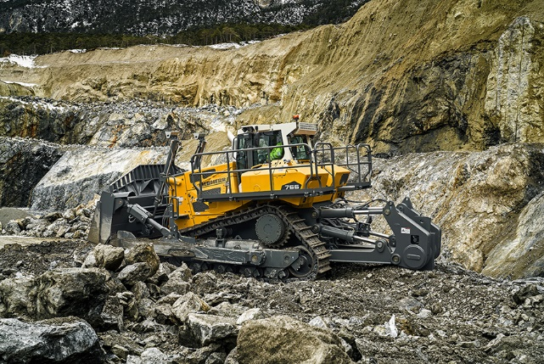

liebherr-pr766-g8.jpg  
With the benefit of hydrostatic drive, the PR 766 G8 automatically delivers the highest possible tractive force when ripping

Contact

Johannes Wiedorfer  
Content Manager  
Telephone: +43 (0)508096 / 1413  
E-Mail: johannes.wiedorfer@liebherr.com

Published by

Liebherr-Werk Telfs GmbH  
Telfs / Austria  
[www.liebherr.com](http://www.liebherr.com)