Press release

Liebherr unveils R 9300 mining excavator at Bauma 2022

⸺

Liebherr Mining introduces the new R 9300 excavator for the first time at Bauma 2022

The second Generation 8 excavator within the portfolio, the R 9300, is fitted with the most advanced Liebherr Mining technologies

Currently in testing phase, the R 9300 will enter serial production in 2024

Liebherr Mining announces the R 9300 Generation 8 hydraulic excavator at Bauma 2022. Replacing the existing R 9250 excavator in the 250-tonne class market, the R 9300 encompasses the OEM’s most advanced design principles and technology platforms to further enhance machine performance, efficiency, and safety.

Munich (Germany), 24 October 2022 – The latest hydraulic excavator to join Liebherr Mining’s portfolio is unveiled at Bauma tradeshow in Germany. The second Generation 8 excavator launched within the portfolio, the R 9300, builds on Liebherr’s decades of excavator design expertise for the mining industry and is fitted with the most advanced Liebherr Mining technologies. The R 9300 will replace the R 9250 in the 250-tonne class within Liebherr’s portfolio when the model enters serial production in early 2024, after completing its validation and testing phase.

Generation 8 Mining technologies

The latest Liebherr Mining technologies will be available on the R 9300 as a Generation 8 excavator, following the same technology platform as the R 9600 Generation 8 excavator launched in 2021. This Generation 8 technology not only provides increased operational performance, but enables future product requirements such as automation and zero emission options.

Setting new standards in the mining industry, the R 9300 is equipped with Liebherr Assistance Systems. These advanced on-board applications are designed to support operators to become more efficient through analytics and actionable insights from live data.

Liebherr’s first step in hydraulic excavator automation, the Bucket Filling Assistant, is available as an option for the backhoe version of the R 9300. The Bucket Filling Assistant is an adaptive or semi-autonomous digging function which allows for easier and faster bucket filling, improving overall productivity and reducing operator fatigue.

The Generation 8 technology also supports the latest Digital Services, a suite of data-driven products aimed to further support customers with equipment performance, asset health, connectivity, and maintenance.

Zero Emission Program: Efficient and sustainable drive options

Complimenting Liebherr Mining’s roadmap to zero emission mining equipment, the R 9300 offers optimal performance with reduced fuel consumption and emissions, improving efficiency of the overall machine. Liebherr Power Efficiency, available as standard on the R 9300, is a proprietary management system for the engine and hydraulic system controls which substantially reduces fuel consumption without compromising the overall productivity of the machine, providing a low emission solution.

The R 9300’s engines are available in FCO and US EPA Tier 4 / EU Stage V (with SCR after-treatment technology). Further, the R 9300 can be configured in either diesel or electric drive, with the electric drive able to take advantage of the Liebherr cable reeler solution. A fully autonomous solution with up to 300m of length, the cable reeler enables management of the cable during operation and provides better mobility of the machine, optimises safety, and reduces the number of crew required for cable handling.

Efficiency by design

Designed for all mining applications, the R 9300 is built for 60,000 hours design life which represents an increase of 33% when compared to the R 9250 model. With component lifetime also aligned to this improved design life and strong parts commonality between the other Liebherr excavator models, the R 9300 offers ease of maintenance for customers.

The lean design development of the R 9300, including components from the existing portfolio, promotes machine effectiveness and efficiency in performance while reducing life cycle costs.

New attachment design

The R 9300 will introduce a new attachment design with serial installation of high-performance components, including aluminium covers and new stick and boom design, which reduces the equipment’s overall weight.

In standard backhoe configuration, the R 9300 comes with a 16.5 m3 / 21.6 yd3 bucket to deliver an ideal truck/shovel match with Liebherr mining trucks. The excavator loads 180-tonne trucks in 7 passes, 130-tonne trucks in 5 passes, and 100-tonne trucks in 4 passes. Also available in face shovel configuration equipped with a 16 m3 / 20.9 yd3 shovel, the R 9300 is suitably matched with 180-tonne, 130-tonne, and 100-tonne haul trucks.

Comfort and safety: Latest cabin generation

Integrating the latest cabin generation, the R 9300’s cabin offers first-class comfort and safety for operators through enhanced cabin ergonomics as well as large touchscreens and a new control panel design.

About the Liebherr Group

The Liebherr Group is a family-run technology company with a highly diversified product portfolio. The company is one of the largest construction equipment manufacturers in the world. It also provides high-quality and user-oriented products and services in a wide range of other areas. The Liebherr Group includes over 140 companies across all continents. In 2021, it employed more than 49,000 staff and achieved combined revenues of over 11.6 billion euros. Liebherr was founded in Kirchdorf an der Iller in Southern Germany in 1949. Since then, the employees have been pursuing the goal of achieving continuous technological innovation, and bringing industry-leading solutions to its customers.

Images

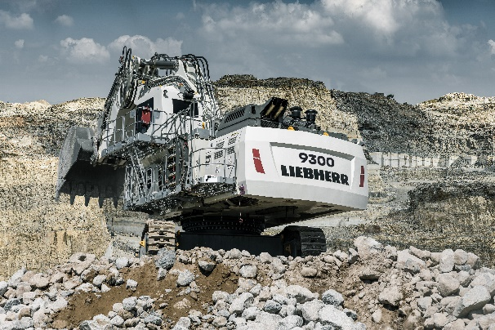

Liebherr-r9300-mining-excavator.jpg  
Liebherr has unveiled the R 9300 250-tonne class hydraulic excavator for the first time at Bauma 2022.

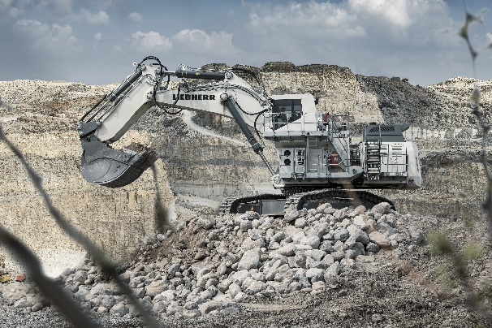

liebherr-r9300-technology.jpg  
The R 9300 Generation 8 excavator encompasses Liebherr Mining’s most advanced design principles and technology platforms.

Contact

Swann Blaise  
Divisional General Manager: Marketing & Business Intelligence  
Telephone: [+1 757 928 2239](tel:+17579282239)  
Email: [swann.blaise@liebherr.com](mailto:swann.blaise@liebherr.com)

Published by

Liebherr-Mining Equipment Colmar SAS  
Colmar / France  
[www.liebherr.com](http://www.liebherr.com)