Press release

Fleet modernization: Grúas Roxu procures ten Liebherr mobile cranes

⸺⸺

* Grúas Roxu procures one used and nine new mobile cranes from Liebherr
* The package includes four LTM 1070-4.2, three LTM 1110-5.1 and two LTM 1150-5.3. cranes, as well as one factory-refurbished LTM 1500-8.1.
* Modernisation of the fleet with innovative cranes from Liebherr
* Longstanding trusting partnership

Grúas Roxu remains true to its policy of continuous renewal of its machinery fleet: a package of modern Liebherr mobile cranes equipped with innovative technology has been procured. The new cranes, ranging from 70 to 150 tonnes capacity, will replace part of the Spanish crane and transport company's crane fleet. A factory-refurbished LTM 1500-8.1 complements the fleet in the upper lifting capacity segment.

Ehingen (Donau) (Germany), 6 Oktober 2022 – To modernize its crane fleet, Grúas Roxu ordered ten mobile cranes from Liebherr Ibérica in May 2021, nine new cranes and one factory-refurbished used crane. The package of new cranes includes four LTM 1070-4.2, three LTM 1110-5.1 and two LTM 1150-5.3. In addition, the Asturian company opted for a refurbished LTM 1500-8.1 to complement its fleet in the 500-tonne range. In the meantime, all deliveries have been made and the project is complete.

"The reason for our investment is nothing other than to renew our machinery fleet with new and innovative models from the Liebherr brand, which we have relied on for years," says José Manuel García, president of Grúas Roxu.

Modern mobile cranes boost competitiveness

Grúas Roxu took delivery of the world's first unit of the Liebherr LTM 1110-5.1 mobile crane two years ago. There are now already four units of this crane type in the fleet. "With a 60-meter telescopic boom and a compact chassis, it is a very versatile crane with an enormously high lifting capacity. These characteristics allow us to gain efficiency and competitiveness," declares the president of Grúas Roxu. We believe "that it is the most technically complete crane in its class in all its parameters, and that is why it makes a clear difference for us. Grúas Roxu is looking for the best in every case, and that was the main reason why we chose this model," continues José Manuel García.

Grúas Roxu also pioneered the purchase of the first Liebherr LTM 1150-5.3 mobile crane in Spain. For the company, the acquisition of this crane model means continuing to be at the forefront of innovative lifting solutions. Roxu also highlights the versatility and large operating radius of the 150-ton crane. "The LTM 1150-5.3 is equipped with hill start assist for manoeuvring on slopes and mountains. This innovative technology, combined with the TraXon transmission, is a great help for us due to the terrain conditions and orography of our region," emphasizes José Manuel García.

The LTM 1070-4.2 is used by Grúas Roxu for a wide range of support activities, particularly in the company's focus areas, such as industry, maritime projects, public works and wind energy. In addition, there is auxiliary work for large cranes, both inside and outside Asturias, where the company is based.

Used crane complements crane fleet

In addition to the modernization plan for new cranes, Grúas Roxu also decided to invest in a factory-refurbished Liebherr LTM 1500-8.1 mobile crane, which will allow the company to offer customized solutions to its clients. This is a model that offers great advantages thanks to its wide range of configurations, the possibility of transporting the crane fully assembled and its high lifting capacity. Currently, Grúas Roxu's LTM 1500-8.1 is in operation at a wind farm, lifting wind turbine components. It joins the other four machines of the same model that are already part of its fleet. For larger tonnages, Gruas Roxu also operates two LR 1600/2 crawler cranes, one LTR 11200 telescopic crawler crane and one LTM 11200-9.1 mobile crane.

Grúas Roxu has a fleet of 172 cranes, 118 of which are from Liebherr. "The Liebherr product range is synonymous with success and guarantee. At Grúas Roxu, we rely on their quality and innovation because they have always given us exceptional results, are easy to use and represent a secure value in the future," concludes José Manuel García.

About Grúas Roxu

Grúas Roxu began its activity in 1979 and now operates throughout Spain. The company's headquarters are located in Meres, in the center of Asturias, and since 2013 it has a branch for Central America in Costa Rica. In its more than 40 years of experience, Grúas Roxu has successfully developed a wide range of projects and operates in various sectors, such as industrial assembly and maintenance, public works, maritime projects, wind farms, special transports, and various tasks that require lifting and transport work of the highest level.

About Liebherr Ibérica, S.L.

Liebherr Ibérica is the Spanish sales and service company of the Liebherr Group and was founded in 1988. Today, Liebherr Ibérica is responsible for the sales and after-sales service of the mobile and crawler cranes, tower cranes, earthmoving machinery, mining, construction machinery, marine cranes and concrete technology divisions.

About Liebherr-Werk Ehingen GmbH

Liebherr-Werk Ehingen GmbH is a leading manufacturer of mobile and crawler cranes. Its range of mobile cranes extends from 2-axle 35 tonne cranes to heavy duty cranes with a lifting capacity of 1200 tonnes and a 9-axle chassis. Its lattice boom cranes on mobile or crawler crane chassis deliver lifting capacities of up to 3000 tonnes. With universal boom systems and extensive additional equipment, they can be seen in action on construction sites throughout the world. The Ehingen site has a workforce of 3,800. Extensive, global service guarantees the high availability of Liebherr mobile and crawler cranes. In 2021, the Liebherr plant in Ehingen recorded a turnover of 2.33 billion euros.

About the Liebherr Group

The Liebherr Group is a family-run technology company with a highly diversified product portfolio. The company is one of the largest construction equipment manufacturers in the world. It also provides high-quality and user-oriented products and services in a wide range of other areas. The Liebherr Group includes over 140 companies across all continents. In 2021, it employed more than 49,000 staff and achieved combined revenues of over 11.6 billion euros. Liebherr was founded in Kirchdorf an der Iller in Southern Germany in 1949. Since then, the employees have been pursuing the goal of achieving continuous technological innovation, and bringing industry-leading solutions to its customers.

Images

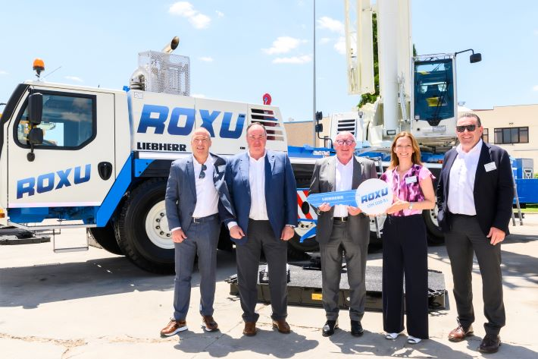  
  
liebherr-ltm1110-5.1-gruas-roxu-handover.jpg  
Official handover of the Liebherr LTM 1110-5.1 mobile crane to Grúas Roxu. From left to right: Tobias Böhler, Managing Director of Liebherr Ibérica; Marco A. García, Deputy Managing Director of Grúas Roxu; José Manuel García, President of Grúas Roxu; Sophie Albrecht, Member of the Board of Liebherr-International AG; Christoph Kleiner, Managing Director Sales of Liebherr-Werk Ehingen GmbH.

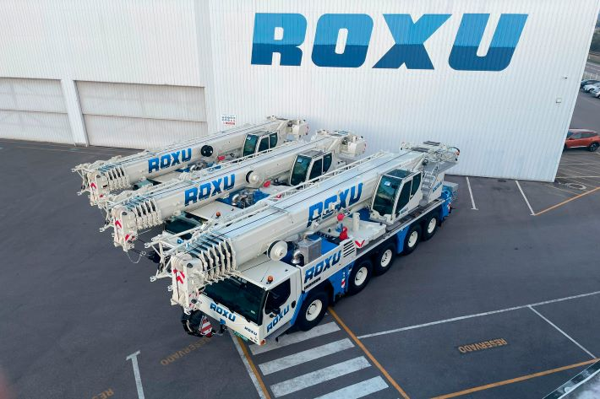

liebherr-ltm1070-4-2-ltm1100-5.1-gruas-roxu.jpg  
Two Liebherr LTM 1070-4.2 and one LTM 1110-5.1 of the package of 10 mobile cranes with which Grúas Roxu is modernizing its crane fleet.

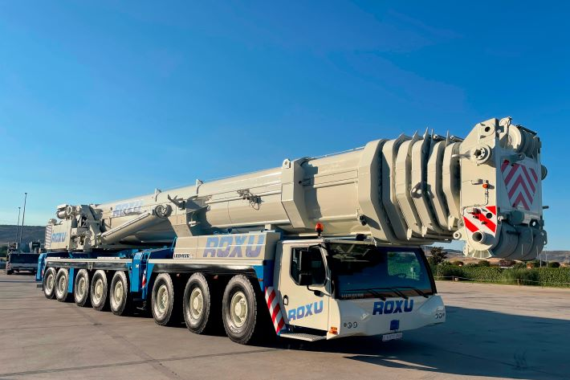liebherr-ltm1500-gruas-roxu.jpg  
The factory-refurbished Liebherr LTM 1500-8.1 mobile crane complements the Roxu fleet in the 500-ton range.

**Contact**

Wolfgang Beringer  
Marketing and Communication  
Phone: +49 7391/502 - 3663  
Email: wolfgang.beringer@liebherr.com

**Published by**

Liebherr-Werk Ehingen GmbH  
Ehingen (Donau), Germany  
[www.liebherr.com](http://www.liebherr.com)