Press release

Modernisation and expansion – Schuch buys 15 new Liebherr mobile cranes

⸺

The machines will be delivered between 2021 and 2023

Full order books due to expansion of infrastructure for rail, road and renewables

Liebherr delivers innovative crane technology, high quality and reliable service

Crane and heavy haulage contractor Schuch is modernising and expanding its mobile crane fleet. With this in mind, the company, which has several outlets in the Rhine-Main and Rhine-Neckar conurbations, has ordered 15 new mobile cranes from Liebherr with lifting capacities between 90 and 750 tonnes. The company is readying itself to face current and future challenges on the market by means of continuous new and replacement purchases as well as innovative crane technology. Schuch has already taken delivery of the first of these cranes with the delivery of the last ones being scheduled for the end of 2023.

Ehingen (Donau) (Germany), 17 January 2022 – The order situation at Schuch is good. And renewables are playing a major role in this situation. Managing Director Stefan Schuch explains: “Expanding the infrastructure for rail, road and renewables requires more mobile cranes. That is what made up our minds to expand our fleet.” Son Tim, also a Managing Director of the family-run company, currently managed by the third generation, adds: “It is important to keep our crane fleet up with the very latest crane technology to ensure that we can provide our customers with the best possible service. That is another reason for investing in new mobile cranes.”

Schuch has selected Liebherr products to modernise its fleet. “Liebherr delivers innovative technology, for example its VarioBase® variable supporting base and Varioballast® adjustable ballast. Another benefit for us, a crane rental contractor, is the fact that the crane control systems are uniform on all Liebherr mobile cranes, from small to large,” Tim Schuch continues. Stefan Schuch goes on: “We have been buying from Liebherr for over 35 years. In addition to the technology, we are delighted with its quality and reliable support from the service team. We can rely on Liebherr.”

Schuch has ten sites between Saarbrücken in the west, Frankfurt in the north and Karlsruhe in the south. The company has a 120-strong workforce and specialises in crane work with a total of around 80 mobile cranes.

About Liebherr-Werk Ehingen GmbH

Liebherr-Werk Ehingen GmbH is a leading manufacturer of mobile and crawler cranes. Its range of mobile cranes extends from 2-axle 35 tonne cranes to heavy duty cranes with a lifting capacity of 1200 tonnes and a 9-axle chassis. Its lattice boom cranes on mobile or crawler crane chassis deliver lifting capacities of up to 3000 tonnes. With universal boom systems and extensive additional equipment, they can be seen in action on construction sites throughout the world. The Ehingen site has a workforce of 3,500. Extensive, global service guarantees the high availability of Liebherr mobile and crawler cranes. In 2020, the Liebherr plant in Ehingen recorded a turnover of 2.03 billion euros.

About the Liebherr Group

The Liebherr Group is a family-run technology company with a highly diversified product portfolio. The company is one of the largest construction equipment manufacturers in the world. It also provides high-quality and user-oriented products and services in a wide range of other areas. The Liebherr Group includes over 140 companies across all continents. In 2020, it employed around 48,000 staff and achieved combined revenues of over 10.3 billion euros. Liebherr was founded in Kirchdorf an der Iller in Southern Germany in 1949. Since then, the employees have been pursuing the goal of achieving continuous technological innovation, and bringing industry-leading solutions to its customers.

**Photograph:**

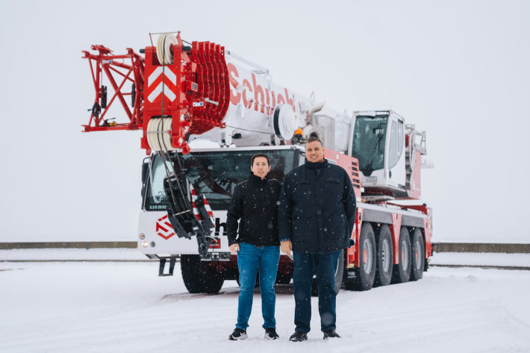

liebherr-ltm1150-5-3-schuch.jpg  
Schuch takes delivery of one of the first mobile cranes from its large order in the form of the LTM 1150-5.3 in Ehingen – from left to right: Tim Schuch, Stefan Schuch. The locally applicable Corona specifications were complied with.

**Contacts**

Wolfgang Beringer  
Marketing and Communication  
Phone: +49 7391/502 - 3663  
Email: wolfgang.beringer@liebherr.com

**Published by**

Liebherr-Werk Ehingen GmbH  
Ehingen (Donau) / Germany  
www.liebherr.com