Press release

Reaching new heights – Liebherr unveils mobile crane with 90 metre telescopic boom – the new LTM 1300-6.3

⸺

The LTM 1300-6.3 can travel with its complete 90 metre telescopic boom on public roads

Liebherr innovations add performance, comfort and safety

LTM 1300-6.2 is still available as an entry point model into the class of luffing jib cranes

Unveiling the LTM 1300-6.3 also sees Liebherr set a new world record – never before has a mobile crane been able to carry a 90 metre telescopic boom with an axle load of just 12 tonnes. The new 300 tonne model will add to the portfolio of Liebherr 6-axle cranes. It is a versatile, economical fast-erecting crane with a peerless telescopic boom length. The latest Liebherr innovations are included to enable the LTM 1300-6.3 to deliver economical, safe, powerful crane operation – ECOmode, ECOdrive, VarioBase®Plus, VarioBallast®, Auto-Ballast, single-engine concept and wind speed load charts. The LTM 1300-6.2 will remain in the portfolio as the entry point model into the class of luffing jib cranes.

Ehingen (Donau) (Germany), 19 January 2022 – Liebherr has extended its portfolio of all-terrain cranes with another 300-tonne model. With its 90 metre telescopic boom, the LTM 1300-6.3 sets new standards in the 6-axle class and goes well beyond what the current cranes on the market have to offer. It is designed to be used as a fast-erecting crane with a high capacity at great hoist heights with a raised boom. That makes it ideal for erecting tower cranes and antennae as well as for wind turbine maintenance work. The LTM 1300-6.2 with 78-metre telescopic boom, offered by Liebherr in parallel, is the economical entry into the luffing jib class and in this configuration already offers unrivalled load capacities for a 6-axle mobile crane.

Liebherr has made it possible to drive the LTM 1300-6.3 with different axle loads and gross weights, to ensure that it can be driven economically all over the world. Components such as the telescopic boom and outriggers can be installed and removed quickly and easily to achieve axle loads of less than 12 tonnes. One particularly interesting feature in this respect is tele-separation, which enables individual telescopic sections to be removed particularly quickly. This makes it straightforward to set up the crane for the road with a gross weight of less than 60 tonnes and axle loads of under ten tonnes. Liebherr can also deliver a self-assembly solution which enables the telescopic sections to be removed without the need for an auxiliary crane. This is compatible with other models such as the LTM 1650-8.1 and the LTM 1450-8.1. The flexibility and economy of the crane is increased enormously as a result.

Record-breaking boom

The record length of 90 metres is achieved by the new LTM 1300-6.3 using an 8-section telescopic boom – the pivot section plus seven telescopic sections. That is one section more than similar cranes in this class. To ensure that the complete boom as well as all the outriggers plus the hook block can be carried on public roads with an axle load of 12 tonnes, Liebherr has optimised the entire steel construction of the crane for lightweight construction.

Although the LTM 1300-6.3 is not designed for use as a luffing jib crane, it has a wide range of lattice jibs available – 11.5 to 20 metre double folding jib, two 7 metre lattice sections to extend the telescopic boom, a 39 metre powerful fixed jib and a 43 metre hydraulically adjustable fixed jib. That enables the new 300 tonne crane to reach hoist heights of up to 120 metres. Particularly economical – various lattice sections are also compatible with other models in the Liebherr portfolio.

Wide range of innovations

**Wind speed load charts –** load charts available for various wind speeds are available for the LTM 1300-6.3. They deliver enhanced safety and longer operating times for crane work in windy conditions. Load charts for cranes are generally only valid for gust wind speeds of up to 9 m/s. To ensure that work can continue safely in even higher wind speeds, Liebherr has calculated the load charts for additional maximum wind speeds and programmed them in the crane control system. For the LTM 1300-6.3, for example, it is 11.2 m/s, or even 13.4 m/s when using lattice equipment. In pure telescope mode, the tables even allow for a speed of 15.6 m/s. If the wind speed measured on the crane’s boom during a job exceeds the set chart wind speed, the crane operator can simply switch to a load chart with a higher maximum wind speed which will often allow the job to be continued.

**VarioBase®Plus –** the rear supports have a double-stage design and achieve a support width of 9.4 metres, 2 metres wider than the front supports. This increases the capacity over the rear supports even more. The single-stage front outriggers have a lower weight, which also benefits the boom length.

**ECOdrive –** an eight-cylinder Liebherr diesel engine in the undercarriage which develops 455 kW / 619 bhp and torque of 3,068 Nm provides the LTM 1300-6.3 with all the power it needs. The power is transferred to the crane axles by the 12-speed ZF TraXon torque gearbox. A torque converter ensures perfect manoeuvring. The additional ECOdrive mode delivers enhanced drive properties which both save fuel and reduce noise.

**Single-engine concept with ECOmode –** Liebherr has continued its single-engine strategy on the new LTM 1300-6.3 with a mechanical power unit for the superstructure. The weight reduction created by removing the superstructure engine has been used to deliver a longer boom and more ballast with an axle load of 12 tonnes. ECOmode in crane operation helps to reduce fuel consumption and noise emissions. The complete pump drive is disconnected automatically when the engine is idling and then reconnected by the intelligent controller in a matter of seconds when required.

**VarioBallast® –** the new LTM 1300-6.3 can be operated with two different ballast radii: 4.94 m or 5.94 m. The ballast radius can be reduced quickly and easily by one metre using standard mechanically adjusted ballasting cylinders. This solution is one of the main benefits of the new 300-tonne model when used in constricted conditions. The large ballast radius achieves maximum capacity. In fact, with its VarioBallast feature, the new crane can be operated with 8 tonnes less ballast compared to the LTM 1300-6.2 without any significant reduction of its lifting capacity. That reduces both transport logistics and CO2 emissions.

**Auto-Ballast –** a single touch of a button is all that is required to secure the ballast to the turntable. That takes the strain off the crane operator as the automatic ballasting process is simple, fast and convenient. In addition, safety is also enhanced, particularly for routine procedures.

The maximum ballast on the LTM 1300-6.3 is 88 tonnes. The 10 tonne suspended ballast blocks on the right and left are compatible with the LTM 1230-5.1 and LTM 1250-5.1 crane models. That makes them another economical solution for operators with these cranes in their fleets. There is also the fact that the individual ballast slabs have been modified in terms of their weight and dimensions to make them suitable for economical transport and fast, easy set up on site. All the ballast can be placed on the crane with just five hoists. The basic ballast of 42 tonnes has a width of just 3 metres, which means that it fits within the overall width of the vehicle. This makes it significantly easier to move the fully set-up crane on constricted sites.

**New options –** the optional central lubrication system for the king pin bearings on the chassis is a new feature. It delivers grease to 24 lube points on the 6-axle crane automatically. Another highlight is that a total of six LED rear lights are available to order, which illuminate the working area perfectly with bright light for manoeuvring on the site.

About Liebherr-Werk Ehingen GmbH

Liebherr-Werk Ehingen GmbH is a leading manufacturer of mobile and crawler cranes. Its range of mobile cranes extends from 2-axle 35 tonne cranes to heavy duty cranes with a lifting capacity of 1200 tonnes and a 9-axle chassis. Its lattice boom cranes on mobile or crawler crane chassis deliver lifting capacities of up to 3000 tonnes. With universal boom systems and extensive additional equipment, they can be seen in action on construction sites throughout the world. The Ehingen site has a workforce of 3,500. Extensive, global service guarantees the high availability of Liebherr mobile and crawler cranes. In 2020, the Liebherr plant in Ehingen recorded a turnover of 2.03 billion euros.

About the Liebherr Group

The Liebherr Group is a family-run technology company with a highly diversified product portfolio. The company is one of the largest construction equipment manufacturers in the world. It also provides high-quality and user-oriented products and services in a wide range of other areas. The Liebherr Group includes over 140 companies across all continents. In 2020, it employed around 48,000 staff and achieved combined revenues of over 10.3 billion euros. Liebherr was founded in Kirchdorf an der Iller in Southern Germany in 1949. Since then, the employees have been pursuing the goal of achieving continuous technological innovation, and bringing industry-leading solutions to its customers.

**Photographs:**

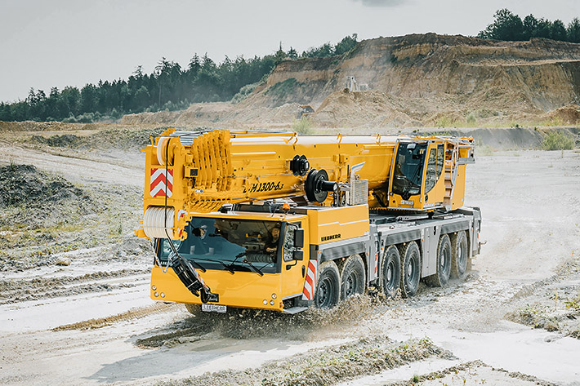

liebherr-ltm1300-6-3.jpg  
The new Liebherr LTM 1300-6.3 mobile crane sets new standards in the 300 tonne class.

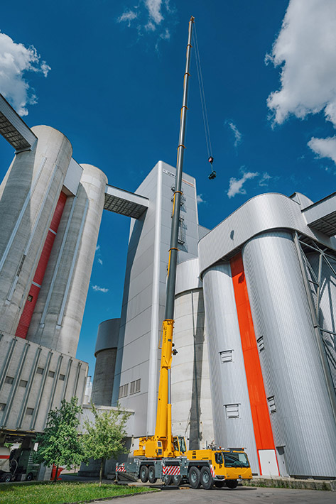

liebherr-ltm1300-6-3-boom.jpg  
The highlight of the new LTM 1300-6.3 is its 90 metre telescopic boom.

**Contact**

Wolfgang Beringer  
Marketing and Communication  
Phone: +49 7391/502 - 3663  
Email: wolfgang.beringer@liebherr.com

**Published by**

Liebherr-Werk Ehingen GmbH  
Ehingen (Donau) / Germany  
www.liebherr.com