Press release

Liebherr LTM 1650-8.1 installs bridge in area struck by disaster

⸺

Wasel GmbH uses Liebherr LTM 1650-8.1 to provide assistance in Euskirchen

THW hoists a 46 tonne temporary bridge over the River Erft to replace the bridge that was washed away

This is a major signal to demonstrate progress in the restoration work

The Bielefeld branch of the Federal Agency for Technical Relief (THW) has hoisted a 46 tonne temporary prefabricated bridge over the River Erft using an LTM 1650-8.1. It will replace the bridge that was destroyed and washed away by the severe flooding in summer 2021. It means that car drivers and pedestrians in the south-west of the district capital will once again be able to cross the River Erft. The temporary bridge has sufficient capacity to carry vehicles weighing up to 30 tonnes. It is an important signal for the local population to show that restoration work is progressing and is due to remain in place for around one year until the brand new Erft bridge is ready for installation.

Ehingen (Donau) (Germany), 24 January 2022 – In the Euskirchen disaster zone, the severe flooding in 2021 resulted in the bridge over the River Erft being destroyed and washed away by the sheer volume of water. THW Bielefeld has provided a solution in the Euskirchen suburb of Roitzheim in the form of a prefabricated temporary bridge. The temporary bridge was built by the THW and then assembled on site using an LTM 1050-3.1. The bridge, weighing 46 tonnes and measuring 22 metres long and 7 metres wide was then hoisted over the River Erft by an LTM 1650-8.1. The THW had engaged Cologne crane and heavy haulage contractor Wasel GmbH to complete this work.

The crane was set up with 135 tonnes of ballast with a ballast radius of 8.4 metres. The radius for hoisting the bridge into position, which weighed 50 tonnes, including the hook and fastening equipment, was 27 metres. Positioned on a concrete foundation, the bridge contains 1260 screw connections, which gives it sufficient capacity to carry vehicles weighing up to 30 tonnes. It will therefore be an important feature for the local population, enabling them to cross the River Erft in the south-west of the district capital. Julian Schmidt, Technical Director at Wasel, takes up the story: “The restoration work in the affected areas is proceeding at full speed and we are delighted that we can provide some assistance in these situations. It’s also wonderful to see how many people are doing such good work every day to get a little bit of normality back to the affected areas as quickly as possible.”

Mayor Sascha Reichelt describes the temporary bridge as a major signal for the people of Euskirchen. It is a symbol of reconstruction and shows that life goes on. The temporary bridge is currently scheduled to remain in place for around one year until the new bridge is ready. The new construction presents a challenge, however, as the gas, water and telecommunications lines were all carried in the old bridge and will also have to be rerouted. THW Bielefeld is one of just 16 local THW organisations which has a specialist “bridge building” group and was already in action in the Ahrweiler district, which was also badly affected by the flood. “This is a special moment for me. I have never done anything like this before,” says an impressed THW Team Leader, Burkhard Aehlich.

About Liebherr-Werk Ehingen GmbH

Liebherr-Werk Ehingen GmbH is a leading manufacturer of mobile and crawler cranes. Its range of mobile cranes extends from 2-axle 35 tonne cranes to heavy duty cranes with a lifting capacity of 1200 tonnes and a 9-axle chassis. Its lattice boom cranes on mobile or crawler crane chassis deliver lifting capacities of up to 3000 tonnes. With universal boom systems and extensive additional equipment, they can be seen in action on construction sites throughout the world. The Ehingen site has a workforce of 3,500. Extensive, global service guarantees the high availability of Liebherr mobile and crawler cranes. In 2020, the Liebherr plant in Ehingen recorded a turnover of 2.03 billion euros.

About the Liebherr Group

The Liebherr Group is a family-run technology company with a highly diversified product portfolio. The company is one of the largest construction equipment manufacturers in the world. It also provides high-quality and user-oriented products and services in a wide range of other areas. The Liebherr Group includes over 140 companies across all continents. In 2020, it employed around 48,000 staff and achieved combined revenues of over 10.3 billion euros. Liebherr was founded in Kirchdorf an der Iller in Southern Germany in 1949. Since then, the employees have been pursuing the goal of achieving continuous technological innovation, and bringing industry-leading solutions to its customers.

**Photographs:**

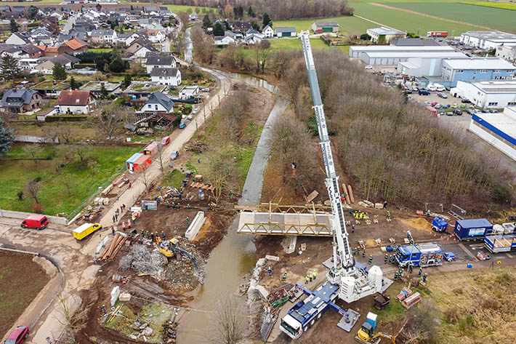

liebherr-ltm1650-8-1-wasel-1.jpg  
THW Bielefeld hoists a 46 tonne temporary bridge with the help of the LTM 1650-8.1 over the River Erft in the Euskirchen disaster zone. It will be a massive help to the people there and represents a major step forward in the reconstruction efforts.

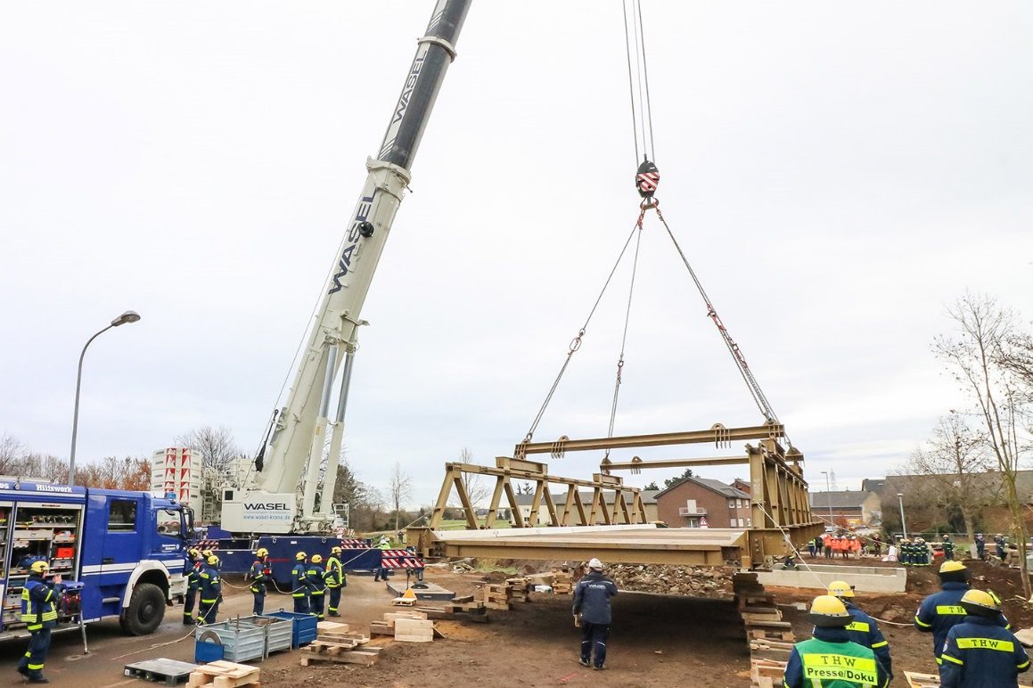

liebherr-ltm1650-8-1-wasel-2.jpg  
To hoist the bridge, THW Bielefeld engaged Wasel GmbH, which used an LTM 1650-8.1 for the project. Over 40 holders of honorary positions were also involved.

**Contacts**

Wolfgang Beringer  
Marketing and Communication  
Phone: +49 7391/502 - 3663  
Email: wolfgang.beringer@liebherr.com

**Published by**

Liebherr-Werk Ehingen GmbH  
Ehingen (Donau) / Germany  
www.liebherr.com