Press release

In Spain's largest wind farm: Transbiaga with three Liebherr LG 1750s in operation

⸺

Three LG 1750s from Transbiaga make their debut at the Spanish wind farm Gecama

The Liebherr LG 1750 lattice boom mobile cranes erect 67 wind turbines with 120-metre hub heights

Good operability, high load capacity and mobility of the cranes are crucial

**Working in Spain's largest wind farm: the crane and heavy transport company Transbiaga is working with three new Liebherr LG 1750 lattice boom mobile cranes in the wind farm Gecama. There, 67 wind turbines with a hub height of 120 metres are being erected to feed energy from renewable sources into the national power grid.**

Ehingen (Donau) (Deutschland), 28 January 2022 - Four Liebherr LG 1750 lattice boom mobile cranes, 67 wind turbines and 120 metre hub height: full operation for the heavyweights at the Gecama wind farm in the Spanish province of Cuenca. The components of the concrete towers weigh up to 255 tonnes. The nacelle, including the generator, weighs 140 tonnes. The rotor blades weigh 21 tonnes and are 74 metres long. "In addition to our three new LG 1750s, there is also an LG 1750 from Grúas Ibarrondo, our partner in this wind project," says Jon Usabiaga, CEO of Transbiaga. The turbines were manufactured by the Nordex Group, one of the world's largest manufacturers of wind turbines, based in Hamburg and Rostock.

Transbiaga is very familiar with the use of the Liebherr LG 1750 lattice boom mobile crane, as the company already has five other units in its fleet. "In addition to its good operability, we also chose this crane model because of its high load capacity and mobility, factors that meet the needs and requirements of a wind farm. We bought the new equipment with the even stronger SX boom system. This means we are also well positioned for the future generation of wind turbines," reports Jon Usabiaga. "The cranes are configured with 165-metre main boom and F-jib."

The three new Liebherr LG 1750s complement Transbiaga's machinery perfectly, "as we use them as main cranes for wind farm assembly. They are indispensable to carry out this type of project in the most efficient way and with the highest possible quality," Usabiaga points out. "They are particularly well suited to work in wind farms, as they can travel independently on the paths between each turbine. They have a smaller width than a crawler crane." Transbiaga focuses its work mainly on the assembly of wind farms in Europe and Latin America. To be able to carry out this type of project, the company also has eight units of the Liebherr LR 1600/2W narrow track crawler crane, which is also predestined for driving on narrow tracks in wind farms.

Largest wind farm in Spain

The Gecama wind farm, owned by Enlight Renewable Energy, is the largest wind farm in Spain built in a single phase. Located in the province of Cuenca, it will cover an area of 41 km2 and have almost 80 km of road network. Gecama will have an installed capacity of more than 300 megawatts, generate around 1,000 gigawatt hours per year and save 160,000 tonnes of CO2 emissions.

For Transbiaga, the work on the installation of the Gecama wind farm is very important. Usabiaga reports: "We are proud that such renowned customers as Nordex trust us to carry out this type of wind project. This means that we are among the benchmarks in the industry worldwide, both in terms of the capacity of our fleet and our work teams, and in terms of maintaining high safety and quality standards." The construction of this wind farm is part of a series of projects that Transbiaga has been carrying out in Spain for years for Nordex, one of its largest customers. Other active projects are in Sweden, Chile, Brazil, Mexico and Puerto Rico. Expansion to other countries is planned for later this year.

Transbiaga has a fleet of 49 cranes. 43 mobile and crawler cranes with telescopic and lattice booms are from Liebherr, testifying to the trust Transbiaga has in the quality and performance of Liebherr products and customer service.

About Transbiaga

Transbiaga started its business with a focus on national and later on international transport. A few years later, the company started operating large mobile cranes and in recent years has complemented both activities with the assembly of all types of structures. The Transbiaga Group, which has branches in Spain, Sweden, South Africa, Brazil, Mexico, Chile, Argentina and Colombia, among others, has around 500 employees. The company combines an experienced and professional team with a fleet of state-of-the-art equipment and machinery from leading brands to offer a complete and comprehensive service for transport, mobile cranes and erection equipment.

About Liebherr Ibérica, S.L.

Liebherr Ibérica is the Spanish sales and service company of the Liebherr Group and was founded in 1988. Today, Liebherr Ibérica is responsible for the sales and after-sales service of the mobile crane, construction machinery, mining, maritime crane and concrete technology divisions.

About Liebherr-Werk Ehingen GmbH

Liebherr-Werk Ehingen GmbH is a leading manufacturer of mobile and crawler cranes. Its range of mobile cranes extends from 2-axle 35 tonne cranes to heavy duty cranes with a lifting capacity of 1200 tonnes and a 9-axle chassis. Its lattice boom cranes on mobile or crawler crane chassis deliver lifting capacities of up to 3000 tonnes. With universal boom systems and extensive additional equipment, they can be seen in action on construction sites throughout the world. The Ehingen site has a workforce of 3,500. Extensive, global service guarantees the high availability of Liebherr mobile and crawler cranes. In 2020, the Liebherr plant in Ehingen recorded a turnover of 2.03 billion euros.

About the Liebherr Group

The Liebherr Group is a family-run technology company with a highly diversified product portfolio. The company is one of the largest construction equipment manufacturers in the world. It also provides high-quality and user-oriented products and services in a wide range of other areas. The Liebherr Group includes over 140 companies across all continents. In 2020, it employed around 48,000 staff and achieved combined revenues of over 10.3 billion euros. Liebherr was founded in Kirchdorf an der Iller in Southern Germany in 1949. Since then, the employees have been pursuing the goal of achieving continuous technological innovation, and bringing industry-leading solutions to its customers.

**Pictures:**

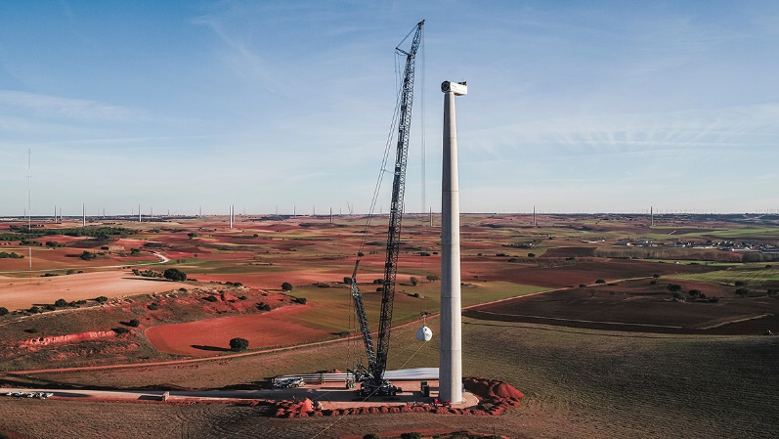

liebherr-lg1750-transbiaga-01.jpg  
Three LG 1750s from Transbiaga make their debut at the Spanish wind farm Gecama erecting wind turbines with 120-metre hub heights.

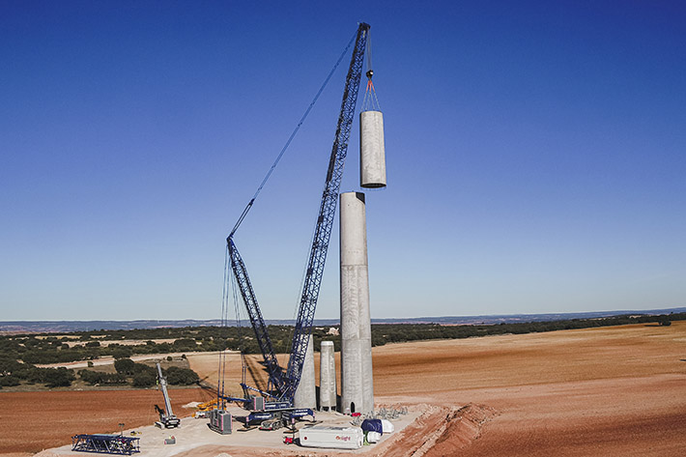

liebherr-lg1750-transbiaga-02.jpg  
Components of the concrete towers weigh up to 255 tonnes. The nacelle with the generator of the Nordex DELTA4000 wind turbine weighs 140 tonnes. The rotor blades weigh 21 tonnes and are 74 metres long.

**Contacts**

Wolfgang Beringer  
Marketing and Communication  
Phone: +49 7391/502 - 3663  
Email: wolfgang.beringer@liebherr.com

**Published by**

Liebherr-Werk Ehingen GmbH  
Ehingen (Donau) / Germany  
www.liebherr.com