Press release

Around the world with 80 cranes

⸺

Liebherr mobile harbour cranes looks back on a successful 2021 with more than 80 new machines sold and an unrivalled order intake volume

Liebherr remains the clear market leader in the field of mobile harbour cranes

Worldwide strong demand for electric main drives and the all-electric LPS 420 E

Rostock (Germany), January 2022 - Liebherr has had a record year with its maritime mobile harbour cranes. The order intake volume in the past year 2021 was higher than ever before. In total, more than 80 new units and also various used units were sold to customers worldwide. Liebherr mobile harbour cranes were ordered from 31 different countries with all continents being represented. There was strong growth in the Middle East and West Africa regions and stable core markets in Europe as well as North and South America. As in previous years, the LHM 550 is the most popular crane, closely followed by the LHM 420. A strong increase in sales of the LHM 800 was recorded, which more than tripled compared to the previous year.

The strong sales in 2021 has helped build up a very-promising order book in the mobile harbour crane sector and we can look forward to 2022 with confidence. "The Liebherr mobile harbour crane and its clear technical advantages in the MHC market have once again convinced customers all over the world. I am very proud of our sales team here in Rostock and in more than 40 sales and service companies worldwide. Only through our cooperative and partnership-based collaboration can we meet the needs of our customers," says Andreas Müller, Sales Director for Liebherr Mobile Harbour Cranes.

**The year of the portal crane**

Another record was set in the area of portal cranes. Liebherr has never before sold so many harbour cranes with a portal substructure. More than 20 new units were Liebherr Portal Slewing Cranes (LPS). Liebherr was able to close the year with a major portal crane project at the end of 2021. The leading steel manufacturer in Italy, Acciaierie d'Italia, ordered four new LPS 800 portal cranes. The four machines are 100 % electrically powered and allow for emission-free bulk handling. They are also equipped with Liebherr's Pactronic hybrid system, which supplies the crane with additional power when required.

**Trend towards emission-free terminals**

Almost half of all mobile harbour cranes sold in 2021 were equipped with an electric main drive and thus equipped for emission-free cargo handling. The demand for various electric drive solutions has doubled when compared to the sales year 2019. "The Liebherr MCC-tec GmbH has stood for sustainability in drives for decades. We see that our sophisticated electric motors are revolutionising port handling. Together with our customers, we will continue on the path to sustainable ports. Our innovative cranes and the development of CO2-neutral drive technology is inspiring the industry. Competition is trying to catch up, but Liebherr-MCC-tec have been leading the field in terms of development and innovation for many years," comments Andreas Ritschel, Deputy Sales Manager for Liebherr Mobile Harbour Cranes.

**All-electric LPS 420 E**

2021 was also the year of the all-electric LPS 420 E portal crane. There is a clear trend within the maritime crane industry towards more electric main drives visible. In addition, the advanced LPS 420 E, which is powered exclusively by electric motors, also had a record year. Although sales have been consistently stable since its launch, a total of six portal cranes were sold in 2021 - one of them to Germany. Euroports Germany, based in Rostock, will commission the first all-electric LPS 420 E in the European market next year. "We want to further strengthen the handling performance at our bulk terminal. In the coming year, we are not only investing in a new crane to be even more efficient, but we also want to make our contribution to sustainability," says Karsten Lentz Managing, Director of the Euroports Germany Group.

**Growth market Africa**

Africa has been experiencing an economic upswing for several years now, accompanied by extensive investments in infrastructure. The continent is expected to have enormous economic potential in the future. This development has been reflected in African ports for years and is also visible in 2021, especially for container handling LHMs. Liebherr has delivered two new LHM 800s in the high-rise variant to the Sogester Container Terminal in Angola. Shortly before the end of the year, two more LHM 800s were shipped to Togo. The customer TIL Terminals will use the two giants for container handling in the port of Lomé.

**Growing responsibility**

A strengthened market position also results in growing responsibility towards customers and partners worldwide. Liebherr MCC-tec is aware of the trust placed in it with regard to quality, reliability, and availability. "We can only live up to this responsibility through joint efforts. We achieve this by continuously optimising our service network, our technologies, and our standards," says Martin Mathis, General Manager Customer Service Liebherr maritime cranes.

**Sustainability in action**

In addition to the various electric solutions, Liebherr also offers the possibility of operating diesel-powered equipment in a more environmentally friendly way. In the first half of the year, the first LHM 420 powered by HVO diesel was delivered to the Swedish port city of Södertälje. HVO Renewable Diesel is a fossil-free premium diesel product made from 100 % renewable raw materials that emits no additional carbon dioxide into the atmosphere. A further step towards sustainability was achieved in September of 2021 when Liebherr-MCCtec was awarded the EcoVadis Gold Medal. EcoVadis is the world's most renowned provider of sustainability ratings with over 85,000 companies assessed. The gold medal places Liebherr-MCCtec among the top 5 % of all rated companies and the top 3 % of manufacturing companies.

About Liebherr-MCCtec Rostock GmbH

Liebherr-MCCtec Rostock GmbH is one of the leading European manufacturers of maritime handling solutions. The product range includes ship, mobile harbour, and offshore cranes. Reach stackers and components for container cranes are also included in the product portfolio.

About the Liebherr Group

The Liebherr Group is a family-run technology company with a broadly diversified product range. It is one of the world's largest manufacturers of construction machinery, but also offers high-quality, user-oriented products and services in many other areas. Today, the group comprises more than 140 companies on all continents, employs around 48,000 people and generated a total consolidated turnover of more than 10.3 billion euros in 2020. Since its foundation in 1949 in Kirchdorf an der Iller in southern Germany, Liebherr has pursued the goal of impressing its customers with sophisticated solutions and contributing to technological progress.

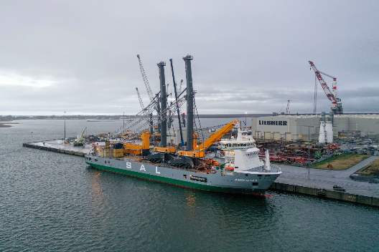Images

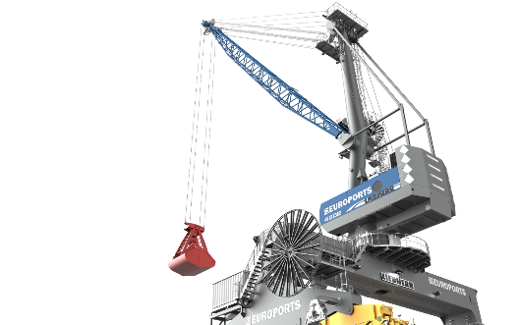TIL Terminals will use two LHM 800 high-rise mobile harbour crane giants for container handling in the port of Lomé, Togo, Africa.

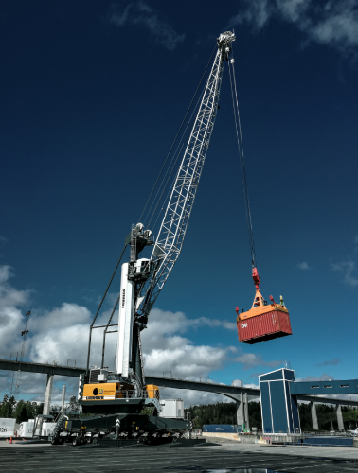LPS 420 E sales have been consistently stable since its market launch, six gantry cranes were sold in 2021 - one of them to Euroports Germany.

The first LHM 420 powered by HVO diesel was delivered to the Swedish port city of Södertälje.

Contact

Philipp Helberg

Tel: +49 381 6006 5024

Email: philipp.helberg@liebherr.com

Published by

Liebherr-MCCtec Rostock GmbH

Rostock / Germany

www.liebherr.com