Press release

Liebherr-EMtec GmbH drives digitisation forward together with customers

⸺
Digitisation is one of the defining megatrends in the construction and material handling technology industry. Liebherr-EMtec GmbH is helping to shape technological progress and, as part of its digitisation strategy, is working with customers to develop solutions that will enable them to carry out construction projects more economically, efficiently and safely in the future. The company provides customers with relevant practical knowledge on a customer-oriented IoT platform so they can operate their entire machine fleet with maximum reliability and productivity. Condition and performance data of earthmoving and material handling machines as well as attachments are the core of the modular and upgradeable application.
Kirchdorf an der Iller (Germany), 19 July 2022 – Part of the digitisation strategy at Liebherr-EMtec GmbH covers digital, machine-oriented solutions for the optimisation of fleets in both operational and strategic terms. Liebherr actively involves customers in the development of these solutions from the start and takes into consideration their individual challenges and problems.
Analysis of current challenges in the construction and material handling technology industry
Liebherr experts conducted extensive interviews in order to gain an even deeper insight into the industry-specific challenges facing customers today. Discussions with customers and Liebherr sales and service partners of varying sizes and orientations, concluded that very different business segments often encounter similar challenges. It appears that construction site processes or projects cannot always be optimally coordinated due to missing or outdated machine information and data. This leads to inefficient machine deployment, which in turn can result in high costs and delays in project execution.
Henri Backhaus, workshop foreman at Reinhard Feickert GmbH, has the following to report: "Sometimes it was the case that a component had to be replaced urgently on site resulting in unplanned machine downtime. If we had been able to keep an eye on this beforehand, the exchange could have taken place within the framework of one of the planned inspections."
Daniel Weis, Business Unit Manager "Mobile processing & recycling plants" at Weimer Group, states that it would be an advantage to have more in-depth insights into the performance data of the machines. For example, what the machine utilisation is during a certain project and the level of fuel consumption.
Olaf Jansen, Head of Machine Technology Department at Friedrich Vorwerk SE & Co. KG, adds that there is a lack of a cross-manufacturer approach: "Because companies of our size generally have large machine fleets from a number of manufacturers, a platform where my entire fleet, including attachments, is visible and with all relevant information would be the optimal solution."
Practical development within the framework of lead customer partnership
For Liebherr the integration of the customer in the development of digital solutions, which should offer customers added value over the long term, is of vital importance. Liebherr-EMtec GmbH implements this within the framework of the lead customer partnership, which started at the beginning of 2021. Meetings with selected lead customers take place regularly in order to obtain their feedback and test new rolled-out functions. The feedback from customers, new ideas and prioritised requirements are then included in the development.
Eugen Schobesberger, Managing Director of Technology at Liebherr-EMtec GmbH, summarises: "We also consistently embody our strategy 'From market to market' in digitisation. Our customers are involved in the development as active partners from the initial idea to the current state of the product. As a result, the solution is optimally tailored to the needs of our customers and they can focus more on their core technologies."
A customer-oriented platform for location-independent performance analysis and condition monitoring
The aim of the IoT platform is to give customers an overview of their entire machine fleet. In combination with AI-assisted recommendations for action, in future the Liebherr solution will represent a fundamental, future-oriented instrument for increasing efficiency.
Together with those in the lead customer partnership, Liebherr-EMtec GmbH develops a digital customer-oriented solution, which should enable the location-independent performance analysis and condition monitoring of earthmoving machines and material handlers. With the aim of providing customers with relevant practical knowledge so they can manage the machine fleet and attachments with maximum reliability and productivity.
With the aid of a condition analysis, unplanned machine downtime should be reduced in the future as well as the time required for problem identification, assessment and solution. This frees up valuable technical resources, especially in times of increasing skill shortages. In addition it will be possible to identify inefficient machine deployments at a glance in the future thanks to the performance analysis. This is supplemented by direct optimisation suggestions, which lower operating costs and make activities more efficient.
Direct links to Liebherr world and customer production process
In the course of the digitisation strategy Liebherr-EMtec GmbH not only develops smart earthmoving machines and material handlers as well as attachments but aims to link these directly with the customer's production process. The solution should connect manufacturers, service partners and operators on one platform. With the aim of being a central interface in order to ensure a high level of availability and operating efficiency as well as short communication channels. The special feature of the solution is that machines from other manufacturers can also be included and managed in the application in the future. Third-party machines are integrated via standard interfaces, whereas attachments from other manufacturers are integrated via specific trackers.
As a vertically integrated technology group, Liebherr delivers further added value to its customers through the precise coordination of components and attachments through to the complete machine. For a consistent customer experience and direct points of connection to the Liebherr world the platform will be anchored in the digital landscape in the future: the digital platform will be integrated into the existing Liebherr portal for all services – "My Liebherr". This means that more synergies are created and the spare part orders can be processed in the same system.
Modular structure for flexible and needs-based use
The machine fleet can be managed in an aggregated view. Customers have all relevant information in their sight. Through the modular structure customers can order machine-oriented digital solutions in one platform as needed and extend them flexibly at any time. Via customizable views as well as configurable notifications customers can flexibly define which information they need and when they request a notification.
About the Liebherr Group
The Liebherr Group is a family-run technology company with a highly diversified product portfolio. The company is one of the largest construction equipment manufacturers in the world. It also provides high-quality and user-oriented products and services in a wide range of other areas. The Liebherr Group includes over 140 companies across all continents. In 2021, it employed more than 49,000 staff and achieved combined revenues of over 11.6 billion euros. Liebherr was founded in Kirchdorf an der Iller in Southern Germany in 1949. Since then, the employees have been pursuing the goal of achieving continuous technological innovation, and bringing industry-leading solutions to its customers.
Images
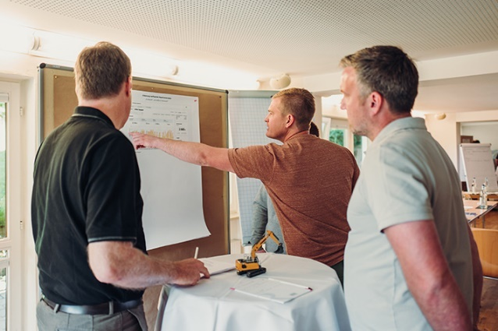
liebherr-1.jpg
Practical development thanks to lead customer partnership: Liebherr-EMtec GmbH actively includes customers in the development of digital, machine-oriented solutions from the start.

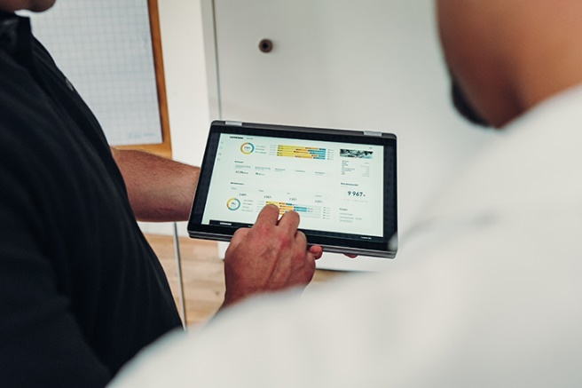
liebherr-2.jpg
Liebherr-EMtec GmbH provides customers with relevant practical knowledge on a customer-oriented IoT platform in order to be able to operate their entire machine fleet with maximum reliability and productivity.
Contact
Nadine Willburger
Marketing
Tel.: +49 7354 / 80 - 7332
E-mail: nadine.willburger@liebherr.com
Published by
Liebherr-Hydraulikbagger GmbH
Kirchdorf an der Iller / Germany
www.liebherr.com

